\Year 8 knowledge organiser and sketchbook work.
ARCHITECTURE & PERSPECTIVE
Key words and their meanings.
Learn these words so that you can use them in your conversations in class.
Line | Any image that consists of distinct straight or curved lines.
Geometric Shape | Shapes made out of points and lines including the triangle, square, and circle.
Form | Describes a three-dimensional geometrical figure as opposed to a shape.
Organic Shape | Naturally these shapes will all be slightly different from one another.
Foreground | Area of the picture space that is nearest to the viewer.
One-Dimensional | Containing only one dimension, this is only possible when you’re dealing with a line.
Composition | The arrangement of elements within a work of art.
Depth | The apparent distance from front to back or near to far in an artwork.
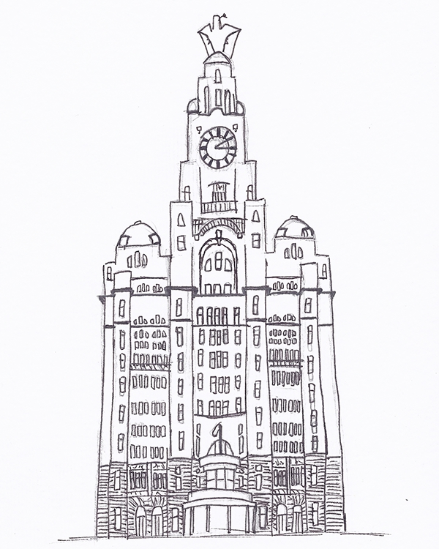
Perspective is a drawing method that shows how things appear to get smaller as they get further away. It is a way of drawing objects upon a flat surface so that they look three dimensional and realistic.
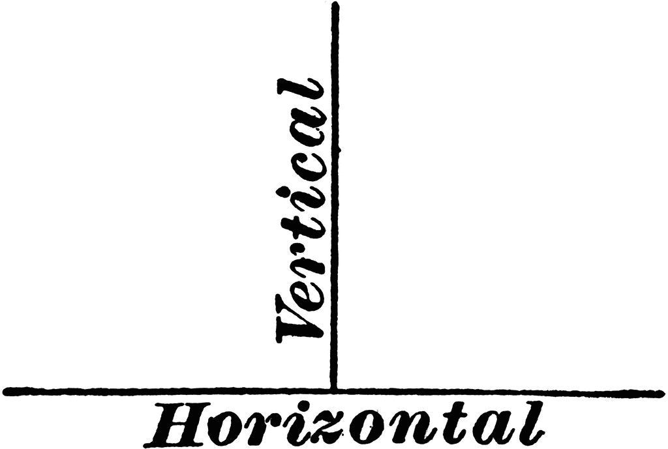
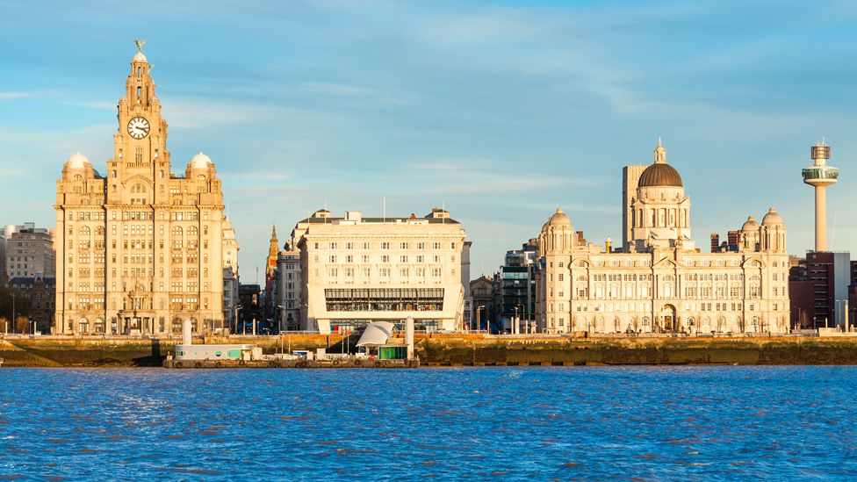
Perspective is the art of representing three-dimensional objects on a two-dimensional surface, to give the impression of their height, width, depth, and position in relation to each other.

The Three Graces:

