Year 7 knowledge organiser. TINGA TINGA
Key words and their meanings.
Learn these words so that you can use them in your conversations in class.
Line | Line is an element of art defined by a point moving in space.
Colour | Color is an element consisting of hues, of which there are three properties: hue, chroma or intensity, and value.
Composition | Composition is the term given to a complete work of art and, more specifically, to the way in which all its elements work together to produce an overall effect.
Background | The back section of a painting/drawing.
Middle Ground | The section in the middle of a painting or drawing.
Foreground | The front section of a painting/drawing.
Pattern | A repeated decorative design.
Culture | The ideas, customs, and social behaviour of a particular people or society.
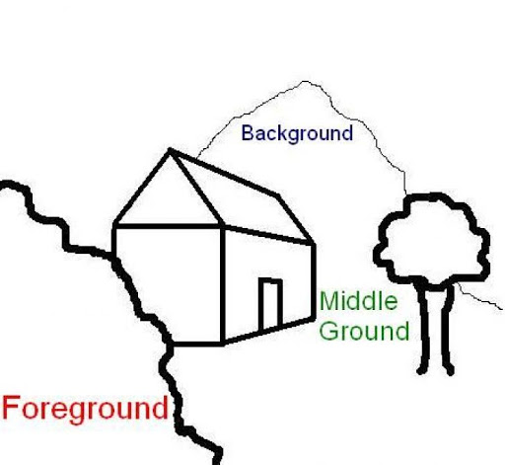
TINGA TINGA TAILS:
Tinga Tinga Tales Official | Why Parrot Can't Keep a Secret | Full Episodes | Full Episodes - YouTube
WATCH ME

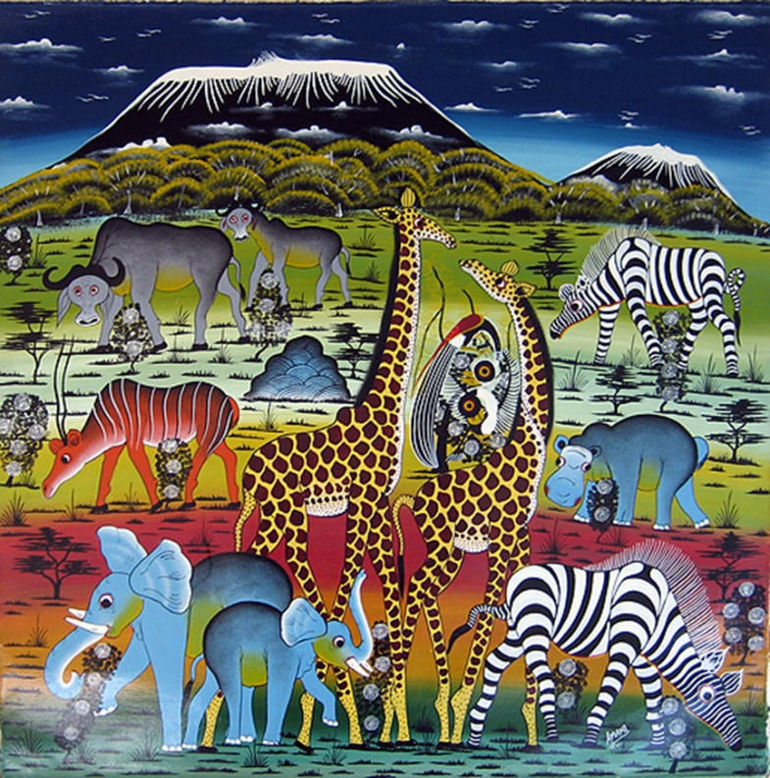

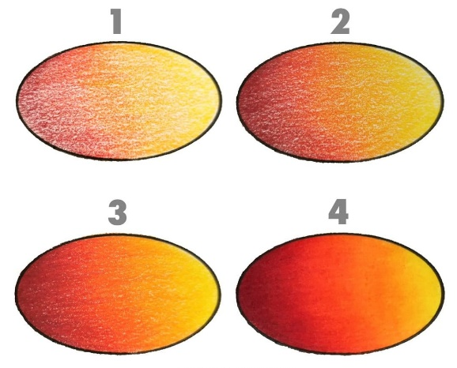
LAYERS OF COLOURED PENCIL TO BLEND SEAMLESSLY

