Key words and their meanings.
Learn these words so that you can use them in your conversations in class.
Graffiti | Graffiti is a type of art genre that means writing or drawings made on a wall or other surface, usually without permission and within public view
Detail | The small, well-defined parts of a work of art
Tagging | The repeated use of a single symbol or series of symbols to mark territory
Pattern | A repeated decorative design.
Composition | The ways in which the elements of a work of art are arranged
Tone | Tone refers to the relative lightness or darkness of a colour
Background | The part of an image that appears furthest away from the viewer
Symbolism | The practice or art of using an object or a word to represent an abstract idea.
Vandalism | Action involving deliberate destruction of or damage to public or private property.

https://www.youtube.com/watch?v=Xoe3Nn5vuBg
Graffiti venue in Liverpool:
WATCH ME
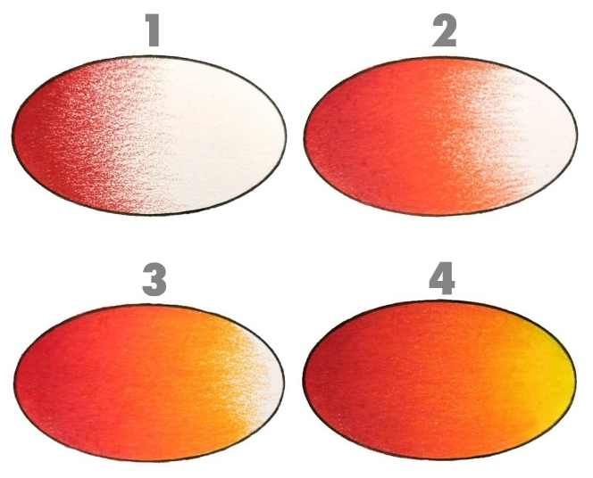
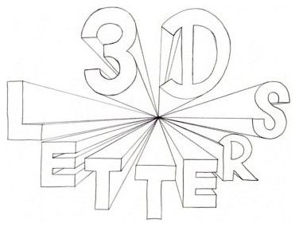
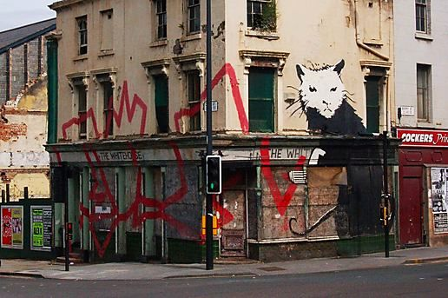
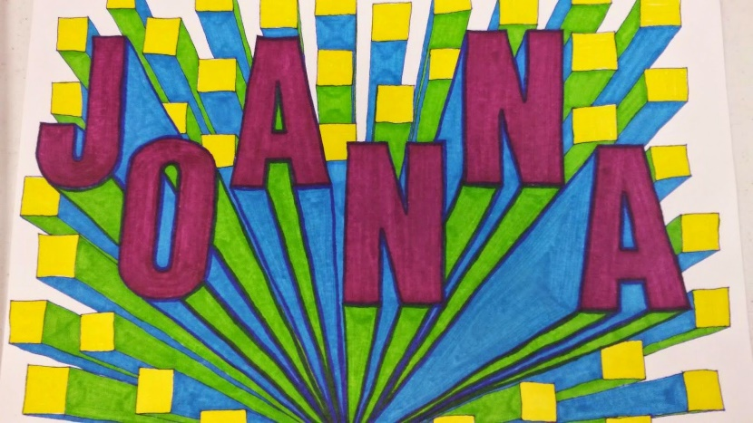
https://www.zapgraffiti.co.uk/
Graffiti in the local area:

