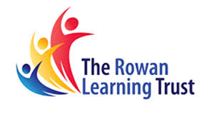
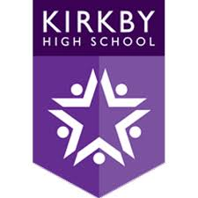
Messages

In this document, you will find the messages that have been sent home to parents/ carers, with the most recent at the top.

Date | Message to Parents
Tuesday 4th January 2022 | Good afternoon. As you are no doubt aware, the new strain of COVID appears to be more infectious than previous strains and it is therefore vitally important that as many students as possible test prior to the whole school return on Friday 7th January to reduce transmission and ensure that school experiences minimum disruption to learning. If you would like your child tested on-site on Thursday 6th January, please complete the short consent form before 7pm tomorrow if you have not already done so by clicking the following link: https://forms.office.com/r/9ZmW6YC7CD. From Friday, students will also be required to wear masks in classrooms in addition to communal areas. We look forward to seeing #ChildName on Friday and we ask you to reinforce our high expectations and ensure that your child returns to a positive start. Students are expected to be in full school uniform with a bag large enough to fit an A4 folder inside and must not wear earrings, false nails or eyelashes. Mr. Durrant.
Wednesday 15th December 2021 | We are in our final stages of the "Switch it Up" attendance competition where students have the chance to win a Nintendo Switch. Students with the most improved attendance or 100% attendance will be placed in our draw on Tuesday. Please continue to support #Childname to attend school every day on time. Throughout this week, in some subjects, students are completing and receiving feedback from Christmas testing, so it is important that they attend every day. Kind regards, Mr McKendrick
Sunday 28th November 2021 | Good evening. Government guidance now states, "Face coverings should be worn in communal areas in all settings by staff, visitors and pupils or students in year 7 and above, unless they are exempt" This guidance starts from Tuesday 30th November. Where possible we would like students, who are not exempt to begin wearing their face covering from tomorrow. We are aware that in some cases this may not be possible, and we will supply a face mask where we can. Please ensure that #Childname follows this guidance by making sure they have a plain face mask from Tuesday. Students should continue to wear a face mask on public transport. I look forward to seeing all students bright and early tomorrow morning. Mr McKendrick
Friday 24th September 2021 | Dear Parents/carers  This autumn all children aged 12 to 15 years are being offered the first dose of the COVID-19 vaccination.  Vaccinating children should help to reduce the need for children to have time off school and to reduce the risk of spread of COVID-19 within schools. The COVID-19 vaccination programme in secondary schools will therefore provide protection to children who are vaccinated and help to reduce disruption to face to face education this winter.  Please click on the below to see further information from the Immunisation team and access your child’s electronic consent form.  We kindly request you could complete this before Midnight Sunday 26/09/2021 to support campaign planning  https://forms.merseycare.nhs.uk/covid-19-vaccination/
Thursday 16th September 2021 | Good evening. Tomorrow morning our form tutors will be delivering some really exciting news about a reward we will be giving out for high attendance at Kirkby High School. Please make sure that #ChildName is in school on time to find out how to enter the competition. You have to be in to win!!. Mr McKendrick #8.38
Tuesday 7th September 2021 | Good afternoon. All students must attend school with a bag that is large enough to fit an A4 folder inside. Students were informed yesterday and today that from Wednesday 8th September, anyone arriving to school with a small bag that does not fit an A4 folder inside will have this confiscated and returned to them at the end of the day. We would appreciate your support in ensuring #ChildName has an appropriate school bag. Thank you. Mr. Durrant.

