Art Knowledge organizer Autumn 2
Challenge yourself and work hard. Can you achieve above your target in all of the skills?
Projects and achievements
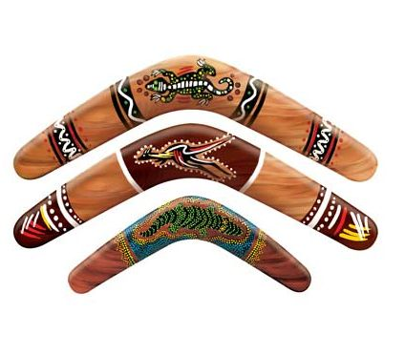
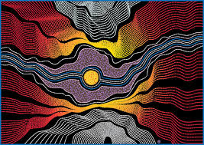
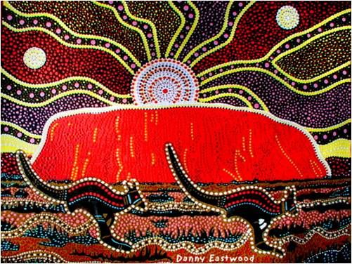
Term 1. Aboriginal art

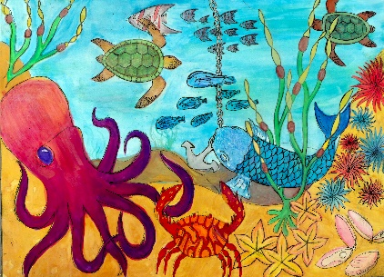
Term 3. Aquatic art

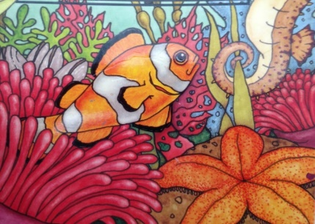

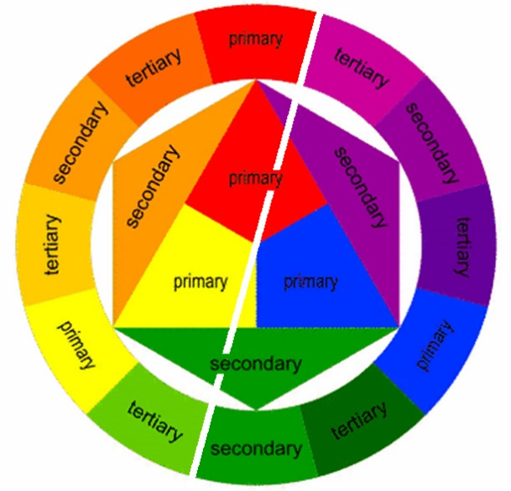
Colour theory
Warm
Colours
Cool
colours

This term you will be learning about the
following art and design key skills.
- Working through ideas.
- Practical skills.
- The progress you are making.
- Your personal and visual response.

Term 2. Architecture and perspective

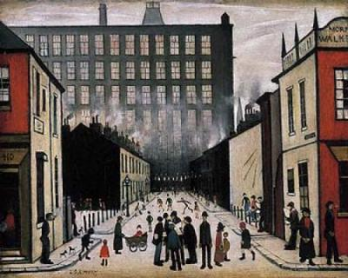
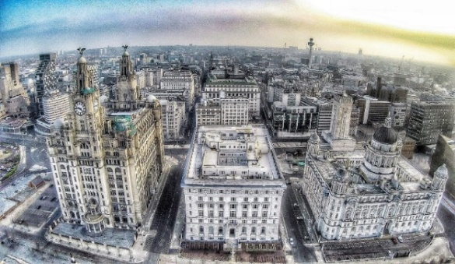
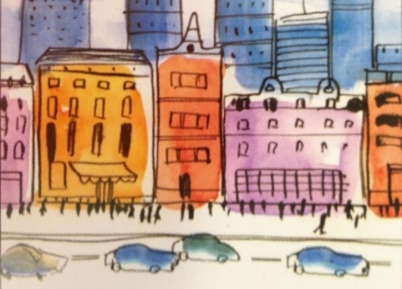

Vocabulary – Elements of art, keywords and meanings.
Line | A line can be horizontal, vertical, diagonal, straight or curved, thick or thin. A line drawing is made up of just lines, no colour, texture or tone.
Shape | The element of art that is a distinct space, having length and width, (2 dimensions); a shape is created when a line reconnects with itself
Organic shape | The shapes without names, frequently from nature (also known as Freeform)
Geometric Shapes | The shapes known by names: circle, square, triangle, etc.
Form | Element of art that refers to the three dimensional – having length, width and depth
Two-dimensional | (2D) having length and width but no depth (flat)
Three-dimensional | (3D) having length, width and depth
Scale | Relative size in comparison to something else.
Architecture | The process of designing buildings
Detail | The small, well-defined parts of a work of art
Tone | Techniques used to emphasis form. This refers to the lightness or darkness of something. Tones are created by the way light falls on an object.
Pattern | Created by repeating shapes.
Colour theory  Look at the colour wheel on the front of this booklet. | There are three primary colours, red, blue and yellow. These colours can be mixed together to create secondary and tertiary colours. Complimentary colours lie opposite on the colour wheel and together create a dramatic contrast. Harmonious colours lie next to each other and blend well together.
Composition | The ways in which the elements of a work of art are arranged
Balance | Principle of design in which elements of a composition seem well arranged
Perspective | A way of representing three dimensional objects on a flat surface,
One point perspective | A drawing method that shows how things appear to get smaller as they get further away, usually leading to a vanishing point.
Vanishing point | The point at which something which has been decreasing in size disappears altogether
Depth of field | A way of showing distance in an image. From the nearest point to the furthest away
Quality | The standard of something in comparison to other things of a similar kind; the degree of excellence of something.
Technique | A skilful or efficient way of doing or achieving something in a certain way.
Expression | Emotion feelings or moods. Commonly created through facial features or stories.
Expressive | An adjective that shows feelings, ideas or moods.
Individuality / unique | Someone that does things differently than other people – ‘one of a kind’.
Atmosphere / atmospheric | An feeling that evokes a particular emotion using tone, colour, lighting or emotion, situation, weather.
Mixed media | Different equipment used for one piece of artwork.

