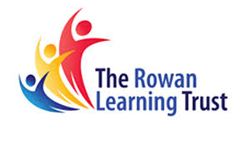
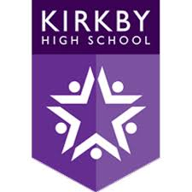
Messages

In this document, you will find the messages that have been sent home to parents/ carers, with the most recent at the top.

Date | Message to Parents
Friday 24th September 2021 | Dear Parents/carers  This autumn all children aged 12 to 15 years are being offered the first dose of the COVID-19 vaccination.  Vaccinating children should help to reduce the need for children to have time off school and to reduce the risk of spread of COVID-19 within schools. The COVID-19 vaccination programme in secondary schools will therefore provide protection to children who are vaccinated and help to reduce disruption to face to face education this winter.  Please click on the below to see further information from the Immunisation team and access your child’s electronic consent form.  We kindly request you could complete this before Midnight Sunday 26/09/2021 to support campaign planning  https://forms.merseycare.nhs.uk/covid-19-vaccination/
Thursday 16th September 2021 | Good evening. Tomorrow morning our form tutors will be delivering some really exciting news about a reward we will be giving out for high attendance at Kirkby High School. Please make sure that #ChildName is in school on time to find out how to enter the competition. You have to be in to win!!. Mr McKendrick #8.38
Tuesday 7th September 2021 | Good afternoon. All students must attend school with a bag that is large enough to fit an A4 folder inside. Students were informed yesterday and today that from Wednesday 8th September, anyone arriving to school with a small bag that does not fit an A4 folder inside will have this confiscated and returned to them at the end of the day. We would appreciate your support in ensuring #ChildName has an appropriate school bag. Thank you. Mr. Durrant.

