Year 7 knowledge organiser. TINGA TINGA
Key words and their meanings.
Learn these words so that you can use them in your conversations in class.
Line | Line is an element of art defined by a point moving in space.
Tone | Tone refers to the relative lightness or darkness of a colour.
Colour | Color is an element consisting of hues, of which there are three properties: hue, chroma or intensity, and value.
Primary Colours | A secondary color is a color made by mixing of two primary colors in a given colour space
Secondary Colours | Something that makes someone want to do something or gives someone an idea of what to create.
Pattern | A repeated decorative design.
Culture | The ideas, customs, and social behaviour of a particular people or society.
https://www.youtube.com/watch?v=N8yuyekP_So
WATCH ME
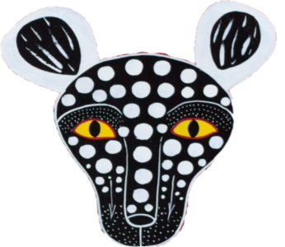
BLENDING COLOURED PENCILS

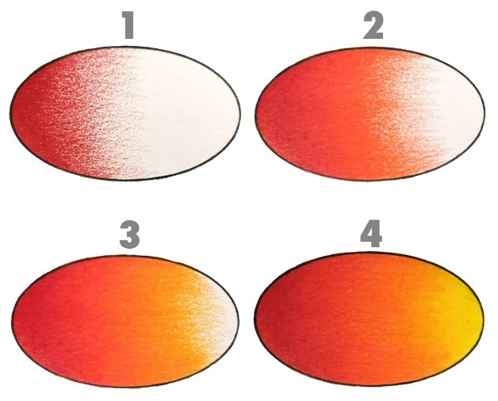

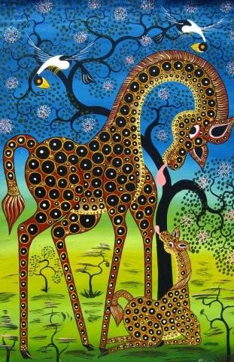

AFRICAN PATTERNS:

Sketchbook work
All of your homework tasks are designed to build on what you have been learning in class and are designed to improve your creative skills and to challenge your imagination. But most of all they are set for you to have fun developing your independent learning skills.

Half Term 1
Task 1.
You must create an ‘African Sunset’ Image.
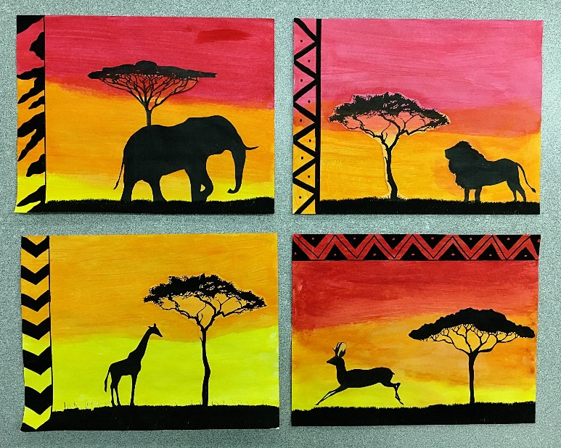
This will be inspired by warm colours and an animal of your choice. The animal will be coloured in black to represent a silhouette. You can add extra such as a tree (seen in the example image).
You can use any materials you like.
- Paints
- Chalk
- Tissue
- Pencils

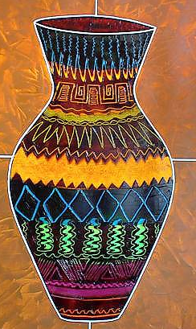
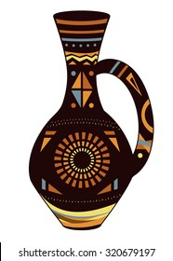
Half Term 2
Your task is to create a traditional African Pot, this should be drawn on one of your pages in your sketchbook.
To decorate your pot, you must use the African patterns that we have explored together in class.
Don’t forget the bright and vibrant colours!
