Year 10 knowledge organiser and sketchbook work.
FRUIT PROJECT
Key words and their meanings.
Learn these words so that you can use them in your conversations in class.
WATERCOLOUR BLENDING TECHNIQUES https://www.youtube.com/watch?v=2ouGKthODvI
Experimenting | Exploring new ideas and/or technology.
Meaningful | To create something with meaning, something that is important and has a purpose.
Observations | The image is not taken from either a photograph or the artist' imagination, but from real life observation, something physically in front of you to copy.
Cross Hatching | An art movement is a tendency or style in art with a specific common philosophy or goal, followed by a group of artists during a specific period of time
Dabbing | Dabbing adds texture and movement to a piece. This is done by gently patting the paint onto the surface.
Foreground | The part of an image that seems closest to the viewer
Background | The part of an image that appears furthest away from the viewer
Composition | Composition is the arrangement of elements within a work of art.
Refine | make minor changes so as to improve or clarify

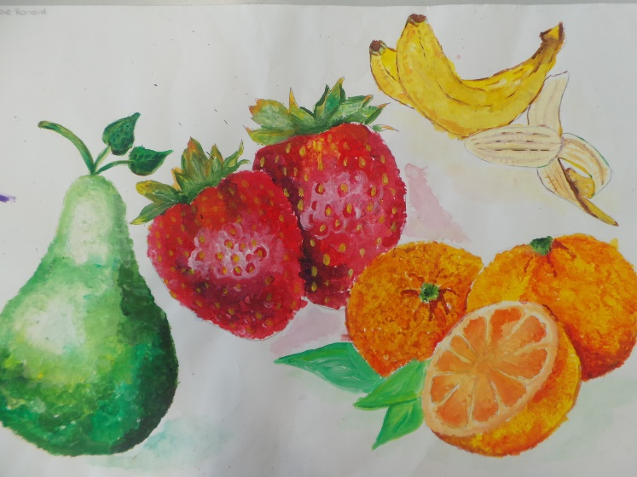
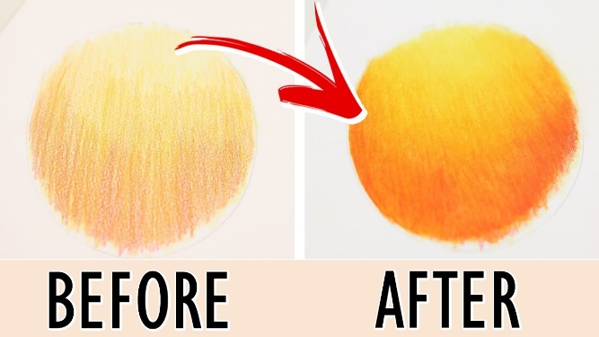
WATCH ME
HAND PRESSURE allows you to achieve different shades with your pencil.

LAYERING your coloured pencils achieves the seamless blend of colours

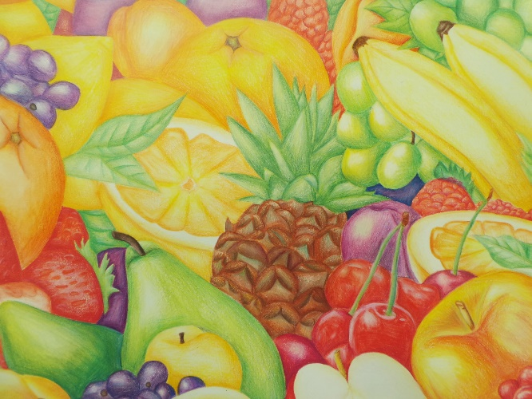

Apple Watercolor Painting Tutorial for Beginners Step by Step - YouTube

