Year 9 knowledge organiser and sketchbook work.
CULTURES
All of your homework tasks are designed to build on what you have been learning in class and are designed to improve your creative skills and to challenge your imagination. But most of all they are set for you to have fun developing your independent learning skills.

You can choose to do just task one or both task one and the additional task. If you choose to focus on task one this should be an in depth study that you should show to your teacher for advice as it progresses over the half term. The additional tasks are set to challenge you and to show how conscientious you are. Your homework should be completed in your school sketchbook.
Your sketchbook needs to last for years 7, 8 and 9 and each page must be used to the full. Please don’t lose your book as a replacement book will not be provided. When not using your sketchbook keep it in your school bag, a detention will be given if you do not have your sketchbook with you in lesson.
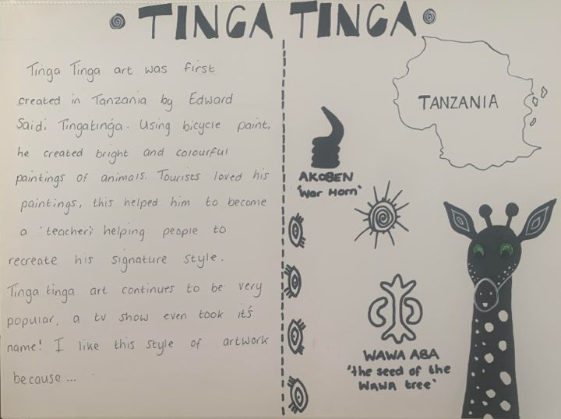
Homework 1
Task 1.

Design your very own Tinga Tinga inspired page in your sketchbook. This can include facts, drawings, patterns, and most importantly, lots of colour!
A checklist to help you structure your page:
- A nice title
- Drawings
- Minimum of 3 facts about Tinga Tinga Art
- Colour
- African Patterns

Homework 2
Task 1.
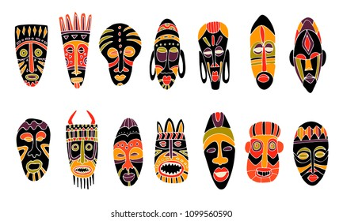
In your sketchbook you are to create an African Mask- exploring colour and patterns. Use pencil and coloured pencils to design the Tinga Tinga inspired mask.

Key words and their meanings.
Learn these words so that you can use them in your conversations in class.
Art in this sense is communication; it allows people from different cultures and different times to communicate with each other via images, sounds and stories.
Culture | The ideas, customs, and social behaviour of a particular people or society.
Detail | The small, well-defined parts of a work of art
Organic shapes | Organic shapes are shapes without names, frequently from nature such leaves (also known as Freeform).
Pattern | a repeated decorative design.
Composition | The ways in which the elements of a work of art are arranged
Tone | Tone refers to the relative lightness or darkness of a colour
Background | The part of an image that appears furthest away from the viewer
Symbolism | The practice or art of using an object or a word to represent an abstract idea.
Perspective | A way of representing three dimensional objects on a flat surface,
Blending Watercolor Techniques For Beginners - YouTube

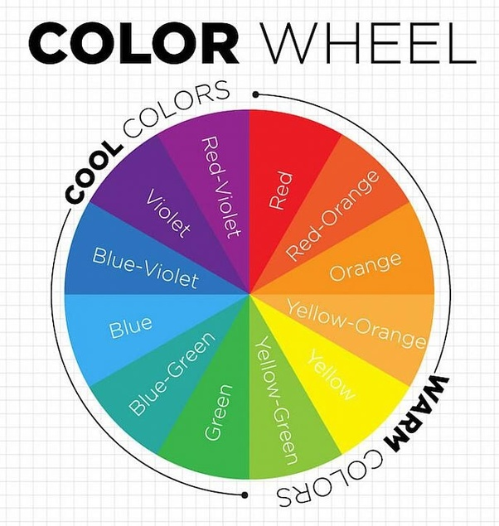
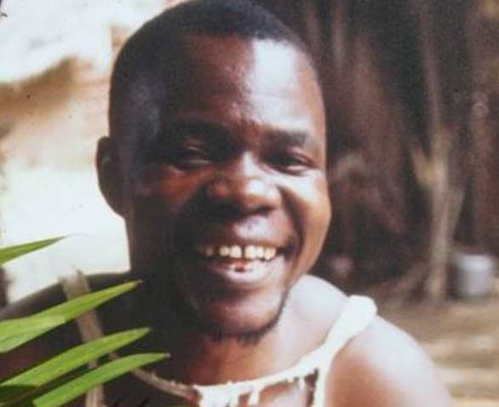
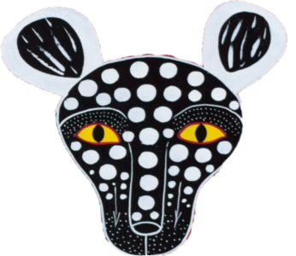
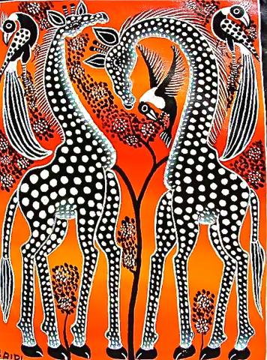
Edward Saidi Tinga Tinga
Tinga Tinga is one of the most widely represented forms of tourist-oriented paintings in Tanzania, Kenya and neighboring countries.
WATCH ME

