Probability | Algebraic representation | Revision
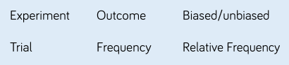 | 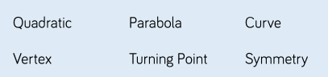 | https://vle.mathswatch.co.uk/vle/
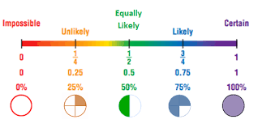 | 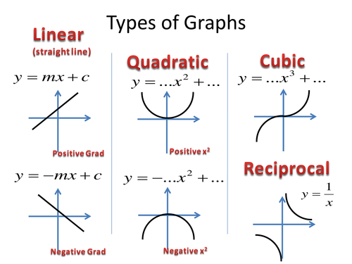 | https://www.drfrostmaths.com/  https://www.bbc.co.uk/bitesize/subjects/zqhs34j  https://corbettmaths.com/contents/  https://mathsmadeeasy.co.uk/ks3-revision/ks3-maths/
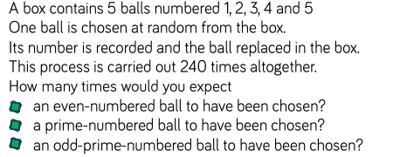 | 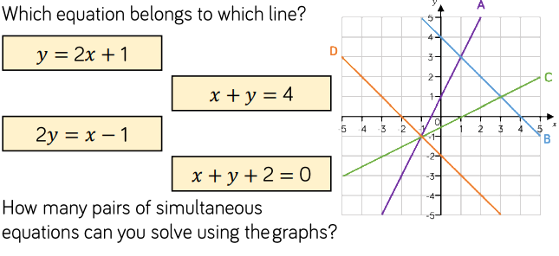 | CHALLENGE  https://www.ukmt.org.uk/competitions/solo/junior-mathematical-challenge/archive  FUN  Numberphile  https://www.youtube.com/channel/UCoxcjq-8xIDTYp3uz647V5A.

