Year 7 knowledge organiser. TINGA TINGA
Key words and their meanings.
Learn these words so that you can use them in your conversations in class.
Line | Line is an element of art defined by a point moving in space.
Tone | Tone refers to the relative lightness or darkness of a colour.
Colour | Color is an element consisting of hues, of which there are three properties: hue, chroma or intensity, and value.
Composition | Composition is the term given to a complete work of art and, more specifically, to the way in which all its elements work together to produce an overall effect.
Inspirational | Something that makes someone want to do something or gives someone an idea of what to create.
Pattern | A repeated decorative design.
Culture | The ideas, customs, and social behaviour of a particular people or society.
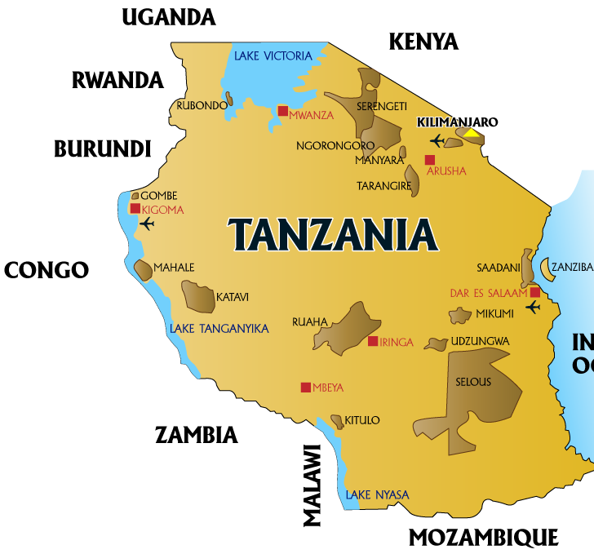
TINGA TINGA TAILS:
https://www.youtube.com/watch?v=95KAgYyrtoI
WATCH ME
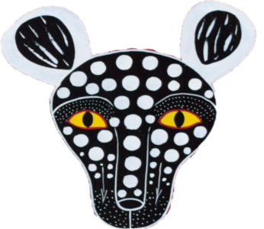

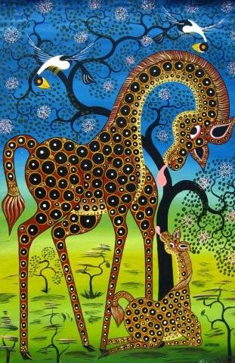

WEBSITES TO EXPLORE:

https://www.tingatingaart.com/pages/about-tingatinga-african-art
https://trueafricanart.com/pages/tingatinga-information
AFRICAN PATTERNS:
Sketchbook work
All of your homework tasks are designed to build on what you have been learning in class and are designed to improve your creative skills and to challenge your imagination. But most of all they are set for you to have fun developing your independent learning skills.

Half Term 1
Task 1.
Design your very own Creative Map of Africa. This can include drawings, patterns, information. Make it bright and colourful!
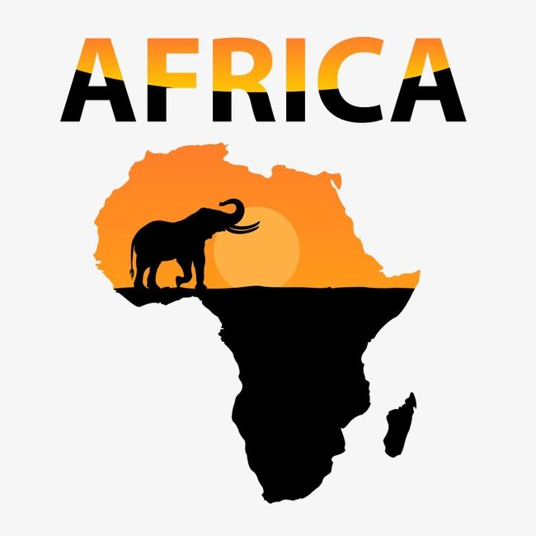

Half Term 2

In your sketchbook you are to create an African Mask- exploring colour and patterns. Use pencil and coloured pencils to design the Tinga Tinga inspired mask.

