Year 7 knowledge organiser. Mixed Media Bugs
Key words and their meanings.
Learn these words so that you can use them in your conversations in class.
Mixed Media | mixed media is an artwork in which more than one medium or material has been employed
Shading | The use of marking made within outlines to suggest three-dimensionality, shadow, or degrees of light and dark in a picture or drawin
Harmonious Colours | Colours that sit next to each other on the colour wheel.
Cross-Hatching | A method of line drawing that describes light and shadow that is created by a density of crossed lines.
Inspirational | Something that makes someone want to do something or gives someone an idea of what to create.
Stippling | Stippling is the creation of a pattern simulating varying degrees of solidity or shading by using small dots
Zentangle | Similar to mandalas and doodles. They require the person to draw repetitive patterns
Blending | Gently intermingling two or more colours to create a gradual transition or to soften lines.
Mixed Media Backgrounds - YouTube

Some great books on Insects
WATCH
THIS

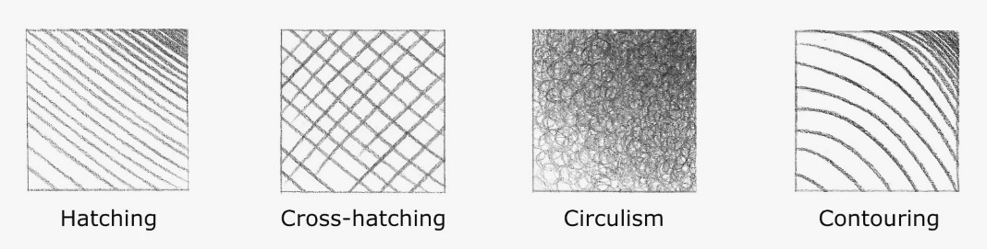

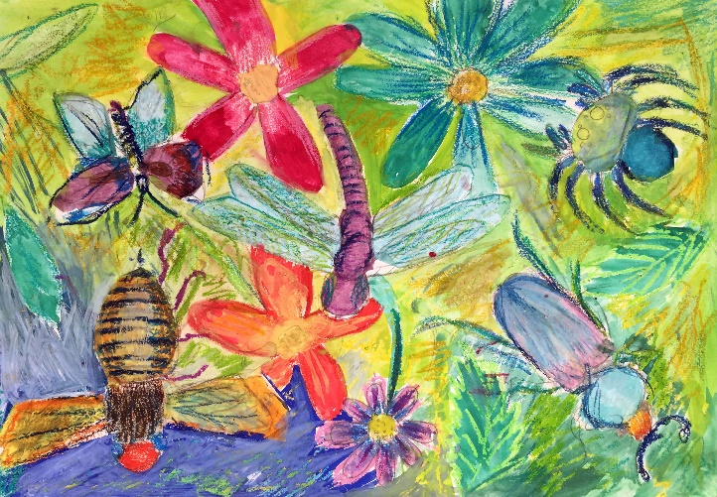
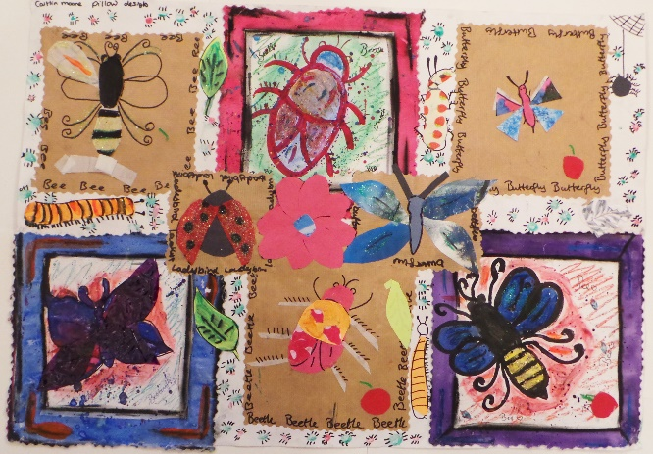

Sketchbook work
All of your homework tasks are designed to build on what you have been learning in class and are designed to improve your creative skills and to challenge your imagination. But most of all they are set for you to have fun developing your independent learning skills.

Half Term 1
Task 1.
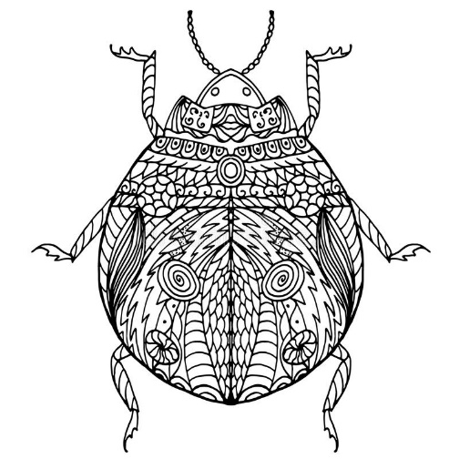
Create your very own Zentangle Bug, make it as detailed as possible with lots of repetitive patters. Use a black pen to make your design really stand out!
Choose one from the Bugs below;
- Beetle
- Butterfly
- Snail
- Fly
- Bee
Tip: You can use the internet to help you choose, simply type in ‘Zentangle Bug’

Half Term 2

Task 1:
You are going to create a ‘collage bug’ You can do this in any way that you like, but you must follow these steps.

- Choose your insect (any insect of your choice)
- Draw the insect in pen or pencil first.
- You then gather your materials that you want to stick on your insect
e.g. Newspaper, Coloured Paper, Tissue Paper, Lined Paper, Card etc.
4. Begin to cut/rip your materials and stick them onto your drawing, you may choose to focus on certain areas (the wings or the body) or fill your whole insect.
