Year 10 Knowledge Organiser. Topic Two. Mixed Media
You should spend at least two hours per week in addition to your class time, working on your artwork techniques.
You could practise your skills or working on your school artwork.
A really good way of working is to draw from still life. This is either an image that you have put items together to draw from, or drawing a person or a scene.

Look at the images on your right and grade yourself from the grid below. The final piece is set out as a 10 hour piece of work because your externally set task is limited to 10 hours. This will get you used to see how much work you can complete in 10 hours.

Below are the assessment objectives set by AQA.
You should grade your first 2 worksheets each lesson based on the grade descriptors below. Use your booklets for key words and VCOP to help with annotation on your design sheets.
AO1 – Developing ideas and how other artist have influenced you work. | Starting  1  Hardly any artist reference. | Developing  2 3  Some artist reference but no ideas of your own. | Capable  4 5  Artist reference has given you ideas of how to develop your work. | Confident  6 7  Artist reference has clearly influenced your work. | Fluent  8 9  A very high individual standard of work influenced by other artists.
AO2 – Experimenting with media, equipment and techniques. | Starting  1  Very few experiments with equipment | Developing  2 3  Some experiments with equipment. | Capable  4 5  Lots of interesting experiments but some haven’t worked out. | Confident  6 7  Experiments are fun, lively and successful, and have a purpose. | Fluent  8 9  Experiments are to a very high standard and have a clear, intentional purpose.
AO3 - Annotation and recording ideas. | Starting  1  Very few design sheets.  No ideas, plans or annotations. | Developing  2 3  Some design sheets but no clear ideas or annotations. | Capable  4 5  Design sheets and annotations mostly link to each other and show your ideas. | Confident  6 7  Design sheets and annotations all link together and clearly show your ideas. | Fluent  8 9  Design sheets and annotations link together showing well though out ideas and plans.
AO4 - Personal response. | Starting  1 | Developing  2 3  Unfinished but shows potential. | Capable  4 5  Completed and shows developing ability. | Confident  6 7  Completed and creative, skills can be clearly seen. | Fluent  8 9  Highly creative and original.

Step1. Basic Drawing Skills of facial features  Starting Developing Capable Confident Fluent  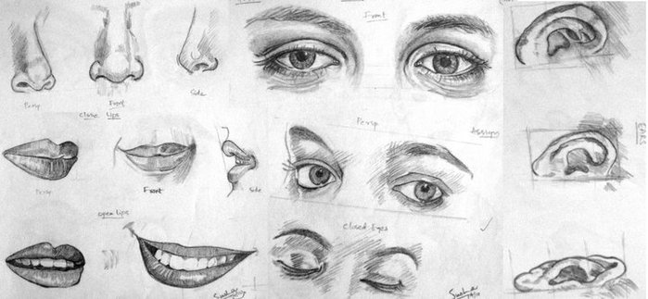 | Step 4. Artist Reference/Research  Starting Developing Capable Confident Fluent  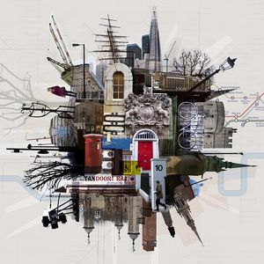  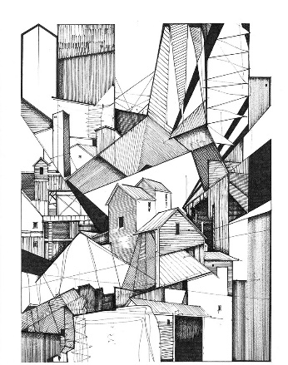  Jon Measures or Kyle Henderson
Step 2. Artist Reference/Research  Starting Developing Capable Confident Fluent  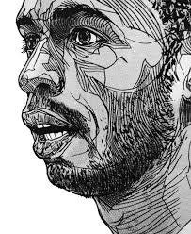  Florian Nicolle or Luke Dixon | Step 5. Artist Response (direct copies of artists work)  Startin Developing Capable Confident Fluent  - Directly copy their work, stick on a small print out of the artist’s work.  - Produce portraits in their style working from a photograph.  - Produce a portrait in the style of one of the artists from a photograph you have taken.  4.Annotate your work.
Step 3. Artist Response (direct copies of artists work)  - Directly copy their work, stick on a small print out of the artist’s work.  - Produce portraits in their style working from a photograph.  - Produce a portrait in the style of one of the artists from a photograph you have taken.  - Annotate your work.  Starting Developing Capable Confident Fluent | Step 6. Personal Response to chosen topic and artist- Refine your ideas.  Starting Developing Capable Confident Fluent  Design additional extra images that will enhance your final design. Create study sheets (A2 or A3) on your chosen topic, exploring new ideas and experimenting with media.
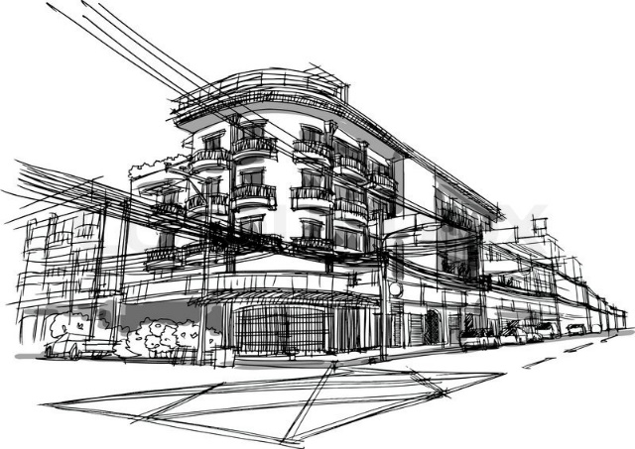  Step 4. Basic Drawing Skills of Architecture  Starting Developing Capable Confident Fluent | Step 7. Final piece  Starting Developing Capable Confident Fluent  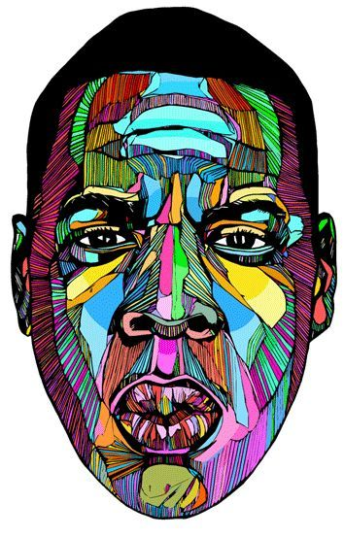  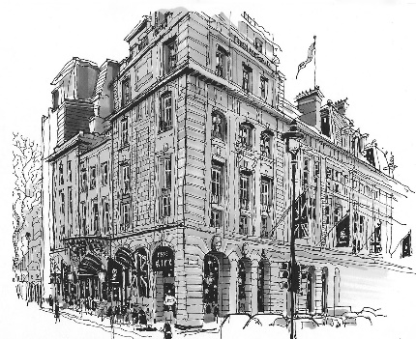  Tick each lesson to keep track of time.  1 2 3 4 5 6 7 8 9 10

