Year 9 knowledge organiser and sketchbook work.
LANDSCAPES
All of your homework tasks are designed to build on what you have been learning in class and are designed to improve your creative skills and to challenge your imagination. But most of all they are set for you to have fun developing your independent learning skills.

You can choose to do just task one or both task one and the additional task. If you choose to focus on task one this should be an in depth study that you should show to your teacher for advice as it progresses over the half term. The additional tasks are set to challenge you and to show how conscientious you are. Your homework should be completed in your school sketchbook.
Your sketchbook needs to last for years 7, 8 and 9 and each page must be used to the full. Please don’t lose your book as a replacement book will not be provided. When not using your sketchbook keep it in your school bag, a detention will be given if you do not have your sketchbook with you in lesson.
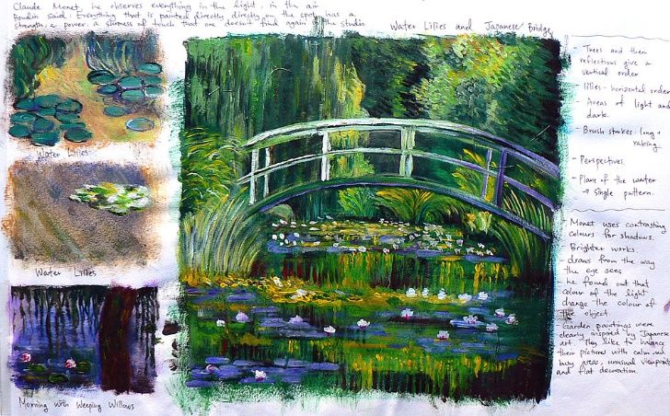
Homework 1
Task 1.
Choose one of the artists we have looked at and create an Artist Research page in your sketchbook.
Write down the key facts on the artist and also what you think about their work. You can decorate this page with relevant Landscape sketches/ copies of the artist’s work.
Task 2.
Paint/Draw one of the Fauvist style Landscape images into your sketchbook, this should fill a whole page in your sketchbook. Use one of the images from the artists we looked at in class.

Homework 2
Task 1.
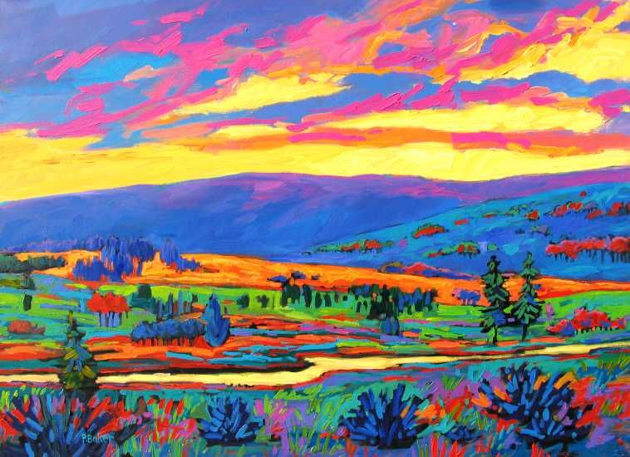
Take an image of a scene which you are familiar with. It could be a park, garden, landscape or even your own street. Make a Fauvist style drawing of your scene. Make it as detailed as possible in this style.
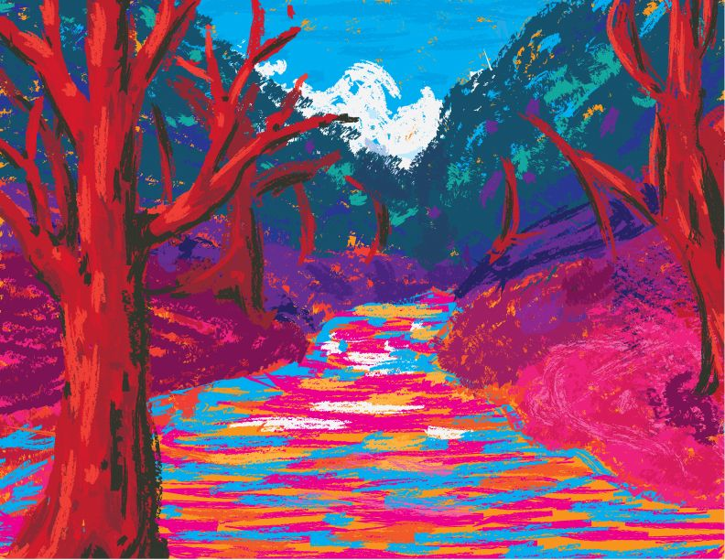

Key words and their meanings.
Learn these words so that you can use them in your conversations in class.
Landscapes | Landscape painting, also known as landscape art, is the depiction of natural scenery such as mountains, valleys, trees, rivers, and forests.
Detail | The small, well-defined parts of a work of art
Organic shapes | Organic shapes are shapes without names, frequently from nature such leaves (also known as Freeform).
Art movements | An art movement is a tendency or style in art with a specific common philosophy or goal, followed by a group of artists during a specific period of time
Composition | The ways in which the elements of a work of art are arranged
Foreground | The part of an image that seems closest to the viewer
Background | The part of an image that appears furthest away from the viewer
Depth of field | A way of showing distance in an image. From the nearest point to the furthest away
Perspective | A way of representing three dimensional objects on a flat surface,
Van Gogh’s sunflowers were a symbol of ‘happiness’ for him.
VINCENT VAN GOGH
http://www.bbc.co.uk/education/clips/zdyr87h

Impressionism- Impressionism is a 19th-century art movement characterized by relatively small, thin, yet visible brush strokes, open composition, emphasis on accurate depiction of light in its changing qualities.

Post Impressionism- Post-Impressionism emerged as a reaction against Impressionists' concern for the naturalistic depiction of light and colour.

Fauvism- Fauvism is the name applied to the work produced by a group of artists from around 1905 to 1910, which is characterised by strong colours and fierce brushwork.

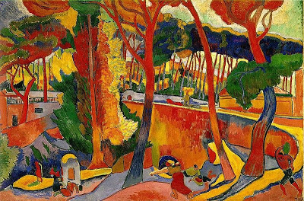
Exaggerated colour was the most important part of a fauvist painting

