\Year 8 knowledge organiser and sketchbook work.
ARCHITECTURE & PERSPECTIVE
All of your homework tasks are designed to build on what you have been learning in class and are designed to improve your creative skills and to challenge your imagination. But most of all they are set for you to have fun developing your independent learning skills.

You can choose to do just task one or both task one and the additional task. If you choose to focus on task one this should be an in-depth study that you should show to your teacher for advice as it progresses over the half term. The additional tasks are set to challenge you and to show how conscientious you are. Your homework should be completed in your school sketchbook.

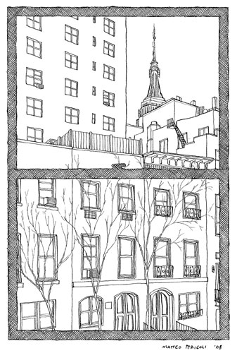
Your sketchbook needs to last for years 7, 8 and 9 and each page must be used to the full. Please don’t lose your book as a replacement book will not be provided. When not using your sketchbook keep it in your school bag, a detention will be given if you do not have your sketchbook with you in lesson.

Homework 1
Task 1.
Filling a whole page in your sketchbook, you are to look out your window at home and draw what you see. Draw it exactly how it is from where you are sitting. E.g. window ledge and window frame will be visible.

Additional task.
Add colour to your drawing, remembering to shade and blend to make the drawing look more realistic.

Homework 2
Design a room using perspective and 3D Geometric shapes.
Add detail, think carefully about what else would be in the room.
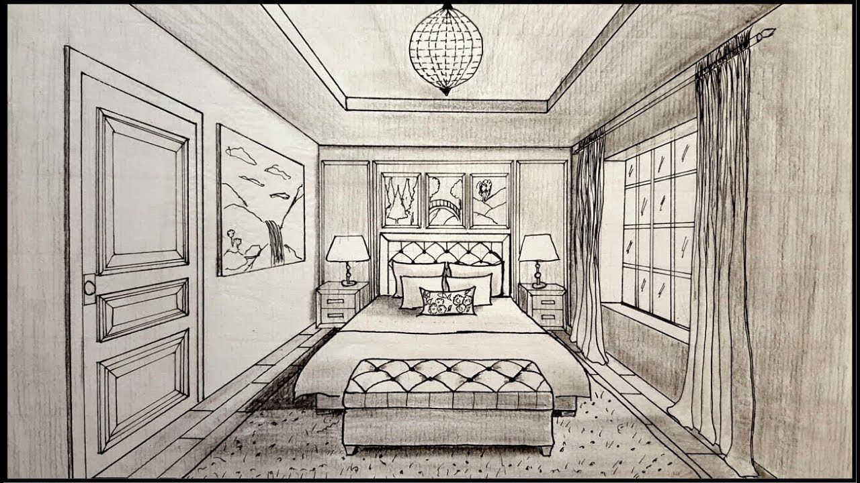

Key words and their meanings.
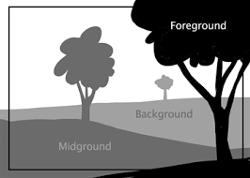
Learn these words so that you can use them in your conversations in class.
The vanishing point is the point on the horizon (at eye-level) where everything disappears.
Line | Any image that consists of distinct straight or curved lines.
Geometric Shape | Shapes made out of points and lines including the triangle, square, and circle.
Form | Describes a three-dimensional geometrical figure as opposed to a shape.
Organic Shape | Naturally these shapes will all be slightly different from one another.
Foreground | Area of the picture space that is nearest to the viewer.
One-Dimensional | Containing only one dimension, this is only possible when you’re dealing with a line.
Composition | The arrangement of elements within a work of art.
Depth | The apparent distance from front to back or near to far in an artwork.
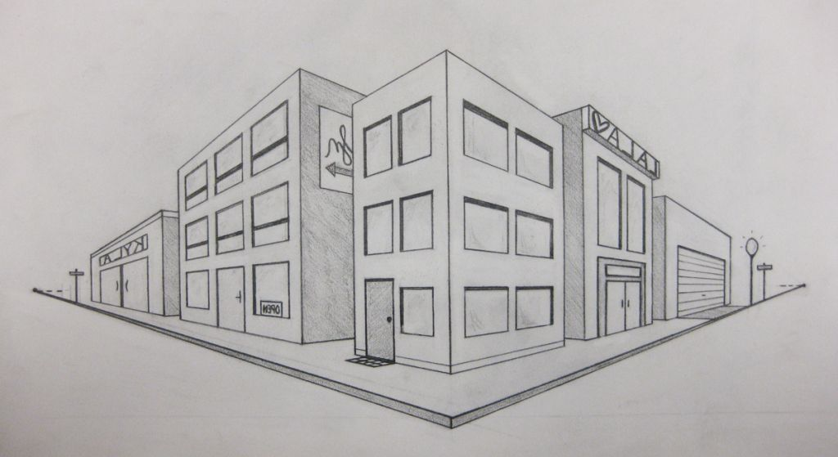
Perspective is the art of representing three-dimensional objects on a two-dimensional surface, to give the impression of their height, width, depth, and position in relation to each other.

Perspective is a drawing method that shows how things appear to get smaller as they get further away. It is a way of drawing objects upon a flat surface so that they look three dimensional and realistic.

