Setting up a Teams Meeting with Students
  - The Rowan Learning Trust – Teams Instructions

This guide will allow you to create a Teams meeting as well as allowing you to have overall control of who you can mute and remove from the meeting. If Students are not set as an attendee, they can remove each other from the lesson.

Step 1:
Within teams, navigate to the Teams pane on the left-hand side and select the class required.
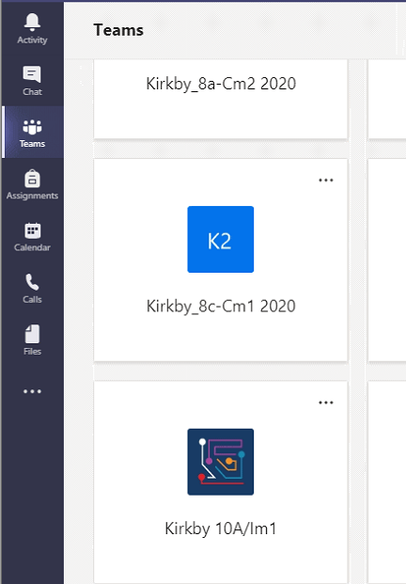

Step 2:
Once your class group has opened click the arrow located next to Meet and click schedule a meeting along the top.
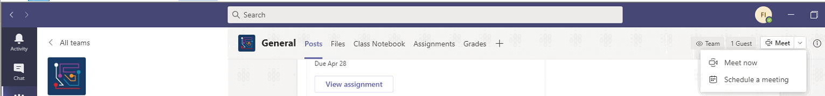

Step 3:
Once you have clicked on schedule a meeting you will be able to fill in your meeting details (title, details for meeting, time set for meeting). Click Send once all the relevant information has been added.

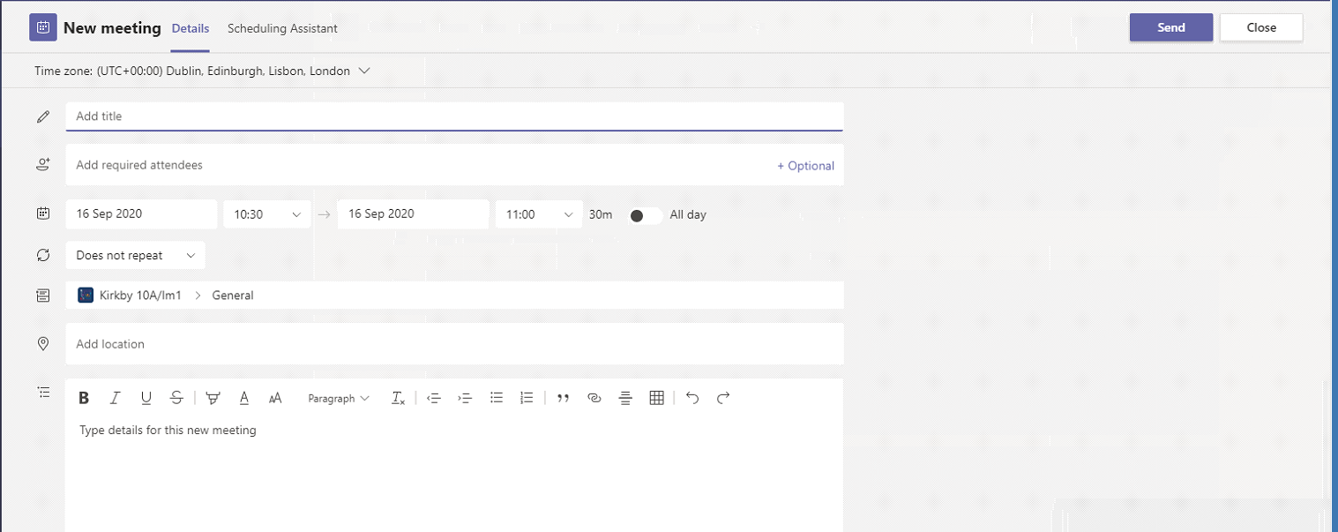

Step 4:
Once the relevant details have been inputted and you have clicked send the meeting will appear in 2 locations. The first location will be in the Posts tab within your group highlighted below.
The 2nd location is in your calendar which can be found down the left-hand side of your Teams screen. Once clicked, the meeting will be in the date and time slot you set.
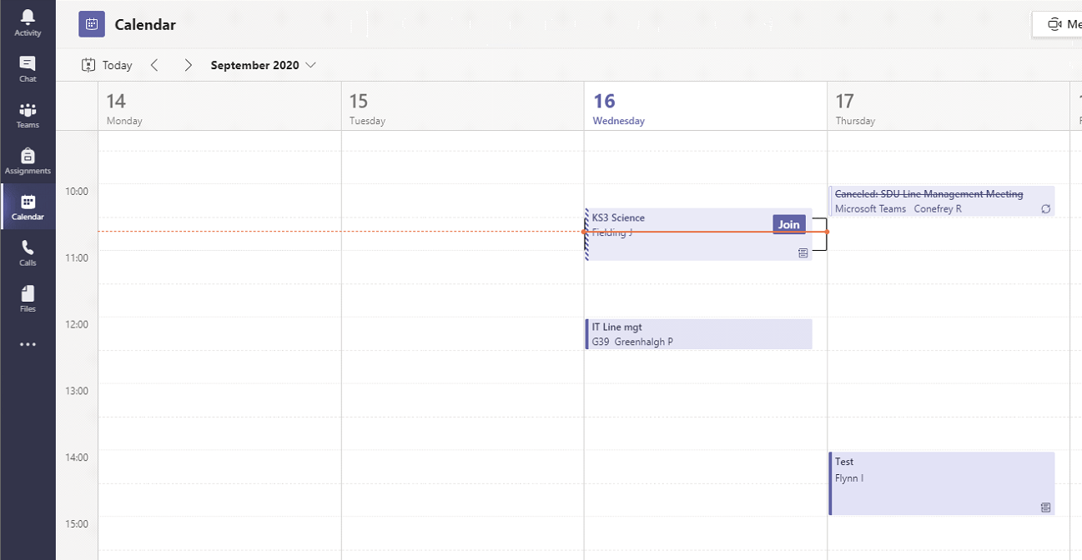

Step 5:
Setting students as Attendees is key to allowing you to teach your lessons without any issues. To do this double click on the meeting from within your calendar and click on Meeting Options.
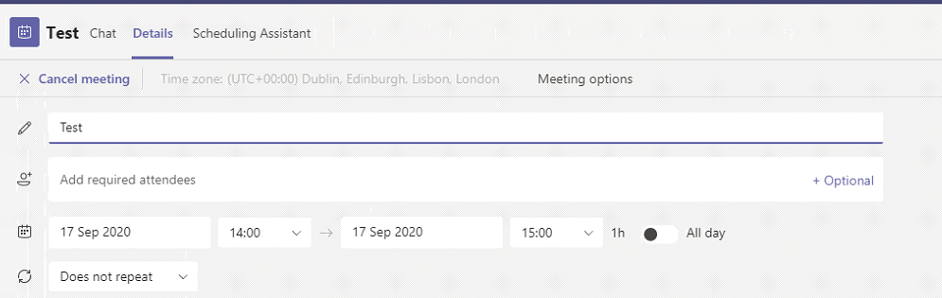

Step 6:
Once you have clicked Meeting Options a google chrome tab will open with the available options. Click the drop-down menu for Who can present? And select only me. Click Save.
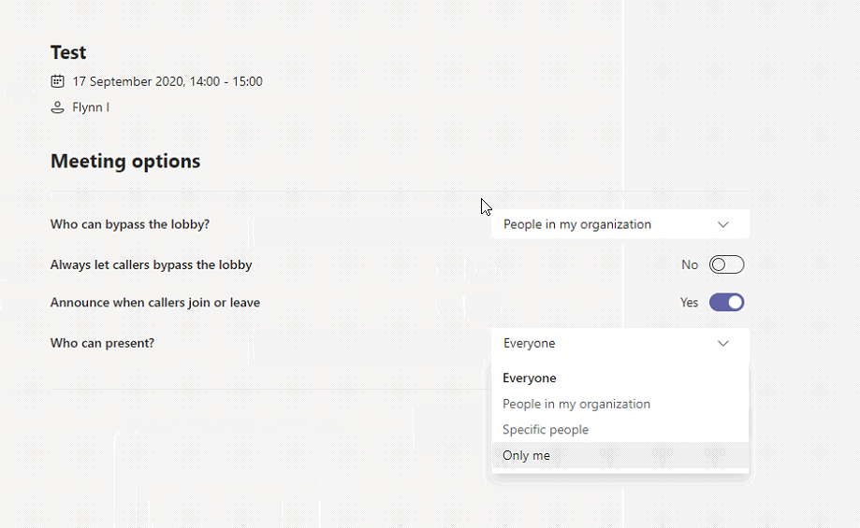

Step 7:
Your meeting settings should match below:
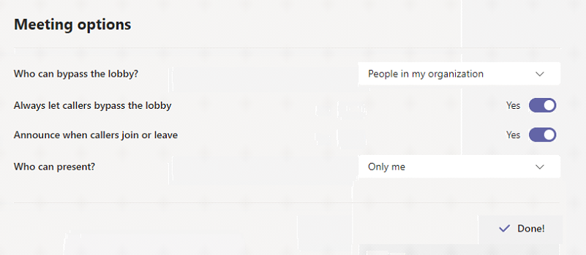

Step 8:
To ensure students are muted you must follow these steps. Remember to “mute” students again after your lesson or they will be able to continue to post within the posts section of that group. When on your group click the 3 dots symbol located next to the group name and select Manage team.
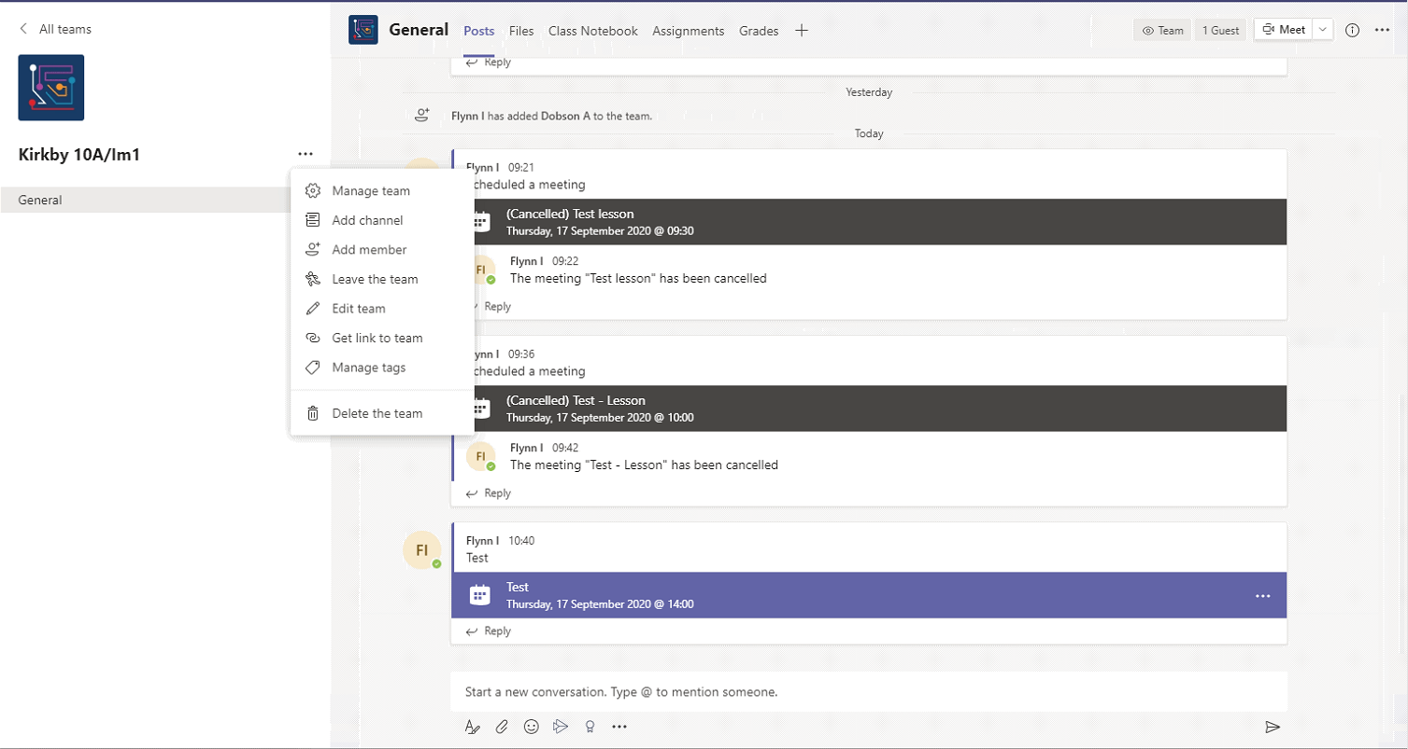

Step 9:
Once opened you will see the members of the group (You should be set as an owner). Under members and guests, the students should be ticked for the time being so that they are muted. If you tick the Mute student’s box (circled red) this will remove all of the ticks, unmuting the students.

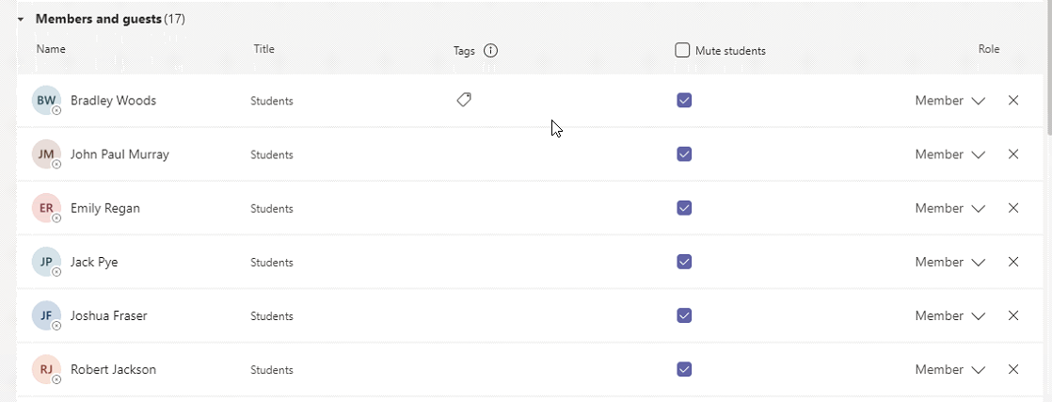

Step 10:
Once they have been unmuted. You need to click on channels located at the top (underlined) and click the 3 dots over to the right-hand side of General (Circled in red) and select Manage Channel.
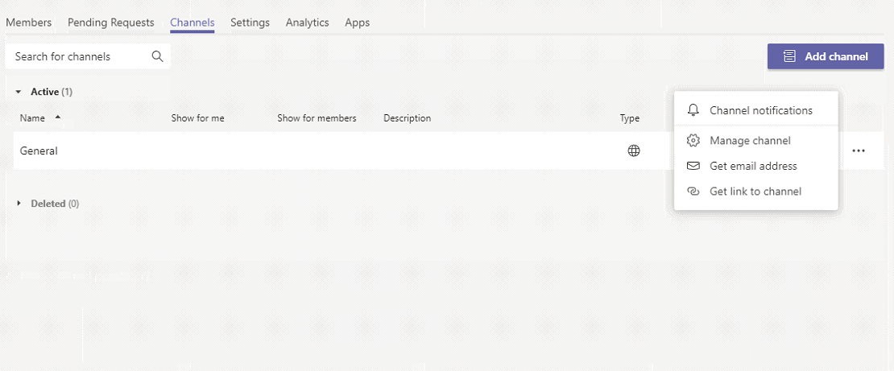

Step 11:
To allow students to post during lessons Anyone can post messages needs to be selected. They are currently set as Only Owners can post messages as the teachers are set as owners of the groups.
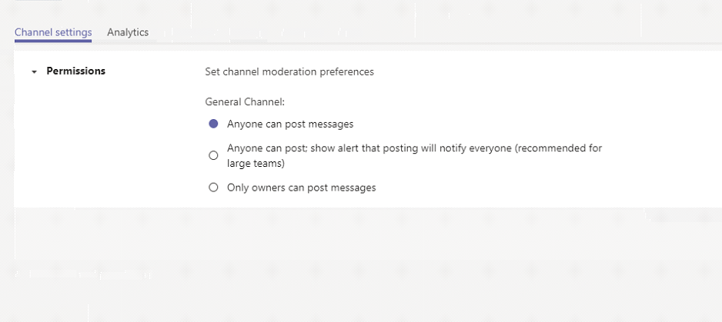

Please remember to change these settings back to the original settings.

