Providing Feedback for an Assignment
  - The Rowan Learning Trust – Teams Instructions

This guide will allow you to mark assignment work and provide feedback for students.

Step 1:
Within teams, navigate to the Teams pane on the left-hand side and select the class required.
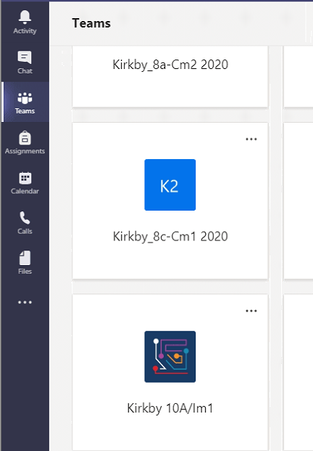

Step 2:
Click on assignments (underlined) at the top of the page and click on the assignment you wish to mark.
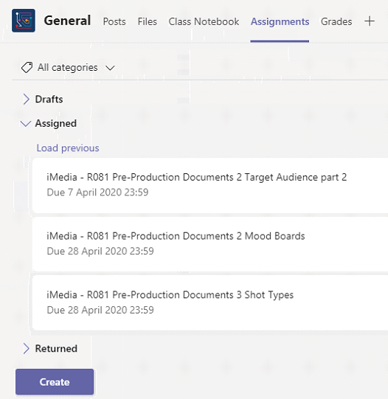

Step 3:
Once you have opened the assignment you will see a list of all the pupils within your class group. The status column will tell you if they have handed it in and the time they have.
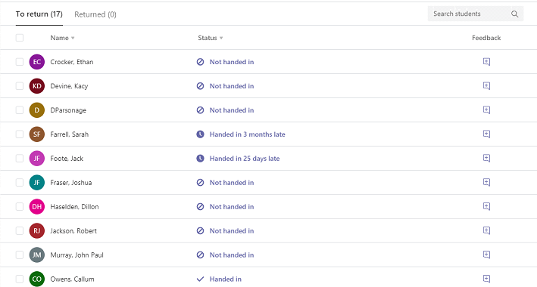

Step 4:
To add specific feedback (page specific). Open the students work and click review located on the top panel. Select the page/slide you want to comment on and click on New Comment located under review.
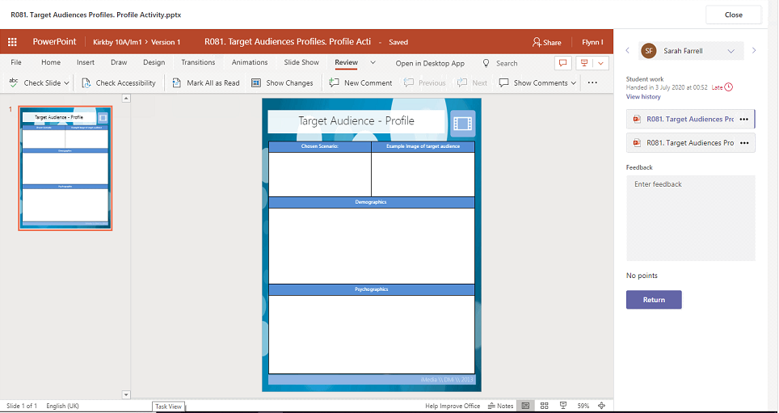

Step 5:
To enter Feedback, you can type this on the right-hand side of the screen and click Return so that the student can read the feedback you have given them.

