Sharing Your Screen During a Meeting
  - The Rowan Learning Trust – Teams Instructions

This guide will allow you to share you screen to display Powerpoints. So that the students can follow as you speak. There is a chat feature that will allow you to see any questions from students whilst presenting.

Step 1:
To share your screen when in the meeting you will need to click the share button (circled red) at the top of your screen.

Step 2:
Select your document to present. Your presentations will either appear under PowerPoint or you can click browse and upload from my PC.
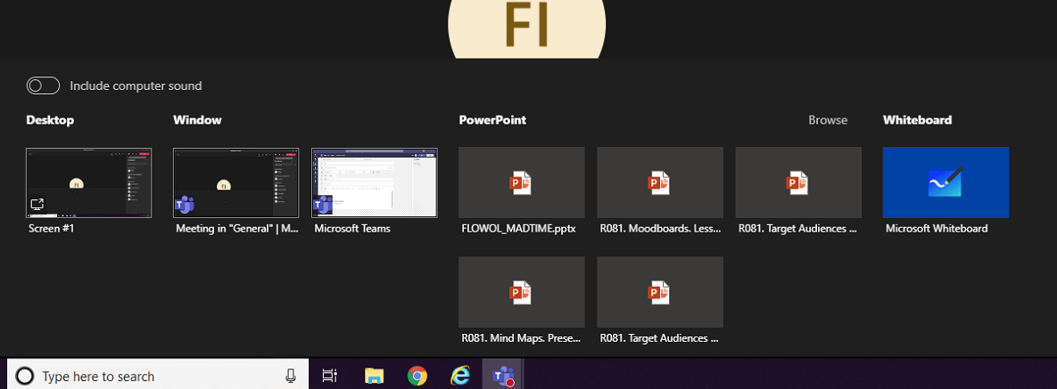

Step 3:
Once you have found your PowerPoint, click it and then click Open. This will display on your Teams meeting.
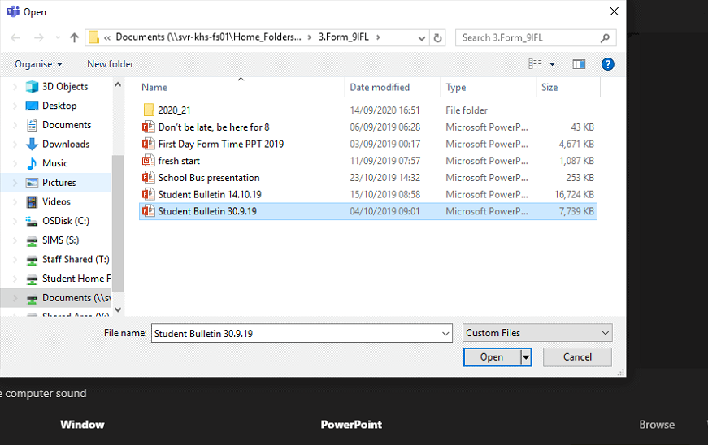

Step 4:
The PowerPoint will display to the students. To view the chat function, click the chat icon (Circled red) and it will display down to the right side of your presentation.
