Distributing Lesson Instructions to an Individual Student
  - The Rowan Learning Trust – Teams Instructions

This guide will allow you to create pre-prepared lessons and distribute it to an individual student.

Step 1:
After completing the action of Guide C, click to open page required from within the content library of Classnotes.
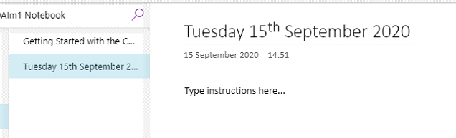

Step 2:
Click on class notebook at the top of the page (Underlined in purple) and click on Distribute Page to drop down the menu. Here you will click on Individual Distribution.
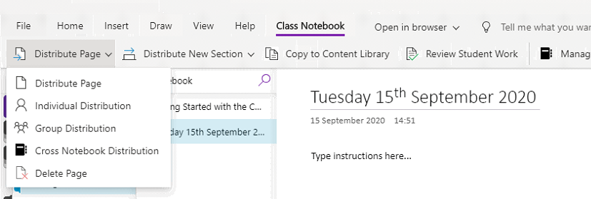

Step 3:
Down the right-hand side an individual distribution page menu will appear, tick the student(s) required and click next. (Names will appear next to the tick boxes).
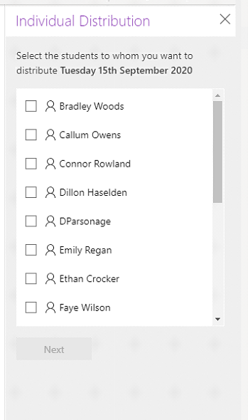

Step 4:
Once you have clicked next, select the section you wish to distribute to. Click Distribute.

