Distributing Lesson Instructions to a Whole Class
  - The Rowan Learning Trust – Teams Instructions

This guide will allow you to create pre-prepared lessons and distribute it to a whole class.

Step 1:
After completing the action of Guide C, click to open page required from within the content library of Classnotes.
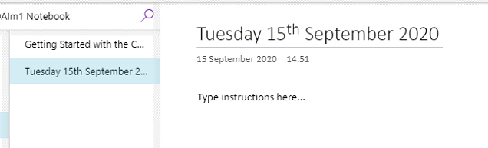

Step 2:
Click on class notebook at the top of the page (Underlined in purple) and click on Distribute Page to drop down the menu. Here you will click on Distribute Page again (Circled in red).
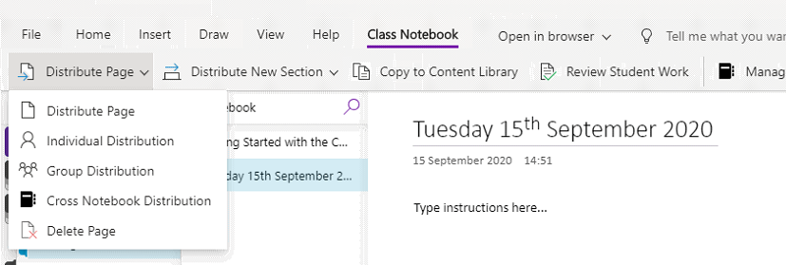

Step 3:
Down the right-hand side a distribute page menu will appear, click on the section you would like to distribute to.
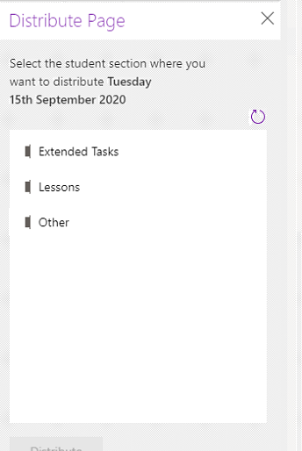

Step 4:

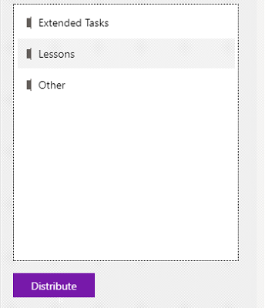
Once the page has been selected, click the distribute button (Will appear people when section is selected) to distribute to the whole class.

