Assigning Assignment to Whole Class
  - The Rowan Learning Trust – Teams Instructions

This guide will allow you to assign assignments to a whole class in order to provide feedback.

Step 1:
Within teams, navigate to the Teams pane on the left-hand side and select the class required.
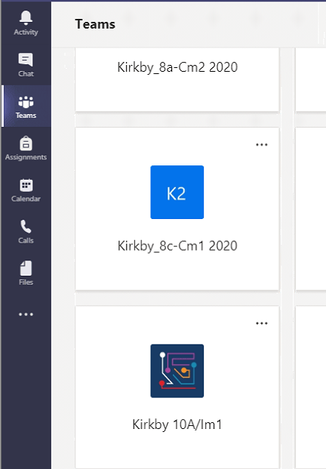

Step 2:
Click on assignments (underlined) at the top of the page and click on create (circled in red).
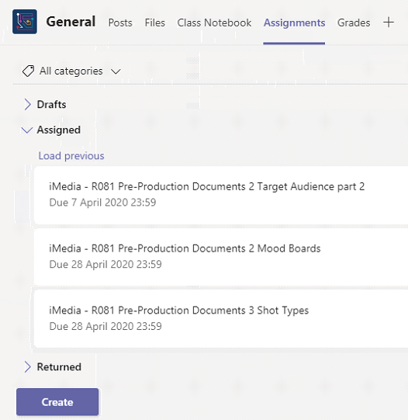

Step 3:
After clicking create, select assignment
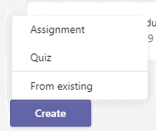

Step 4:
Add a title and Instructions for students to follow. If you wish to attach a file, click on add resources (circled in red) under the instructions and select upload from this device.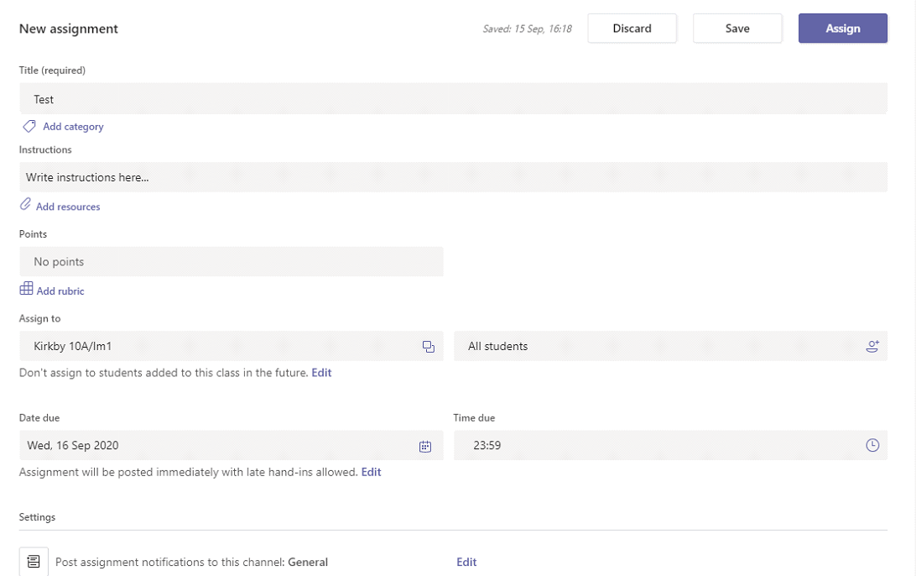

Step 5:
Assign to all students and add a date due. Click assign.

