Assigning Assignment to Individual Student(s)
  - The Rowan Learning Trust – Teams Instructions

This guide will allow you to assign an assignment to an individual student/students in order to provide feedback.

Step 1:
Within teams, navigate to the Teams pane on the left-hand side and select the class required.
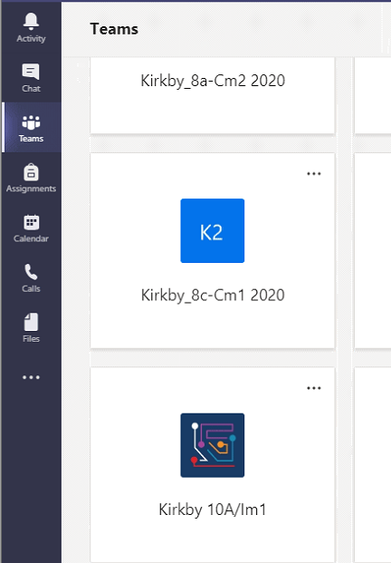

Step 2:
Click on assignments (underlined) at the top of the page and click on create (circled in red).
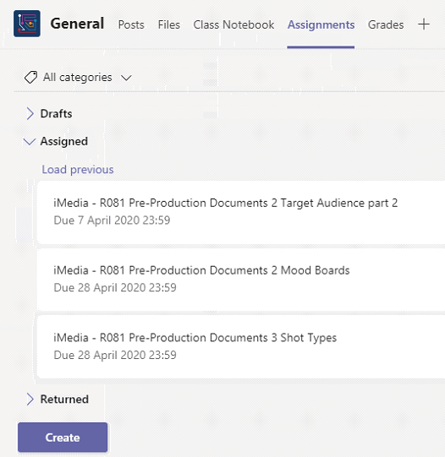

Step 3:
After clicking create, select assignment
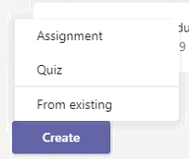

Step 4:
Add a title and Instructions for students to follow. If you wish to attach a file, click on add resources (circled in red) under the instructions and select upload from this device.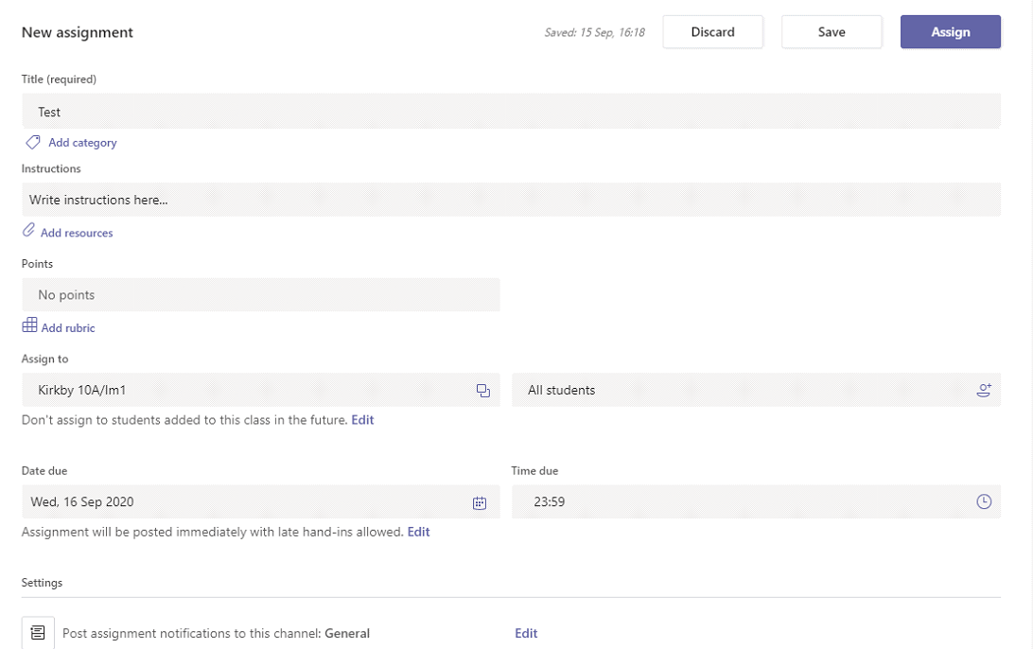

Step 5:
To assign to an individual student, click on All students (circled red). A menu of all of the students within the class will appear.

Step 6:
Select the student you wish to assign to. (Student names will appear). A tick will appear next to the students you have selected, click off when done ticking students.
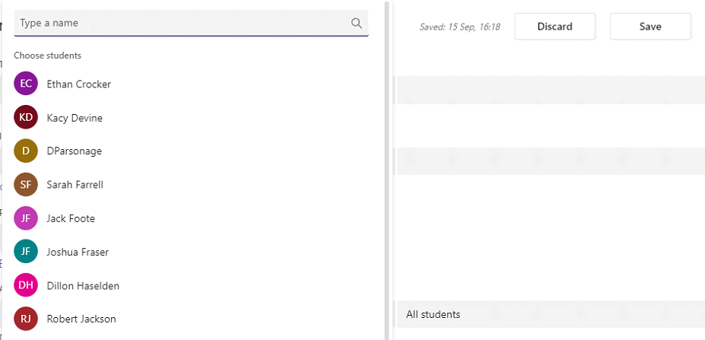

Step 7:
Click assign in the top right of the page.
