Adding Lesson Instructions to Teams
  - The Rowan Learning Trust – Teams Instructions

Adding Lesson instructions to Microsoft Teams allows you to guide students through pre-prepared lessons.

Step 1:
From within Teams, navigate to the Teams pane on the left-hand side. Click on the class required. (Example shown below)
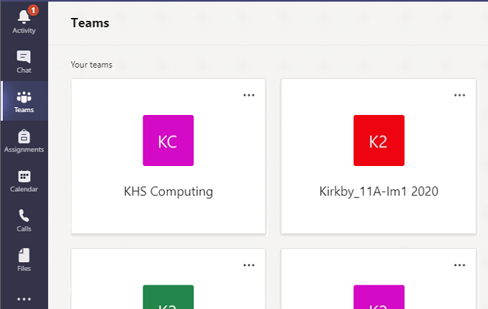

Step 2:
Click on class notebook at the top of the page

Step 3:
Click on the arrow on left hand side to open the navigation panel
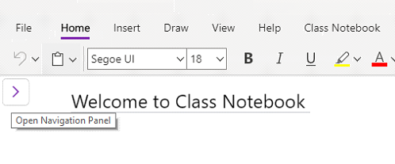

Step 4:
Once the navigation panel is open, click on content library and add page
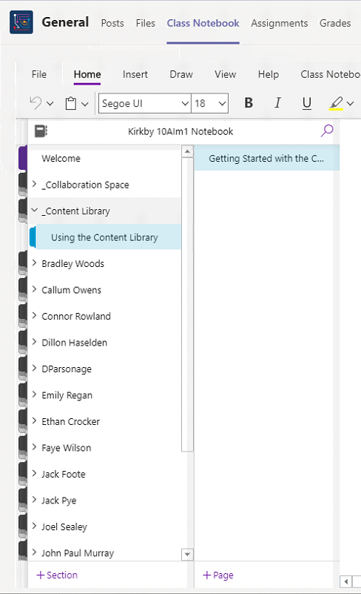

Step 5:
Type the date on the right-hand side (above the line)
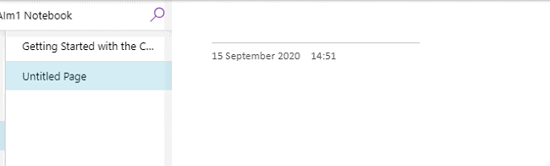

Step 6:
Type instructions for your lesson underneath the date
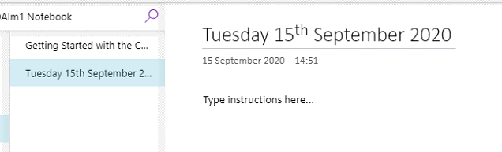

Step 7:
You can add a power point / word document for students’ reference by clicking insert / file / insert as attachment
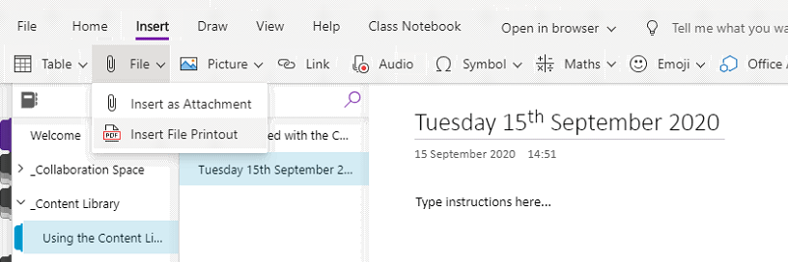
If you want students to write on a file, click insert / file / insert file print out. Students will then be able to write directly onto the document / image and it will automatically save to their page

This will then need to be distributed to whole class (Guide D) or individual student (Guide E)

