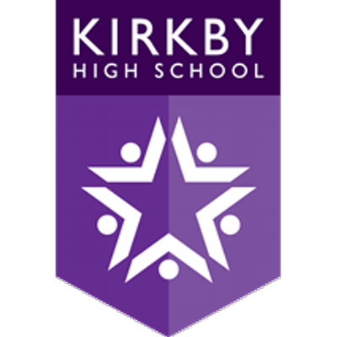

Remote Education Provision:
Information for Parents

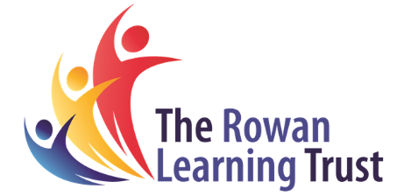

This information is intended to provide clarity and transparency to students and parents or carers about what to expect from remote education if local restrictions require entire cohorts (or bubbles) to remain at home.
For details of what to expect where individual students are self-isolating, please see the final section of this page.

The remote curriculum: what is taught to students at home
A student’s first day or two of being educated remotely might look different from our standard approach, while we take all necessary actions to prepare for a longer period of remote teaching.

What should my child expect from immediate remote education in the first day or two of students being sent home?
Parents / carers will be informed by telephone if their child ‘s bubble is to remain at home. During this call, information will be gathered if your child requires a device or internet access to complete their remote learning.
Your child should log on to Microsoft Teams at the normal start time for lessons 1-4 and will receive a ‘live’ online lesson from their class teacher.
Your child will be able to hear their teacher throughout the lesson and will be able to ask questions using the ‘chat’ function of Microsoft Teams. If there are any technical issues, please consult the guides on the school website:
https://kirkbyhighschool.net/student-area/
Alternatively, please contact school by phone 0151 4778710 or email admin@kirkbyhighschool.net
Additional tasks can be found in the classnotes section of your child’s year group team on Microsoft Teams. Your child should complete one additional hour a day.

Following the first few days of remote education, will my child be taught broadly the same curriculum as they would if they were in school?
We teach the same curriculum remotely as we do in school wherever possible and appropriate. However, we have needed to make some adaptations in some subjects. For example, some practical subjects might require changes to the sequencing of the curriculum.

Remote teaching and study time each day

How long can I expect work set by the school to take my child each day?
We expect that remote education (including remote teaching and independent work) will take students broadly the following number of hours each day:
KS3 students (Year 7,8 and 9) | 5 hours per day (plus homework as per our policy)
KS4 students (Year 10 and 11) | 5 hours per day (plus homework as per our policy)

Accessing remote education

How will my child access any online remote education you are providing?
They will access their online remote education through Microsoft Teams and their homework tasks through Classcharts. Support is available on our school website:
Microsoft Teams: https://kirkbyhighschool.net/student-area/
Classcharts: https://kirkbyhighschool.net/homework/

If my child does not have digital or online access at home, how will you support them to access remote education?
We recognise that some students may not have suitable online access at home. We take the following approaches to support those students to access remote education:
During the initial phone call, a member of the senior leadership team will enquire as to whether your child has a suitable device and / or internet access. We will then contact you to inform you of how we will issue or lend a laptop or Wi-Fi dongle to your child.

How will my child be taught remotely?
We use a combination of the following approaches to teach students remotely:
Live teaching (online lessons for periods 1-4 in the school day) on Microsoft Teams
Pre-prepared content on Microsoft Teams (year group specific)
Pre-prepared additional lessons for Science and KS4 options subjects which will continue to be set on Classcharts.
Homework tasks which will continue to be set through Classcharts

Engagement and feedback

What are your expectations for my child’s engagement and the support that we as parents and carers should provide at home?
We expect your child to attend each ‘live’ lesson
Please encourage your child to remain in their ‘normal’ school routine and ‘attend’ lessons according to their timetable

How will you check whether my child is engaging with their work and how will I be informed if there are concerns?
You will receive a parents app message or phonecall if your child has not attended a lesson

How will you assess my child’s work and progress?
Feedback can take many forms and may not always mean extensive written comments for individual children. For example, whole-class feedback or quizzes marked automatically via digital platforms are also valid and effective methods, amongst many others. Our approach to feeding back on student work is as follows:
Your child will receive verbal feedback throughout the online lessons
Your child will receive feedback on their written tasks through Microsoft Teams at the same frequency as to which they receive feedback in school
Your child will be given time during the ‘live’ lessons to respond to this feedback

Additional support for students with particular needs

How will you work with me to help my child who needs additional support from adults at home to access remote education?
We recognise that some students, for example some students with special educational needs and disabilities (SEND), may not be able to access remote education without support from adults at home. We acknowledge the difficulties this may place on families, and we will work with parents and carers to support those students in the following ways:
School place for lower ability SEND and all EHCP students with personalised intervention.
Educate city (online learning platform aimed at the lower ability SEND)
Email and telephone support for any technical and learning needs
Home learning packs (Literacy, numeracy, handwriting)
Access to telephone support with a qualified counsellor

Remote education for self-isolating students
Where individual students need to self-isolate but the majority of their peer group remains in school, how remote education is provided will likely differ from the approach for whole groups. This is due to the challenges of teaching students both at home and in school.

If my child is not in school because they are self-isolating, how will their remote education differ from the approaches described above?
Your child will receive pre-prepared lessons in the ‘classnotes’ section of Microsoft Teams. Each lesson will be dated. These lessons will follow the curriculum as normal. Although your child can access this at any time from the start of each individual lesson, we recommend that they try to follow their normal timetable as far as possible.
They will also receive homework tasks as normal on Classcharts.
If they do not have access to a device and / or the internet, please contact school by email: admin@kirkbyhighschool.net

