Careers Information
As the new academic year begins, many colleges and Universities are beginning their virtual open events. You can find the dates of the college open events here.

Colleges

Knowsley Community College: https://www.knowsleycollege.ac.uk/
City of Liverpool College: https://www.liv-coll.ac.uk/
CofLC currently have a virtual tour: https://www.eventbrite.co.uk/o/the-city-of-liverpool-college-30415820730
Winstanley College: http://www.winstanley.ac.uk/
Carmel College: https://www.carmel.ac.uk/
Hugh Baird College: https://www.hughbaird.ac.uk/

If you are considering University after college it would still be useful to see what they have to offer. Here is a list of possible Universities in the area, so check the websites for details of virtual open evenings for each University.

University of Liverpool https://www.liverpool.ac.uk/
John Moores University https://www.ljmu.ac.uk/
Edge Hill University https://www.edgehill.ac.uk/
Liverpool Hope University https://www.hope.ac.uk/
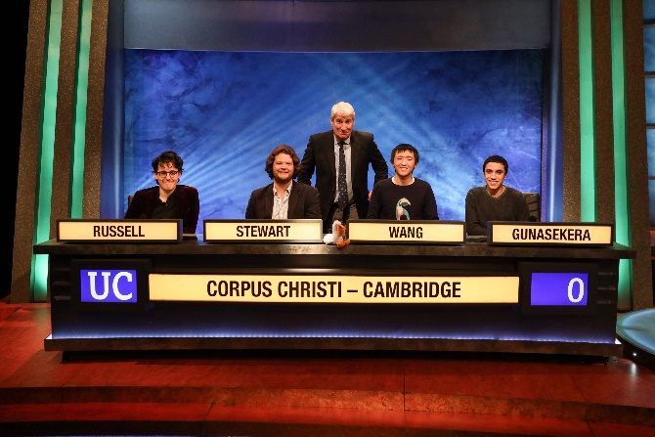
University Challenge!!!!
Your challenge is to visit a University website and take their online tour. The first person to find Mr Jackson with 3 key facts about that University will win a prize. All others will receive Kirkby Child Points!!!

The Apprentice!!!
The firs person who finds Mr Jackson and tells him 3 different levels of apprenticeship, will also win a prize. All others will receive Kirkby Child Points!!!!

Apprenticeships (There are many degree level apprenticeships you can apply for once 18)
Apprenticeships: https://www.theapprenticeshiphub.co.uk/
Register for apprenticeship notifications: https://www.gov.uk/topic/further-education-skills/apprenticeships
Rate my Apprenticeships: https://www.ratemyapprenticeship.co.uk/
Construction Information: https://mailchi.mp/successatschool/careers-in-engineering-your-complete-guide-1277051
Careers in Rail: https://mailchi.mp/successatschool/careers-in-rail-1277047

