Accessing assignments in MS Teams
  - The Rowan Learning Trust – Teams Instructions

This guide will show you how to access an assignment in MS Teams and how you can get feedback.

Step 1:
Log into Office 365 and select the Teams app from the right hand side.

Step 2:
Once Teams has loaded select the Team for your lesson
You will see this screen:
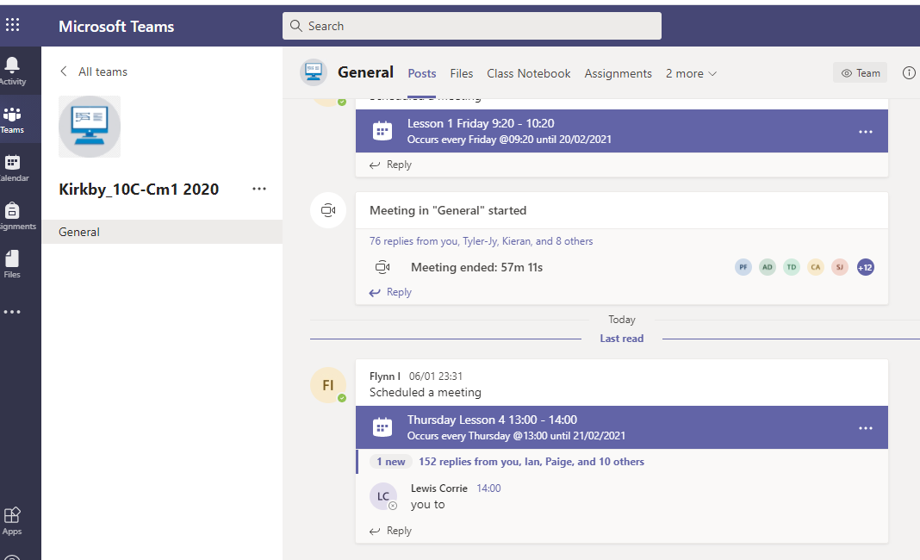
Select assignments at the top.

Step 3:
Any assignments set by your teacher will can be seen here.
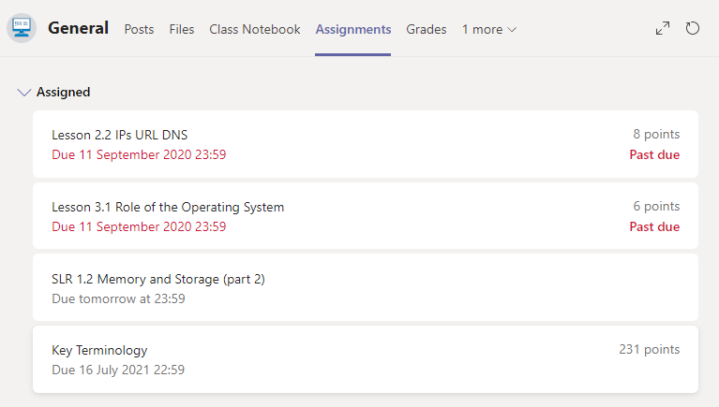
Click on the assignment you want to access.

Step 4:
Then you will see this screen.
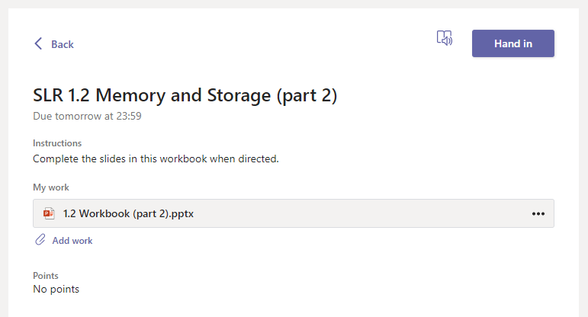
To access any work a teacher has set for you click on the file.
If you need to attach a file of your own go to step 8.

Step 5:
You should be able to work on the file straight away, stay in the online app to complete your work.
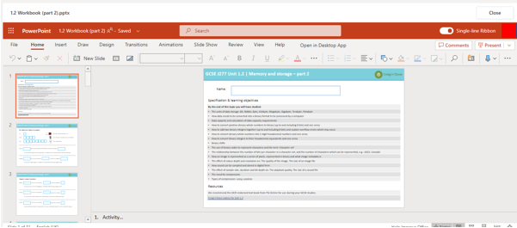
In some apps you might have to ensure it is set to editing so you can edit the file.
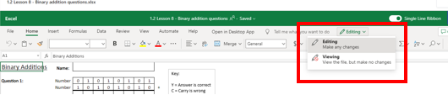

Step 6:
Closing your file and saving it.
The file will save automatically while you are working on it. You can see if the file is saved in the top left of the app it will say ‘Saved’.
To close the file and not lose any work you have done then use the close button on the right.
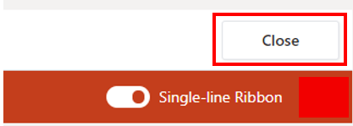

Step 7:
Handing in your work. In order for your teacher to see that you have completed the work you need to hand it in. When you have closed the app use the hand in button.
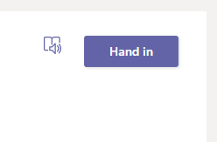

Step 8: optional step
To insert a file that you have saved to your device (you might need to do this if you are using a mobile device, or if you have downloaded a file and not completed the work in online app).
Click the add work option next to a picture of a paperclip.
You will see this dialogue box
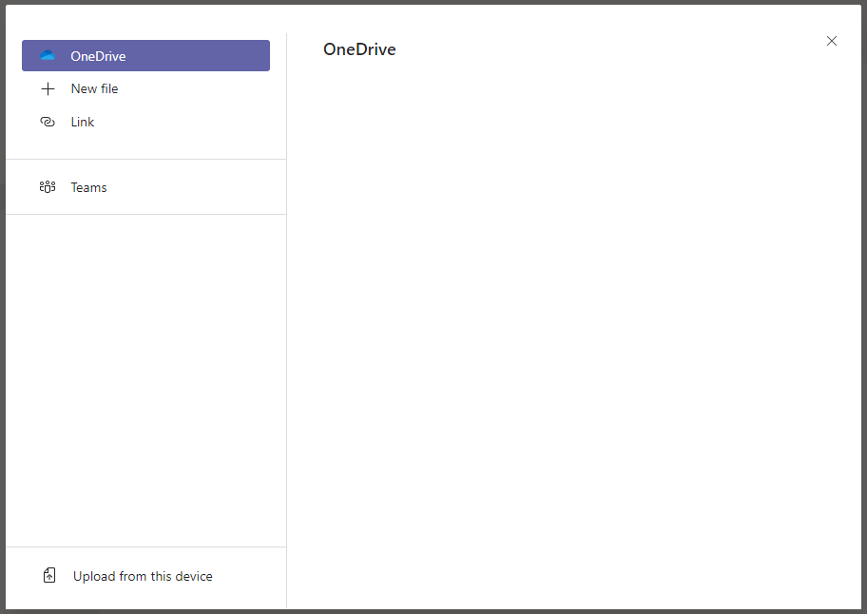
Click ‘Upload from this device’ if the file has been saved to the device, locate the file and double click it, if the file is saved in OneDrive you will see it on the right hand side.
Go back to step 7.

Miscellaneous:
Other useful things to know about getting feedback on assignments.
Your teacher can use comments within your work to give feedback even if you have not submitted the work.
Comments on submitted work
Click on the assignment that you want see the feedback on.
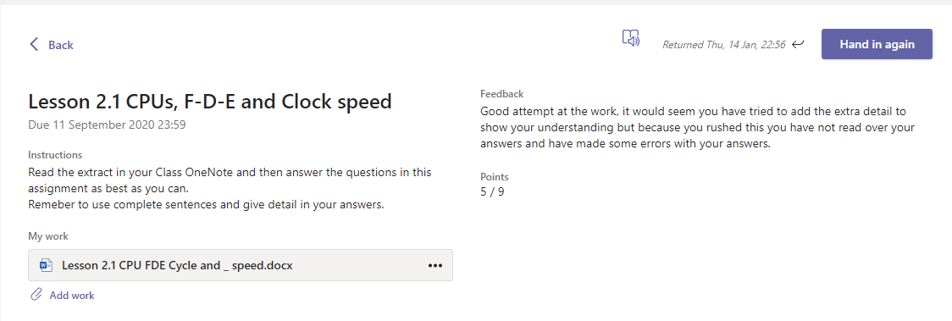
Overall feedback for the work can be seen here, this can be WWW and EBI or just a comment from your teacher.
If your teacher has given a points (marks) value you can see it here.
You can click on the file to open the work and see if your teacher has made any specific comments on the work. You can also make changes and hand it in again.

Press this button to reveal all comments in the document.
Speech bubbles mean a comment has been added

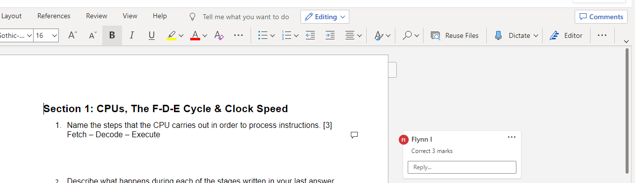
You can reply straight to the comment and make changes on the actual work, remember to change you font colour to purple to show your improvements.

Comments in work that has not been submitted.
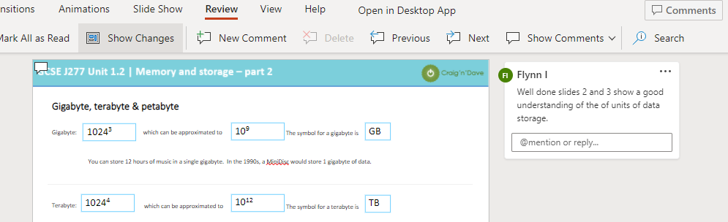
Comments work the same way in work that has not been submitted, the speech bubble indicates a comment is present, and the comment can be seen on the right hand side. If you can see the bubble but not the comment then press the comments button in the top right of the app.

