Baptism

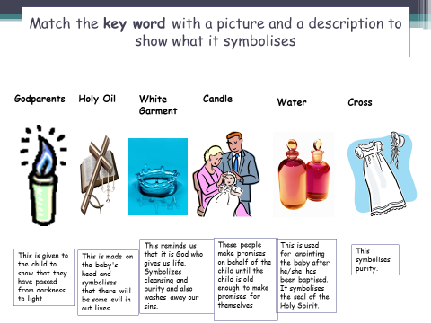

Each symbol in baptism represents a different meaning.

Look at the symbols below to see what they show about the impact of baptism.

Bar/Bat Mitzvah

Tallit

Prayer shawl with knots to represent 613 rules

Kippah

Sign of respect to God

Outward way of showing you are Jewish

Yad

Not to touch the Holy Torah

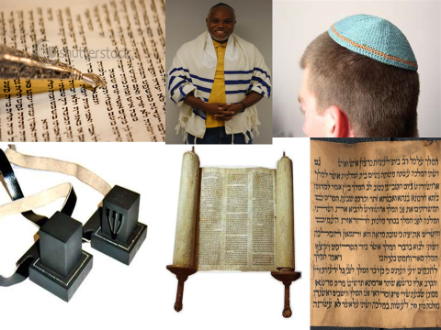

Teffellin

Worn on the head and arm.

Head- think about God

Arm- in line with the heart to love God

The Torah

Jewish holy book

Hebrew

The language that the Torah is written in

