**AQA 1-9**

GCSE Dance



**Component 2**

1. A Linha Curva

2. Infra

3. Shadows

4. Emancipation of Expressionism

5. Within Her Eyes

6. Artificial Things

7. Use of Camera

**Top Ten Exam Tips**

1. Read the whole paper before answering any questions.

2. Understand the command words: **IDENTIFY, DESCRIBE, EXPLAIN, COMPARE**. Only do what it asks you to do. Underline these key words.

3. Make sure you answer about the correct constituent feature. **Do not write about costume if it asks you about lighting. No marks given!**

4. Look for how many marks the question is worth

5. For the 6 mark questions: **WWY (what, when, why)** For top band marks always give extra detail about what the movement suggests. For the 12 mark question you must write about both works or constituent features. Give detailed descriptions of the constituent feature and explain the contributions and your interpretations in detail. **Use DIL /DCIL ladders.**

6. When you have finished the paper, read each question carefully. Use all of your time to check the answer against the question. You should never be sat doing nothing.

7. Know what the units are in the course.

- **Component 1: Solo Set Dances**

**- Component 1: Performance in a duo/trio**

**- Component 1: Choreography**

8. **You can lie** in an exam if it helps you answer your question – the examiner doesn’t know what we do or what your choreography/performance piece looks like!

9. **Create a revision timetable!!**

10. **Failing to prepare is preparing to fail.** Make sure you revise at home, **attend all support and intervention** and ask for help.



A Linha Curva

**Costume**

**Descriptions**

* Black vest tops
* Male vest tops have slashes in to expose their torso
* Multi-coloured (10 colours) lycra shorts
* Metal collars worn by male dancers

**Contributions**

* Stimulus – Brazilian way of life – colours of the shorts reflect the colours of Brazilian carnivals
* Intention – Just have fun – the costumes are tight fitted allowing the movement to be performed to its maximum, enhancing the ‘just have fun’ intention.
* Mood – colours of the costumes reflect a bright and happy mood.
* Complements other components – colours of the shorts complement the colours of the lighting
* Sculpts body – costumes are tight fitting sculpting the body
* Uniformity – costumes are the same creating uniformity
* Gender – metal collars highlight the male gender in the opening. Slashes in the torso highlight their masculinity.
* Geographical location – short in length, colourful

**Interpretations**

* Colours of the shorts are representative of the colours seen on carnival costumes
* Slashes in males vests represent their masculinity
* Metal collars represent strength and power as the males try to impress the females
* All dancers wearing the same suggests the matching costumes worn by dancers in a samba parade.

**Moods**

Happy, vibrant, exciting, unpredictable, carnival, celebratory

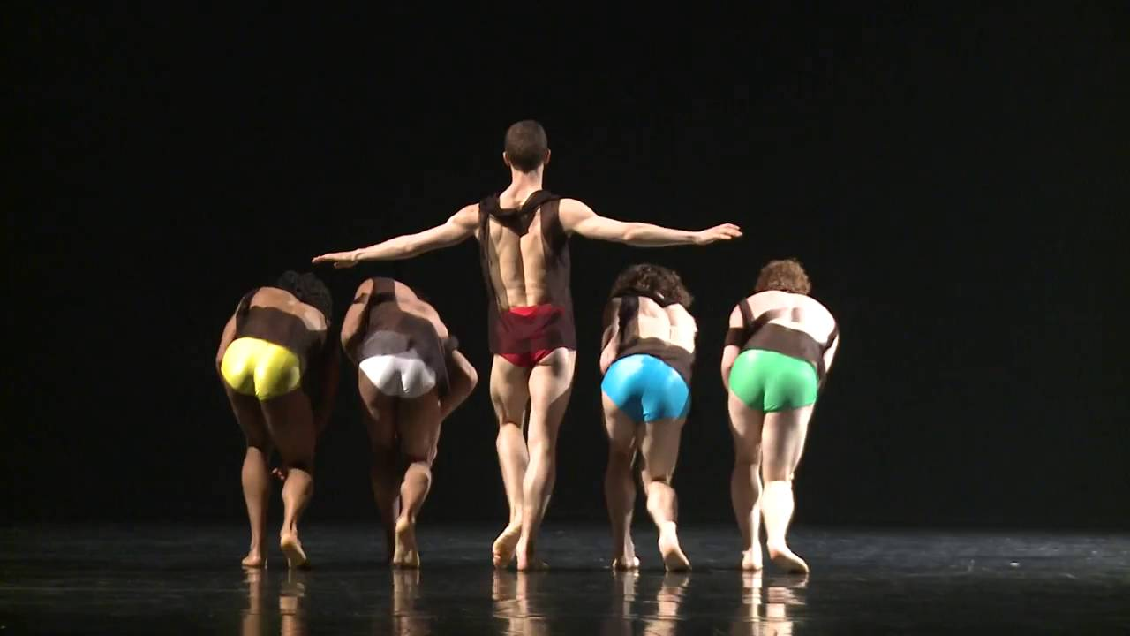

A Linha Curva

**Lighting**

**Descriptions**

* Use of overhead coloured lighting; blue, green, yellow, pink
* Creates checkerboard effect on the floor
* Checkerboard moves around the floor in different spaces including lines and diagonals
* White light is reflected from the collars of the men in the opening
* Lighting is dimmed with white side and overhead lights in narrative sections

**Contributions**

* Stimulus – Brazilian way of life – colours reflect colours of Brazil and carnivals
* Intention – Just have fun – checkerboard moving erratically around the stage as the dancers keep up with the pre-programmed lighting enhances the fun aspect.
* Mood – Lighting reflected from the collars enhances an unpredictable and fun mood
* Highlights dancer – Spotlights used in solo and duet sections highlight each dancer
* Highlights dance space – Checkerboard creates a dance space which each dancer must stay in
* Sculpts body – Lighting sculpts the bodies of the dancers and enhances movement
* Geographic context – colours connote the colours of the Brazilian flag – green, blue, yellow
* Complements other components – colours of light complement the colours of the costumes

**Interpretations**

* The colours of the lighting (blue, yellow, pink, green) represent the bright colours seen on the decorations and costumes seen at a Brazilian carnival.
* The colours of the lighting also reflect the colours of the Brazilian flag being green, yellow and blue.
* The checkerboard effect moving across the stage in lines represents the carnival dancers and floats moving through the streets.
* The darkening of the lights in the narrative sections represents a darker and more sinister side to Brazilian culture which is dark and sinister.
* The darkening of the lights also represents the heightened tension and emotions felt as males compete for females.
* The lights reflecting from the collars in the opening could represent the flashing lights of torches and cameras during a carnival.

**Moods**

Happy, vibrant, exciting, unpredictable, carnival, celebratory

A Linha Curva

**Set & Props**

**Performance Environment**

End Stage

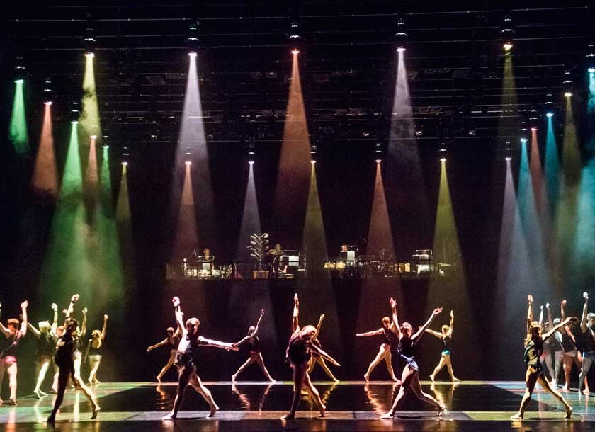

**Descriptions**

* No set: black tabs and black floor
* Raised platform at the back of the stage to elevate the samba band
* Skateboards used to travel across the stage

**Contributions**

* Stimulus – Brazilian way of life
* Intention – Just have fun
* Mood - Exciting  
  Complements other components – Black set and floor complement black costumes
* Context – Stage creates a sense of a live performance at a carnival
* Creates levels – stage elevates the band and makes them a part of the performance
* Incorporated into action – Skateboards used by dancers to travel across the stage

**Interpretations**

* The black tabs and floor create a box type environment that represents an empty street about to be filled with carnival
* The raised platform at the back represents a stage that performers and musicians are seen on at carnival performances
* The skateboards represent the floats that move through the streets
* The skateboards also represent a sense of fun, carefree and joyful living

**Moods**

Happy, vibrant, exciting, unpredictable, carnival, celebratory

AQA 1-9

GCSE Dance

Component 2

1. A Linha Curva

2. Infra

3. Shadows

4. Artificial Things

5. Emancipation of Expressionism

6. Within Her Eyes

A Linha Curva

**Aural Setting**

**Descriptions**

* Played live
* Samba percussion band
* Repetitive drums
* Vocals from dancers at the beginning (male) and the middle (all)
* Clanging, lower pitched sound in female’s narrative section
* Very loud

**Contributions**

* Stimulus – Brazilian culture – Samba bands portray traditional Brazilian style music
* Intention – Just have fun – rapid tempo and use of vocals where dancers ‘feel the moment’ creates a sense of fun and excitement.
* Mood – High energy tempo creates a happy and vibrant mood
* Complements other components – Use of samba style music complements the carnival coloured lighting and carnival inspired costumes.
* Geographical context – Live samba band creates a sense of being immersed in Brazil
* Climax – Re-introduction of fast samba beats with vocals after narrative section creates a sense of climax
* Contrast – narrative section in the middle with slower, deeper and longer notes creates a contrast from the rapid drumming of the ensemble sections

**Interpretations**

* The live performance if the samba band creates a genuine sense of a live carnival performance – creating a ‘one off’ performance.
* The samba style aural setting represents the music played at Brazilian celebrations
* The repetitive nature of the drumming represents the repetitive music played as it travels through the streets of Brazil
* The vocals from the dancers portray male domination
* The vocals from all dancers represent the calls and cheers of people in the crowds at celebrations

**Moods**

Happy, vibrant, exciting, unpredictable, carnival, celebratory

Infra

**Costume**

**Descriptions**

* Fitted shorts, vests, t-shirts in flesh, black, grey. One female dancer wears a wrap-around skirt. One male dancer wears long trousers. Females wear pointe shoes.
* Street clothes worn for brief appearance of crowd.

**Contributions**

* Stimulus – Life beneath a city – monochrome colours used to reflect the dark and depressing nature of those living below the poverty line in a city.
* Intention – Seeing below the surface – top of the body is covered and bottom exposed is many of the costumes, giving a sense of focus on the legs of the dancers, which could reference ‘below’ or the ‘bottom’.
* Mood – Dull, monochrome colours create a dark and serious mood.
* Complements other components – The use of monochrome coloured costumes complement the use of white lighting.
* Sculpts body – The tight fitting costumes and bare legs sculpt the lines of the dancers’ bodies.
* Uniformity – The use of black shorts for most of the dancers creates a sense of uniformity
* Gender – one male dancers wears trousers but no top to highlight his masculinity and male gender

**Interpretations**

* The simple black, grey and white colours could reflect a black and white picture of a city, which highlights the stimulus of TS Eliot’s quote from the poem Wasteland.
* The bare legs of all of the dancers except one male draws the eyes to the legs, which are the bottom of the body, representing ‘life below the surface’ whereby the waist is the surface.
* The pedestrian style clothing worn by the crowds represent the everyday people living and working in a city.

**Moods**

* Serious, intense, animated, tense, sad

Infra

**Lighting**

**Descriptions**

* White side lights light the floor
* Green side lights light the floor
* 6 white rectangles on the floor
* Orange side lights light floor
* Warmer white side light lights the floor
* Blue shafts light the edge of the stage
* Lights used to only light the dancers bodies
* Dark intensity throughout

**Contributions**

* Stimulus – Beneath the surface – lights light the floor only suggesting ‘below’ or ‘low’
* Intention – Human interactions – lighting used to light the duets dancing and no other space, so that whole focus is on the interactions between the dancers
* Mood – Intense – use of dark lighting creates an intense mood
* Complements other components – use of white lights to light dancer’s bodies complement the monochrome costumes.
* Sculpts bodies – white light sculpts the bodies of the dancers
* Highlights dancer – dancers are specifically lit to highlight them amongst a black stage
* Highlights dance space – white rectangles dictate dance space.

**Interpretations**

* The lighting being focused on the floor signifies the word ‘below’.
* The lighting coming from below the LED screen suggests it is all going on ‘below the surface’.
* The change of colours suggests moving through time and a change in section.
* The lighting only highlighting the dancers in a completely black space emphasises the idea of isolation.
* The lighting only highlighting the dancers in a completely black space also emphasises the interactions of the dancers, enhancing them and making them a focal point.

**Moods**

Serious, intense, animated, tense, sad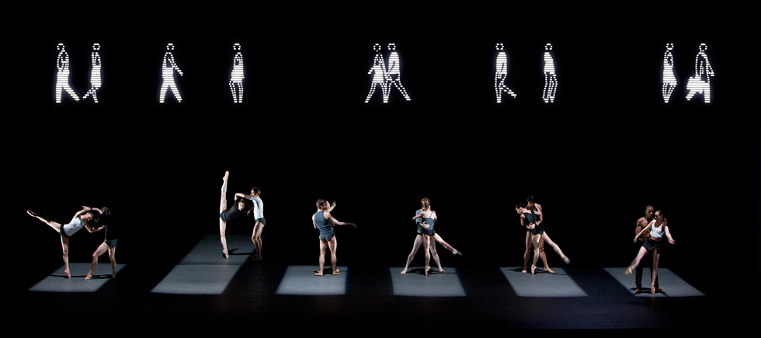

Infra

**Set & Props**

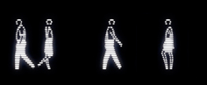

**Performance Environment**

End Stage

**Descriptions**

1. Black stage and floor
2. 18M LED screen showing animated figures walking across

**Contributions**

* Stimulus – Life beneath the surface – dancers literally performing below the surface of the LED screen.
* Intention – Human interactions – lack of set underneath the screen enhances the focus on the dancers and their interactions with one another
* Mood – darkness with light only focusing on dancers’ bodies creates a serious mood
* Complements other components – black set and white lights on the LED screen complement the monochrome costumes
* Geographical context – the LED screen has animations of everyday people walking across, suggesting a city location.
* Context – as they are underneath the screen, the location could be dwellers who live in basements or homeless people who live under bridges.

**Interpretations**

* Figures walking across the screen represent everyday people
* Walking figures are dressed in business attire suggesting they are corporate working people who may ignore or belittle those living beneath or alongside them
* The use of a totally black stage represents the darker side of city life.

**Moods**

Serious, intense, animated, tense, sad

Infra

**Aural Setting**

**Descriptions**

* String instruments, electronic sounds and everyday sounds such as train whistles

**Contributions**

* Stimulus –.The use of everyday sound such as a train whistle highlights the stimulus of ‘life below the surface of a city’ as this is a typical everyday sound you would hear when living or working in a city.
* Intention – The use of sound effects such as the sound of a train passing highlights the intention of ‘life below the surface’ as it sounds the sound is similar to if you were stood under a rail bridge listening to trains passing over.
* Mood – the use of string instruments creates a sombre and sad mood.
* Complements other components – the use of classical strong instruments complements the classical ballet style of the piece
* Structure – the aural setting works with the lighting to support each section of the work, informing the audience of the structure of the piece.

**Interpretations**

* The uses of string instruments to portray sadness reveal the thoughts and feelings of those living ‘below the surface’; trapped and feeling sad and isolated.
* The electronic sounds resonate with the fast-paced city lifestyle and replicate the sounds of pedestrians footsteps as they walk through the streets and over bridges.
* The use of everyday sounds such as trains passing and train whistles highlight the pedestrian thoughts and represent everyday people living and working in a city.
* The use of a train passing could be what is heard if you were stood under a rail bridge listening to a train pass, highlighting the idea of being ‘below the surface’.
* The use of train sounds could represent someone feeling suicidal and standing near train lines considering ending their sad lives.

**Moods**

Serious, intense, animated, tense, sad, sombre.



Shadows

**Costume**

**Descriptions**

* Clearly gendered – skirts and dresses for females, shirts and trousers for males.
* Large overcoats
* Colours are muted and worn (dull)
* Shoes and over-sized coats are put on towards the end

**Contributions**

* Stimulus – European history – The design of the costumes with knee length skirts and dresses for the females and a shirt and waistcoat for the father highlight the stimulus of European history as this was typical dress for the era
* Intention – Poverty – The drab and dreary colours used in the costuming highlights the intention of poverty.  
  Mood – The dull colours in the costuming highlight a sad and dull mood.  
  Complements other components – The worn out colours in the costumes complement the worn of textures of the set design such as the table and stools.
* Historical context – The design of the costume is clothing typically worn in the 1930’s, highlighting the historical context
* Social context – The dull colours and use of oversized coats for the children suggest the family are of a low social status and poor.
* Gender – females wear skirts or dresses and males wear trousers and shirts to highlight their gender
* Age – the daughter wears a child-like smock dress and the son does not wear a waistcoat ot highlight their younger age
* Highlights character – the different costuming for each character highlights which member of the family each of them are. For example the father wears a waistcoat to signify he is an elder.
* Sculpts body – The costumes are tight fitted to the tops of the body to allow contact work to be safe and the lines of the arms to be seen.

**Interpretations**

* The clearly gendered clothing of skirts or dresses for females and trousers for males highlights the traditional family dynamic.
* The large overcoats worn in the final section by the children are clearly too big for them, highlighting the family is too poor to buy new, well fitted clothes.
* The muted colours of the costumes not only represent depravation, but also highlight the sad inner feelings of the family who may never escape poverty.
* Shoes are put on towards the end to signify the family trying to move on from their traumas and difficulties.

**Moods**

Sinister, scary, eerie, frightening, fearful, anticipatory

Shadows

**Lighting**

**Descriptions**

* Intimate to create a sense of a room
* White light only
* White shaft from stage right
* Side lights create shadows
* Always dark intensity
* Lighting blacks out very quickly occasionally

**Contributions**

* Stimulus – poverty – lack of lighting suggests an poverty stricken family with little electricity
* Intention – forces unknown outside – lighting towards downstage right shows where the force is coming from
* Mood – dark intensity creates a sinister and scary mood
* Complements other components – simple lighting complements simple set  
  Highlights dancer – side lights highlight dancers as they move into the light
* Sculpts body – side lights sculpt the lines of the female’s body as they perform contemporary movement
* Context – side lights create a sense of a room lit by candles

**Interpretations**

* Use of white light suggests candles used in a poor family home
* White shaft from stage right suggests this is where a door is
* Side lights create shadows owing to the name of the piece and creating a tense and sinister atmosphere.
* Always darkness creates a sense of anticipation and fear
* Lighting black outs is similar to lights used in a scary film when a figure runs across the camera.

**Moods**

Sinister, scary, eerie, frightening, fearful, anticipatory

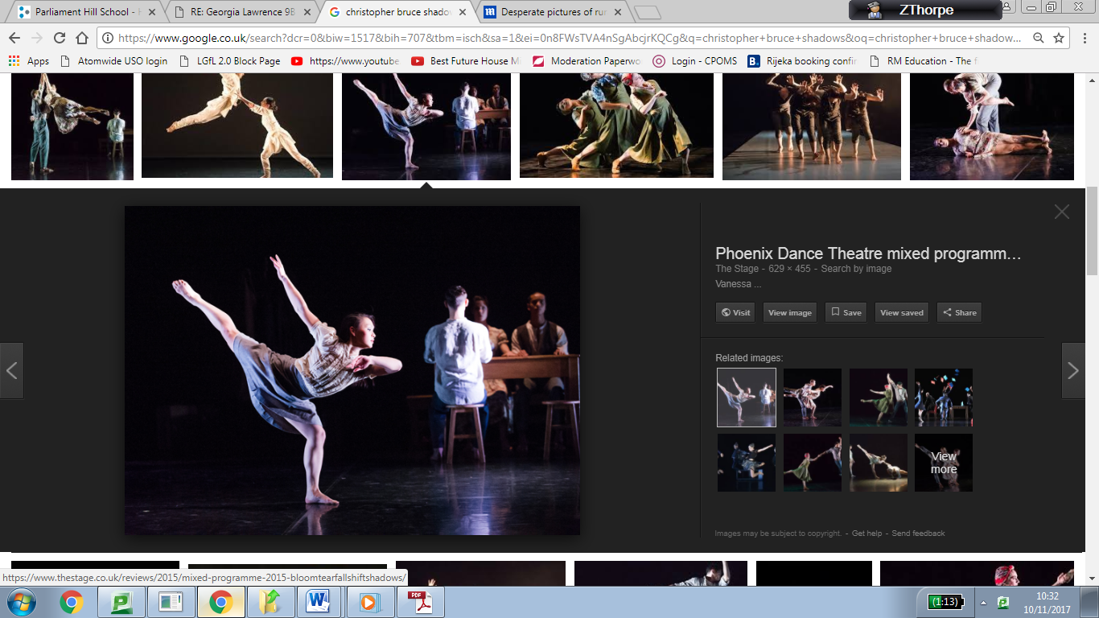

Shadows

**Set & Props**

**Performance Environment**

End Stage

**Descriptions**

* Black box stage – black floor and walls/tabs
* Worn looking table, bench, two stools, coat stand and suitcase

**Contributions**

* Stimulus – Family dynamic – Table and chairs create a sense of a family home, highlighting the stimulus of a family dynamic.
* Intention – Poverty/deprivation – Table, chairs and stools are all worn out and drab, highlighting the idea that the family are poor with no money for finer things.
* Mood – The use of a black box type stage creates a dark atmosphere and sinister mood.
* Complements other components – The worn out and drab table and chairs complement the dull and drab costumes of the dancers.
* Historical context – The table, stools, coat stand and suitcase all look old fashioned and worn, highlighting the historical context of 1930’s Europe.
* Context – The table, chairs and coat stand depict the context of a family home.
* Social context – The worn out table, chairs and suitcase all suggest the family are living in poverty.
* Creates levels – The table is used to create levels when the daughter stands on it.
* Narrative – The table, chairs and coat stand highlight the narrative of a family home, the suitcase enhances the narrative idea of the family wanting to flee from the troubles outside the home.
* Incorporated into action – The table is moved by the son towards the door and hidden behind, therefore incorporated into the action rather than just static set.

**Interpretations**

* The table, chairs and stools represent the furniture found inside a typical family home.
* The distressed and worn look of the furniture and suitcase suggest the family are poor.
* The use of a black box stage enhances an enclosed environment, represent a dark and dreary unlit family home in 1930’s Eastern Europe.
* The use of a suitcase suggests the family wants to flee it’s troubles that lie outside the home.
* The moving of the set suggests the family are desperate to block out the outside forces that are scaring them.

**Moods**

Sinister, scary, eerie, frightening, fearful, anticipatory

AQA 1-9

GCSE Dance

Component 2

1. A Linha Curva

2. Infra

3. Shadows

4. Artificial Things

5. Emancipation of Expressionism

6. Within Her Eyes

Shadows

**Aural Setting**

**Descriptions**

* Violin and piano
* No breaks in tempo.
* A continuous fast paced section followed by contrasting slower sections.
* Broken chords and staccato sounds used throughout
* Changes in speed and dynamic used to introduce different characters

**Contributions**

* Stimulus – Outside force – the high pitched, eerie and erratic tempo of the aural setting highlights the sense of an outside force, with some specific sections sounding very much like something could be banging on the door trying to enter
* Intention – Eastern Europe family – the music is typical of Eastern Europe, the composer is also from Eastern Europe which adds to the intention of a European family.
* Mood – The low notes and broken chords create a sombre, sad and sorrowful mood.
* Complements other components – The use of European style music complements the European style costumes
* Historical Context – The piece was composed in 1977, but was inspired by earlier classical work and sounds similar to some war-time classical music which is of the same era as this piece.
* Geographical Context – The composer is from Estonia which is in Eastern Europe, this influence contributes to the geographical context of the work being set in Easter Europe

**Interpretations**

* The violin and piano are classical instruments, and the sounds they create being fast and high pitch din the opening connote the frantic feelings felt by the family as they are confronted with a scary outside force.
* The slower sections portray the feelings of sadness felt by the family, at their poverty and also their fear of what lies outside their home.
* The music is similar to war-time music composed around WW1 and WW2, connoting the sad and dreary feelings of people living at that time

**Moods**

Sinister, scary, eerie, frightening, fearful, anticipatory

Emancipation of Expressionism

**Costume**

**Descriptions**

* Blue short sleeved t-shirts
* Blue denim jeans
* Grey trainers with white sole
* Individual tattoos, jewellery and hairstyles allowed.

**Contributions**

* Stimulus – Expressing individuality – allowance of personal jewellery, hairstyles and tattoos reflects the stimulus of expressing yourself.
* Intention – Intention of ‘Order and Chaos’ is shown as all dancers wearing the same creates order
* Mood – dark coloured clothing contributes to a dark and serious mood.
* Complements other components – use of blue colour complements the blue lighting
* Uniformity – all dancers wearing the same creates uniformity
* Gender – costumes are gender neutral which represents equality despite of gender
* Sculpts body – although not tightly fitted, the shapes of the sleeves allow the lower arm to be seen while performing intricate gestures.
* Historical context – clothing suggests modern day as is typical urban style seen worn from 1990’s onwards.
* Social context – simple costumes suggests the social context is of middle-lower social class.

**Interpretations**

* Blue colour represents embryonic fluid inside of a womb
* Urban clothing represents the urban style as per the stimulus of the work
* Individual tattoos, hairstyles and jewellery reflect individuality.
* Blue colour represents the name of the company ‘Boy Blue entertainment’.

**Moods**

Serious, intense, powerful, chaotic, energetic

Emancipation of Expressionism

**Lighting**

**Descriptions**

* Blue wash from above
* Spotlights in white and blue to highlight soloists
* Edges not lit to create a central focus
* White lights from offstage create a shaft across the side
* Use of fades and blackouts for dramatic effect
* Purple colour used on white cyclorama

**Contributions**

* Stimulus – Freedom of expression – spotlights highlight dancers to express themselves in their own moment in the ‘limelight’.  
  Theme – Order and Chaos – flashing lights create a sense of chaos
* Mood – dark intensity creates an intense mood
* Complements other components – Blue colour complements blue costumes   
  Highlights dancer – spotlights highlights dancers in their solos
* Sculpts body – side light sculpts the bodies of the dancers as they scramble towards it  
  Highlights dance space – sides not lit to create a central focus, centre of the stage is lit
* Context – blue creates a sense of liquid, as though inside a womb.

**Interpretations**

* Blue lighting represents the name of the company ‘Boy Blue Entertainment’
* Blue colour represents liquid and embryonic fluid found in a womb
* Dark intensity suggests the sinister struggles of battling against oppression
* White light offstage suggests hope as dancers struggle towards it
* Change to purple on cyclorama suggests a change in power and energy

**Moods**

Serious, intense, powerful, chaotic, energetic

Emancipation of Expressionism

**Set & Props**

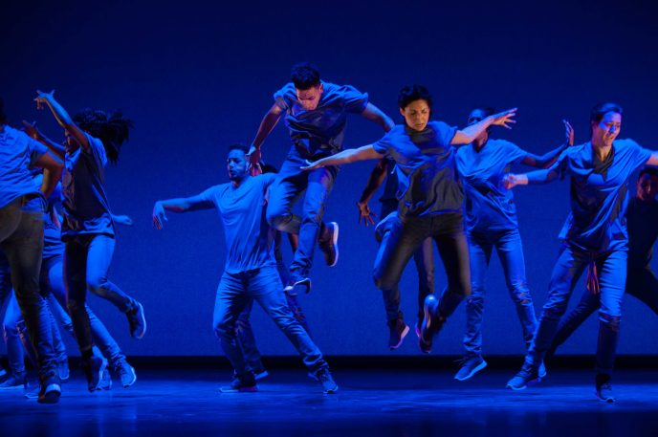

**Performance Environment**

End Stage

**Descriptions**

* No set – black walls and floor only
* Smoke used with lighting
* White cyclorama revealed towards the end

**Contributions**

* Stimulus – Free to express through hip-hop – No set = no distractions from the movement
* Intention – Life’s journey – dark and secluded set creates a sense of a womb
* Complements other components – dark set and floor complement the dark coloured jeans worn by the dancers
* Context – dark and secluded set creates a context of a womb
* Mood – dark and secluded set creates a tense and serious mood

**Interpretations**

* Dark walls and floor represent the inside of a womb
* White cyclorama revealed towards the end represents a change in perspective and change towards empowerment and freedom.

**Moods**

Serious, intense, powerful, chaotic, energetic

Emancipation of Expressionism

**Aural Setting**

**Descriptions**

* Aural accompaniment specifically created for Boy Blue Entertainment
* Urban dubstep style music
* Classical sections
* Repetitive beats and sounds
* Repeated vocal ‘The One’

**Contributions**

* Stimulus – Individuality – use of the vocal ‘The One’ suggests individuality and being ‘one’ or unique.
* Intention – Order and Chaos – rapidly changing tempos and beats create a sense of chaos.
* Mood – Use of classical section uplifts the mood to a hopeful one
* Complements other components – use of fluid sounding classical music complements the liquid style lighting creating a sense of being submersed in water.
* Historical setting – the music starts very modern with dubstep type beats, but progresses to classical music suggesting a step back in time.
* Climax – Til Enda is used as a climax for the piece contrasting with the previous sections
* Structure – Each of the 4 sections has its own distinctive section of aural setting aiding the audiences following of the structure.

**Interpretations**

* Fast beats create a sense of chaos and struggle
* Fluid dynamics of the violins used in classical sections create the feeling of being submersed in water or fluid inside of a womb.
* The moving from very modern dubstep music in the beginning, classical music in the middle and then a fusion of both at the end suggests moving through time, as though on a journey where backwards steps may be taken.
* The 4 different sections of accompaniment could represent different stages of life; pre-birth, childhood, adolescence and adulthood – all coming with their own struggles and torments.

**Moods**

Serious, intense, powerful, chaotic, energetic

Within Her Eyes

**Costume**

**Descriptions**

* Stylised everyday clothes
* Female: Beige skirt and shirt
* Male: Khaki jumper and jeans

**Contributions**

* Stimulus – the everyday clothes portray the stimulus of a love story gone wrong, as everyday people go through love and loss.
* Intention – the skirt’s flowing nature is romantic but also wraps around the male at times, symbolising the romantic love story and the intention of wrapping around him.
* Mood – The earthy and dull colours used in the costumes highlight the sad and depressing mood
* Complements other components – The earthy colours of the costumes complement the earthy colours of the landscapes
* Gender – The female wears a skirt to highlight her female gender whilst the trousers signify the male’s gender.
* Sculpts body – the jeans and jumper of the male dancer sculpt his body to clearly see the lines, especially in the silhouette section.
* Highlights character – the skirt worn by the female highlights her feminine character
* Historical context - the clothes are modern stylised clothes informing the audience the piece is set in the present day.

**Interpretations**

* The stylised everyday clothing suggest the everyday turmoil people in difficult relationships go through
* The female having light coloured earthy clothing draws her into the landscape creating a sense of her sense of self slowly fading into the background as her relationship comes to an end.
* The male’s dark clothing suggests he is stable, solid and secure; the one the female relies on completely.

**Moods**

Dark, sad, intense, passionate, sad, sorrowful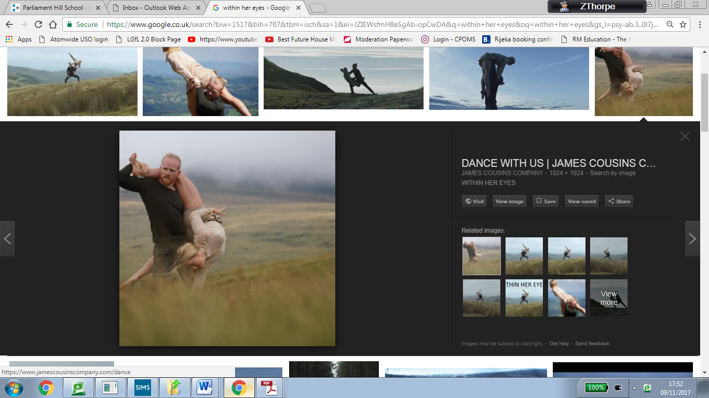

Within Her Eyes

**Lighting**

**Descriptions**

* Natural lighting from the environment
* Overcast, grey and dull
* Lighting becomes darker as the piece progresses
* Use of camera shows dancers as silhouettes
* Extra darkness added in editing process to enhance the sense of darkness

**Contributions**

* Stimulus – love story with a twist – impending darkness suggests a dark and twisted love story
* Intention – intimacy and passion – growing darkness suggests growing dark feelings between the dancers
* Mood – darkness suggests a deep, dark and passionate mood
* Complements other components – dull lighting complements the dull colours in the setting and costumes
* Time of day – Begins early evening, progressing to late evening

**Interpretations**

* Natural lighting suggests real and natural emotions when losing a loved one.
* Natural lighting progressing from day to night suggests changes in time
* Lighting becoming progressively darker suggests the darkening of feelings
* Dancers portrayed as silhouettes suggests they are one person merged; dealing with a split personality.
* Extra darkness added in ensures a sense of darkness, sadness and sorrow are felt through the film.

**Moods**

Dark, sad, intense, passionate, sad, sorrowful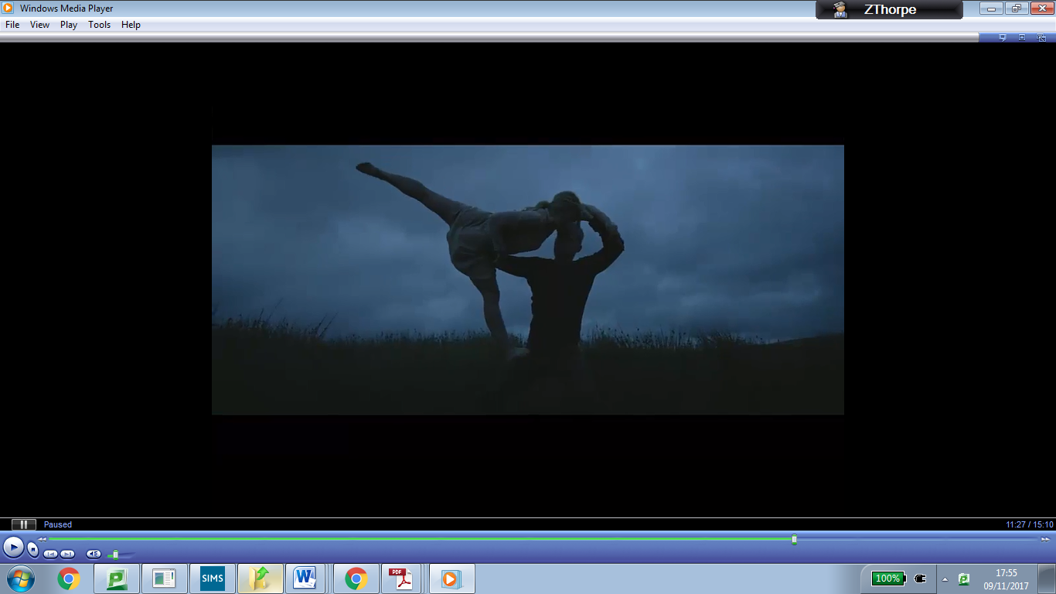

Within Her Eyes

**Set & Props**

**Performance Environment**

Site-Sensitive

**Descriptions**

* Graveyard  
  Vast open landscape/hilltop
* Quarry
* Clearing in woodland
* Long grass on a hill

**Contributions**

* Stimulus – Love and Loss – The prologue sees the female dancer in what appears to be a graveyard, emphasising the stimulus of loss.
* Intention – Love story. The changing locations become progressively more intimate, highlighting and suggesting the intimacy of a love story.
* Mood – The enclosed spaces highlight an intense and passionate mood.
* Complements other components – The dreary colours of the landscapes complement the dull lighting and earthy colours of the costumes.
* Geographical context – The piece is literally set in a variety of geographical landscapes including a field, quarry and woodland – stating the geographical context.
* Historical context – The images in the prologue shown an abandoned town and graveyard, which could be in modern day as the architecture although not modern, is still seen in towns today.
* Narrative – the changing settings enhances the narrative of a relationship moving through time.

**Interpretations**

* The graveyard could represent the feelings of sadness and loss after losing a loved one.
* The vast open landscape could represent the beginning of a relationship when each person feels open and free.
* The quarry could represent the harshness of the feelings in the relationship as it turns sour.
* The woodland represents enclosing and impending sadness and enhances the intimacy of the relationship.
* The long grass on the hill could signify everything coming to an end and the surrounding feeling of sadness felt by the characters.

**Moods**

Dark, sad, intense, passionate, sad, sorrowful

Within Her Eyes

**Aural Setting**

**Descriptions**

* Created specifically for the work
* Electronic elements with strings and piano
* Haunting undertones

**Contributions**

* Stimulus – Love story with a twist – The use of haunting tones in the electronic sounds create a sense of a sinister and sad story – depicting the emotions of the dancers as they go through a break up.
* Intention – Love and Loss – the use of piano and strings create a romantic feeling which enhances the intention of love.
* Mood – The haunting undertones of the strings create a sad and intense mood.
* Complements other components – The haunting sounds of the strings and violins complement the haunting and dark lighting of the piece.
* Narrative – each section of the accompaniment matches the scenes of the narrative becoming darker and more twisted, sections previously heard are repeated but developed with lower notes to complement the narrative of a dark, twisted love story.
* Structure – each section of the accompaniment flows seamlessly into the next highlighting the structure of the piece with a prologue and 6 sequential sections following.
* **Interpretations**
* The single notes played on a piano create a sense of sadness and could represent single tears falling from a person’s face.
* The haunting nature of the accompaniment invites the audience into the emotions of the dancers going through turmoil at the loss of a loved one.
* The repetition but development of the sections of accompaniment reflect the repetitive nature of trying to fix a relationship that is ultimately doomed.

**Moods**

Dark, sad, intense, passionate, sad, sorrowful

Artificial Things

**Costume**

**Descriptions**

* Able bodied dancers’ costumes have colour streaming down them
* Able bodied man wears loose fitting trousers and shirt
* Laura wears fitted trousers and short sleeved vest
* Dave wears colour stream tshirt and cut off trousers, puts on a suit jacket
* Pedestrian style clothing

**Contributions**

* Stimulus – paintings – streaming colours down the costumes of the able bodied dancers and Dave highlights the use of the same technique in the paintings.
* Intention – life’s limitations – the different costume worn by Laura singles her out, as though she is fighting against conforming or battling against regrets.
* Mood – dull colours in the costumes contributes to the sad mood
* Complements other components – the colours streaming in the costumes complement the colours streaming in the backdrop
* Uniformity – the colours streaming in three of the dancers’ costumes creates uniformity
* Gender – the able bodied female dancer wears a dress, signifying her female gender.
* Sculpts body – Laura’s vest top is tight to her body and reveals her arms and shoulders, sculpting and enhancing her upper body.

**Interpretations**

* The colours streaming from the costumes could represent life and hope draining from the dancers.
* The pedestrian style clothing suggests the dancers are everyday people struggling with everyday issues
* Dave puts on a suit jacket to show time has passed

**Moods**

Peaceful, sorrowful, sad, hopeful

Artificial Things

**Lighting**

**Descriptions**

* White shaft of light highlighting the floor and dancers from the side.
* Warmer use of golden lighting.
* Blue wash.
* White spotlight.

**Contributions**

* Stimulus – Snow globe – white lighting on the fake snow highlights snow globe,
* Stimulus – Urban landscape – warm lighting reflects warm lights of homes against a white city landscape  
  Intention – Overcoming life’s limits. Lighting is limited, only simple use of one type of lighting at a time reflects this.
* Complements other components – White lighting complements the white fake snow used on the floor of the stage.
* Highlights dancer – The spotlight used on Dave’s solo highlights him.
* Highlights dance space – The shaft of light across the stage highlights the fake snow and creates a path that dancers dance in.
* Sculpts body – The spotlight sculpts the upper body of Dave and sculpts Laura’s legs.
* Mood – The dark intensity of the lighting combined with blue wash highlights a sorrowful mood.
* Geographical Context – The use of blue and warmer yellows suggests an urban landscape with a blue sky, covered in snow with warm lighting coming through the windows.
* **Interpretations**
* The shaft of lighting suggests hope, that there is light at the end of the tunnel whilst fighting life’s limitations.
* The warmer yellow lighting suggests the lighting coming through the windows of a snowy urban landscape.
* The warmth also represents the coming together of the dancers to overcome life’s limitations and difficulties.
* The blue wash suggests coldness, depicting a snowy landscape.
* The white spotlight suggests a window into another world, where limits are the dancers can escape to a place without limitations and drawbacks.

**Moods**

Peaceful, sorrowful, sad, hopeful

Artificial Things

**Set & Props**

**Descriptions**

* Heavy backdrop with paint streaming down
* Collapsed wheelchair
* Fake white snow on the floor
* Glass cabinet on its side filled with fake snow
* Two stools
* Headless mannequin

**Contributions**

* Stimulus – paintings by Goran Djurovic – colour streams down as seen in the paintings
* Intention – life’s limits – use of headless mannequin shows you can have a whole body but not be able to move
* Mood – dull use of colour suggests a sorrowful mood
* Complements other components – paint streamed backdrop complements paint streamed costumes
* Geographical context – use of fake snow suggests the geographical context of a snow covered urban landscape
* Creates levels – the vitrine on its side and stools creates levels for the dancers to create the portrait photo
* Incorporated into action – collapsed wheelchair is used by able bodied and disabled dancers as part of the movement as they piece it together

**Interpretations**

* Colour draining from the paintings could represent hope and content draining from the dancer’s lives
* Paint streaming down the backdrop could represent the water streaming down the inside of a snow globe
* Collapsed wheelchair represents the support required t get through life’s limitations
* Collapsed wheelchair suggests a sense of ‘broken hope’
* Fake white snow represents the snow seen inside a snow globe
* Glass cabinet portrays the glass cabinet seen in the Goran Djurovic paintings
* Glass cabinet suggests a snow globe inside a snow globe
* Two stools represent the support needed for both the disabled and able bodied dancers
* Headless mannequin suggests an empty body with no personality

**Moods**

Peaceful, sorrowful, sad, hopeful

Artificial Things

**Aural Setting**

**Descriptions**

* Mostly piano
* Futuristic feel
* Individual notes played one at a time
* Sound effects: wind and footsteps through snow
* Song; Sunshine of your smile used for Dave’s final solo.
* Slow tempo

**Contributions**

* Stimulus – snow globe – individual notes played represent individual snowflakes falling and landing on the ground.
* Intention – life’s regrets – low and dull notes create an uneasy tension, suggesting life’s regrets.
* Mood – slow and sustained notes create a sorrowful mood
* Complements other components – low notes create a sorrowful mood and complement the lighting which enhances a sad mood too.
* Historical context – futuristic sounds created by the piano create a sense of time moving into the future, suggesting a modern or futuristic historical setting.
* Geographical context – the sound effects of walking through snow suggest a landscape covered in snow.

**Interpretations**

* Piano notes played one at a time suggests snowflakes falling and landing on the ground.
* High pitched notes create a cold and eerie atmosphere, as though in a winter landscape.
* Sound effects of wind suggest the shaking up of a snow globe as everything inside moves around.
* The slow tempo suggests a long and drawn out process of struggling with limitations.
* The song sunshine of your smile is a tribute to Dave’s father who sang it to him as a child, suggesting Dave has moved from childhood where he faced struggles to a place of adulthood where he is overcoming difficulties.

**Moods**

Peaceful, sorrowful, sad, hopeful

**A Linha Curva**

* Use of wide camera angle throughout to capture all changes in formation and lighting states
* Very little variation in camera direction/angle or effect to allow audience to focus on movement and lighting

**Artificial Things**

* Opening uses a close up to give a filmic atmosphere
* Long shots allow full length tableaux to be viewed which make them appear as one of GD paintings
* Camera pans to follow actions as if gliding with the movement and travelling sections

**E of E**

* Mid shots used to focus in on more intricate isolations – action reaction section
* Long shots to view the large formations – final section
* Mid shot in opening to view facial expression of dancer in the middle

**Within Her Eyes**

* Close up during poignant moments – first time they look at each other to ensure audience understand the importance
* Wide lens used to ensure audience see vast open landscape enhancing the idea that they are isolated
* Quick camera angle changes in forest section compliment the music and add to the tension and fast dynamics
* Camera on tracks provide a smooth finish and allow audience to focus on movement
* Handheld camera for the ending brings the audience closer to the action and tilts downwards towards her feet to enhance the idea of her finally touching the floor

**Infra**

* Close up of female dancer crying to highlight emotional distress
* Wide shot to show group ensemble on stage in crowded section – allows audience to see full crowd together with LED screen

Mid shots allow for audience to clearly see shapes of the body and intricate gestures ie in duets where male performs choking gestures on female

**Shadows**

* Mid shots to view the distressed facial expression of son – positioned DSR. Allows audience to connect with narrative
* Long shots to view travelling pathways to DSR corner from table
* Mid shot to enhance the poignancy of dancers walking into light – what will await them outside the home?