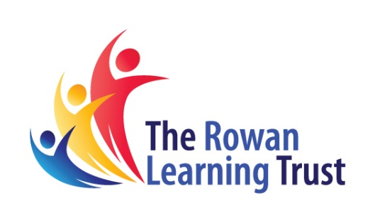
Accessing live lessons
  - The Rowan Learning Trust – Teams Instructions

This guide will show you how to access live lessons on MS Teams. This will work better if you have Teams installed on your device.

Step 1:
If your entire year group has been told to access remote learning, you will receive 'live' lessons. In each subject, every other lesson will be 'live'. Your teacher will invite you to your lesson.

Step 2:
You will need to click on the team / class that you should have and the invitation to the live lesson will be on the general news feed.
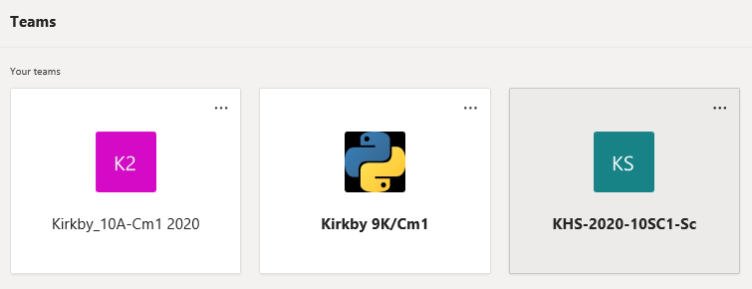
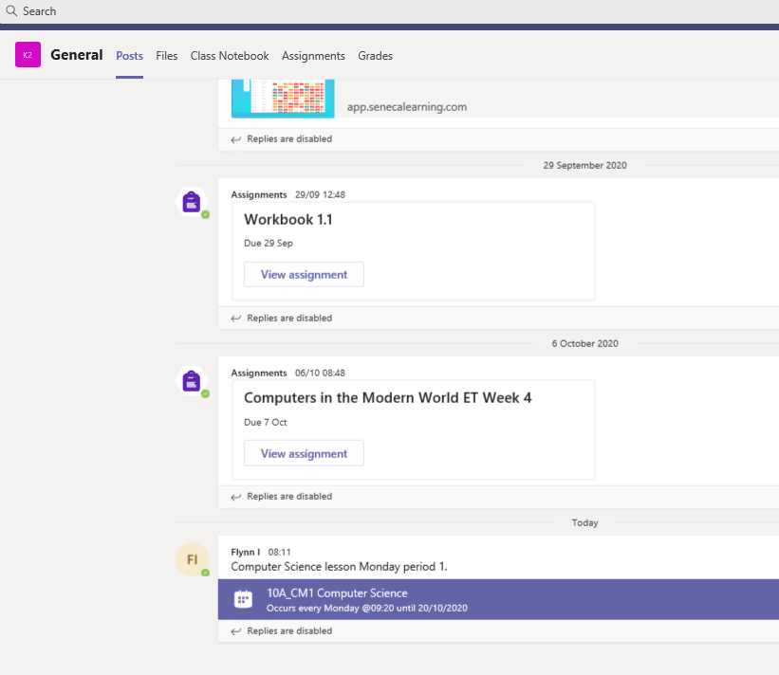

Step 3:
Once you have selected the live lesson you will need to select the join Microsoft Teams meeting:
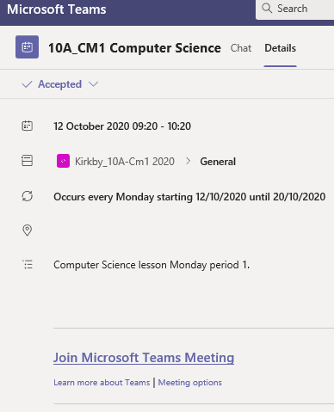

Step 4:
Click on the join now button
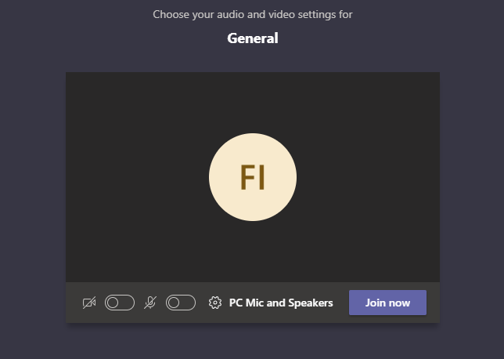

Step 5:
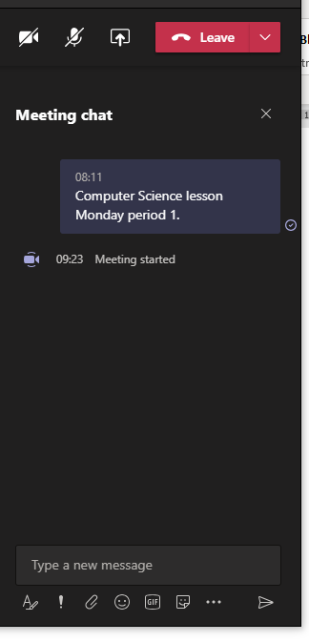
Your teacher will present the lesson and you will hear them, they will tell you where to access the work inside your MS Teams NoteBook. You will be able to ask your teacher questions using the chat function.
