The Kirkby Child  Healthy relationships  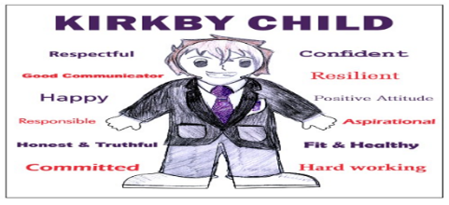  Healthy relationships allow people choice.  Marriage of choice- you choose your own partner  Arranged marriage – Your marriage is arranged by family members (you still have choice)  Forced marriage – a marriage which you are forced into  Online safety  - Never tell people your password  - Don’t give too much personal information away  - Log out of any shared devices  - Not everything you see online is true! | Sexuality and PRIDE  Homosexuality – attracted to people who are the same gender as you  Heterosexuality – attracted to people who are a different gender to you.  PRIDE 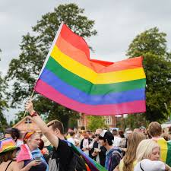  An international event to allow people to learn tolerance and the history of people who have been persecuted for their sexuality.
The Christian wedding ceremony  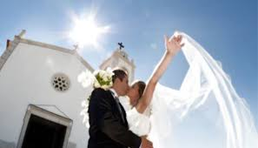 It takes place in a Church  The bride wears white as a symbol of purity (the groom is her only partner)  The bride is ‘given away’ by her father (showing the dad passing responsibility to the groom)  Vows are exchanged  Rings are exchanged (circle to represent eternal love)  Confetti is thrown as a symbol of fertility  Hymns, prayers and Bible readings are given.  The couple celebrate with a wedding breakfast | Muslim wedding ceremony  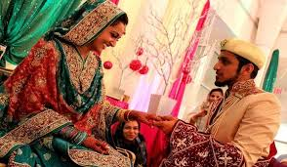 Often a Muslim wedding is an arranged marriage.  Mahr- this is a dowry given to the bride from the groom. She gets to keep this even if they divorce  Nikah – the wedding contract  Walimah – the feast that occurs after wards.  A Muslim wedding does not have to take place in the mosque. Men and women often stay separate whilst the Nikah is signed.

