Kirkby High School
Transition Booklet
Stratford School Academy

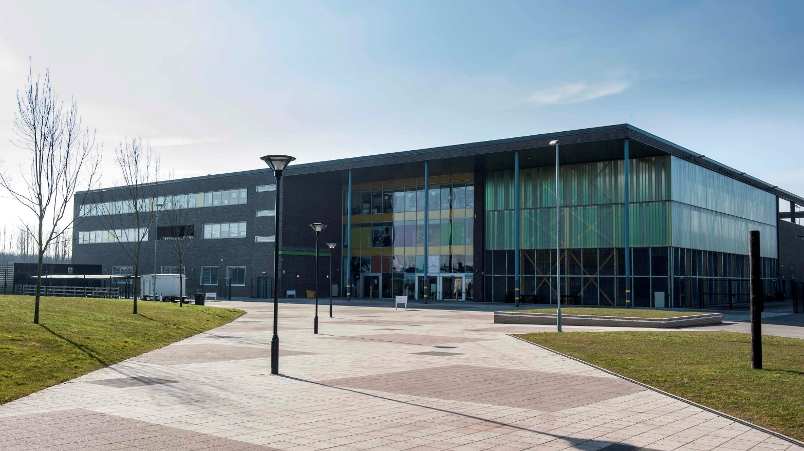

#

Let us start with some advice from students who have been in your position.

Focus on yourself and being you. Good friendships will happen naturally.
Never be afraid to ask for help or talk to somebody new at secondary school.

Secondary school is not as scary as it feels before you begin.
Try your best to do your homework as early as possible to allow you time to ask for help if needed.

Make sure you have fun!

Always be honest with yourself.

Aspire, succeed and be excellent!

Do the work to the very best of your ability. Ask if you need help or don’t understand
something.

In your first few days, try starting conversations with others you haven’t met yet.

Develop new interests by joining a club. Try something new.

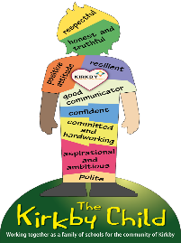

Welcome to Kirkby High School

It is certain to say that we have all experienced something very strange this year.

COVID-19 caused your final year of primary school to end abruptly, but then restart for some. It has made you miss out on your transition day, Year 6 trip,and many other fun things – particularly the SATs…

Starting at secondary school may seem scary one minute, but fantastic the next. You may have waves of excitement, quickly followed by nerves. This is completely normal and will be very common for everybody moving to secondary school this year.

At Kirkby High School, we want you to use this transition booklet as a tool to look back but also to move forward and begin that step up to secondary school. We want you to get to know how we do things here at Kirkby High School and for you to share what makes you, you.

This booklet will keep you occupied over the summer. You can complete the tasks in your own workbooks or paper. If you wish to share any of your work with us, please email it to transition@kirkbyhighschool.net I will feature the very best work on our Year 7 Twitter feed (@MissMorrinKHS) which you can follow on Twitter.

Contents:

01 About Me
02 Getting Started
03 Feelings
04 Looking Forward
05 My New School
06 Getting Organised
07 Setting Goals
08 The KHS Challenge

About Me

Name:
_____________________________________

My Primary School:
_____________________________________

My Family:
_____________________________________
_____________________________________

My Greatest Achievement:
_____________________________________
______________________________________

What I want my future to look like:
_____________________________________
_____________________________________

Something my friends say about me:
_____________________________________
______________________________________________________

The best place I’ve ever visited:
_____________________________________
_____________________________________

If I could have a super power it would be:
_____________________________________
_____________________________________

My favourite book is:
_____________________________________
_____________________________________

One day I want to travel to:
_____________________________________
_____________________________________
If I could travel back in time I would go to:
_____________________________________
______________________________________________________

Getting Started

Start looking to the future by looking back. We would like you to write a letter to a member of staff at your primary school (Year 6 Teacher, the Headteacher, a Teaching Assistant) using the structure below. (You can also handwrite your letter)

After you have planned your letter using the structure,
why not write it and send it to your old primary school?
Your address:

Their name:

Their address:

Dear:

Tell them why you are writing:

Your best memory from primary school:

What you are looking forward to about secondary school:

Bring the letter to a close:

Give regards:
Your signature:

Your name:
Transitioning from Year 6 to Year 7.

What does the word ‘transition’ mean to you?
________________________________________________________________________________________________________________________________________________________________________________________________________________________________________________________________

What other words come to mind when you think about transitioning to secondary school?
________________________________________________________________________________________________________________________________________________________________________________________________________________________________________________________________________________________________________________________________________________________________________________________________________________________________________________________________________________________________________________

Make an acrostic poem below:
T - ___________________________________________________________
R - ___________________________________________________________
A - ___________________________________________________________
N - ___________________________________________________________
S - ___________________________________________________________
I - ___________________________________________________________
T - ___________________________________________________________
I - ___________________________________________________________
O - ___________________________________________________________
N - ___________________________________________________________

Feelings
When moving to secondary school it is completely normal to be feeling a mixture of emotions. We have added some of the feelings you may be feeling below. Give each of the feelings a different colour.

Excited | Happy | Worried
Nervous | Other | Sad

Now that you have selected your colours, colour in each of the boxes below to show how you are feeling about that element of moving to secondary school. Have a conversation with an adult at home or a friend about how you are feeling about each of these things.

Making new friends | Learning my timetable | Finding my way around
Learning new subjects | Meeting new teachers | Getting to school
Being on time | Homework | Exams
Break and lunch times | Being the youngest year group again | School work
PE | Remembering my equipment | New uniform
Expectations | My future | Social media
Growth Mindset

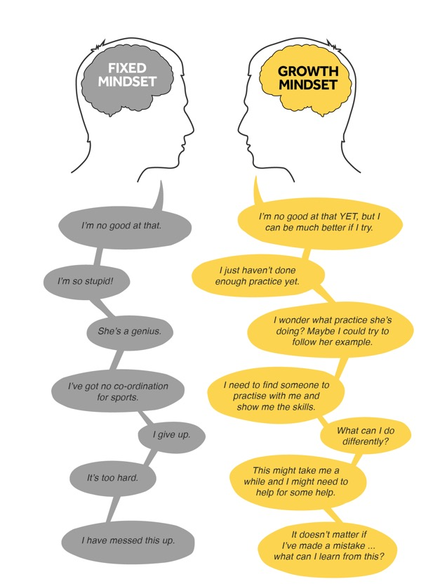

Identify three things you ‘can’t do’ or are worried about and write them here:

- ___________________________________________________________
- ___________________________________________________________
- ___________________________________________________________

Now change these to be written with a growth mindset approach. For example: ‘I can’t do maths’ turns into ‘I am going to work on the things in maths I find difficult’.

- ___________________________________________________________
- ___________________________________________________________
- ___________________________________________________________
Looking Forward
You will have a new school uniform when you join us, and for some of you this will be the first time wearing a school tie.

Until you have your own Kirkby High School tie, why don’t you have a go with a tie you have in the house. Practice makes perfect!
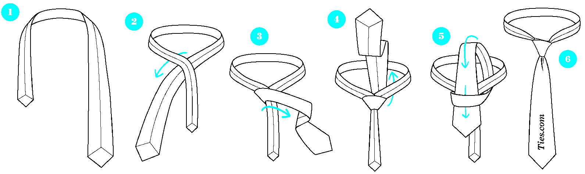

Getting to us safely is just as important as being here. Use the box below to draw a map and show your route to school, whether that is walking, cycling, or taking the bus or getting a lift. Identify any spots that could be hazardous. How long do you estimate it will take you to get to us each morning?

Thinking Long-Term

It is never too early to think about your career, your best qualities, and new things you would like to learn. At Kirkby High School, we like to focus on careers throughout all your time with us. Over the summer we would like you to make a start by completing two tasks:
Task 1: Complete the ‘What are my qualities?’ table (Or draw it out on a piece of paper). Each box states a quality. Tick the box if you think you have this quality, and then explain using an example, how you have demonstrated this quality. This is important as it can help you to identify your strengths and qualities you need to develop going into year 7.
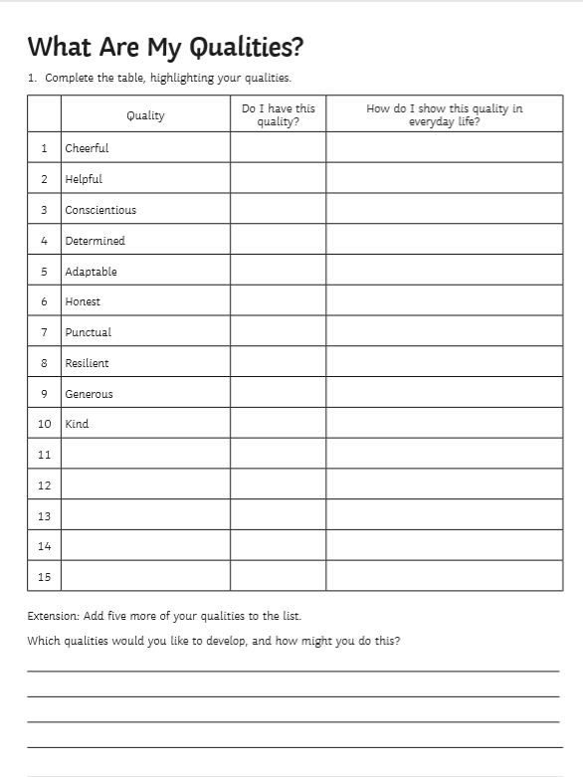

Task 2: Now that you have a better understanding of your best qualities, your task is to now choose a business or job you think you would be best suited to. Once you choose a job or business you are best suited to, explain why you have chosen that role in the space below.
The job/career I think I am well suited to is ___________________. I think I would suit this role because _____________________________________________________________
________________________________________________________________________________________________________________________________________________
________________________________________________________________________
________________________________________________________________________
Now that you have chosen a career you think you are well suited to, you need to think about a career action plan. Answer the following questions to help you think about what steps you need to take in year 7 and beyond:
What subjects do you need to study or need for your career?

What activities can you do outside of school that will help you to achieve this career (sports captain, cadets, scouts etc)?

Can you research any famous or well-known people who have achieved well in your chosen career? Write down their name and state three things they did that helped them.

What qualities will you need to show to overcome and difficulties or challenges you may encounter?

My New School

We have sent you the Kirkby High School handbook which explains all our school routines and expectations. Use the handbook, our school website and other research to fill out and answer the following:

- Who will be the Headteacher of Kirkby High School in September?
__________________________________________________________
- What are the names of your head of year and Year 7 mentor?
__________________________________________________________
- What are the names of our Year 7 form tutors?
-
-
-
-
-
-
-
-

This is an example of a Year 7 pupil’s timetable.

- How many times a week will you have English?
___________________________________________________________
- Which classroom would you be in for Science? How do you know?
___________________________________________________________
- What are the initials of your maths teacher?
___________________________________________________________
- How many lessons in total do you have in a week?
___________________________________________________________
We think we have done a good job at building a great school, but we want you to try and do even better. Fill each of the boxes below to show us what an amazing school is to you.
Learning also happens outside of the classroom. What clubs and activities should there be?
Start with the subjects. Which subjects should have the most amount of time on the timetable?

Now think about the teachers. What five things should teachers do every lesson?
Every school needs rules. In this box write out the five rules for pupils to follow.

What should a classroom look like?
Make sure you label everything so it is clear.

What things should be on the desk in every classroom provided by the school?
What about the uniform?
What should boys wear?
What should the canteen menu look like? Which snacks should be available at break time and which meals should be on offer at lunch? Make sure you are thinking about what makes you healthy
What about the uniform?
What should girls wear?

You need a good school motto, something catchy but with meaning. What will yours be?

Getting Organised
Work backwards to plan your morning routine to make sure you get to school on time. What time will you do each of the morning tasks?

Time | Task
08:45 | Registration Starts
 | What time do you arrive at school?
 | What time do you leave the house?
 | Check school bag
 | Brush teeth
 | Eat breakfast
 | Get dressed
 | Have a wash
 | Wake up

Shade in the different questions that you need to know the answers to about your journey to school. You will need to know the answers before September:

Is there someone I can walk to school with?
Where will I meet my friends?
Is someone giving me a lift?
What time?
What time does the bus come so that I’m on time for school?

Could I travel to school safely on a bike?
If I am going to take a bus, what number bus is it?
Do I need money for the bus? How much?
How long does it take me to get to school from home?

Equipment checklist: (Your school bag needs to be big enough to hold an A4 folder. You also need it with you EVERY DAY….no excuses)

Setting Goals
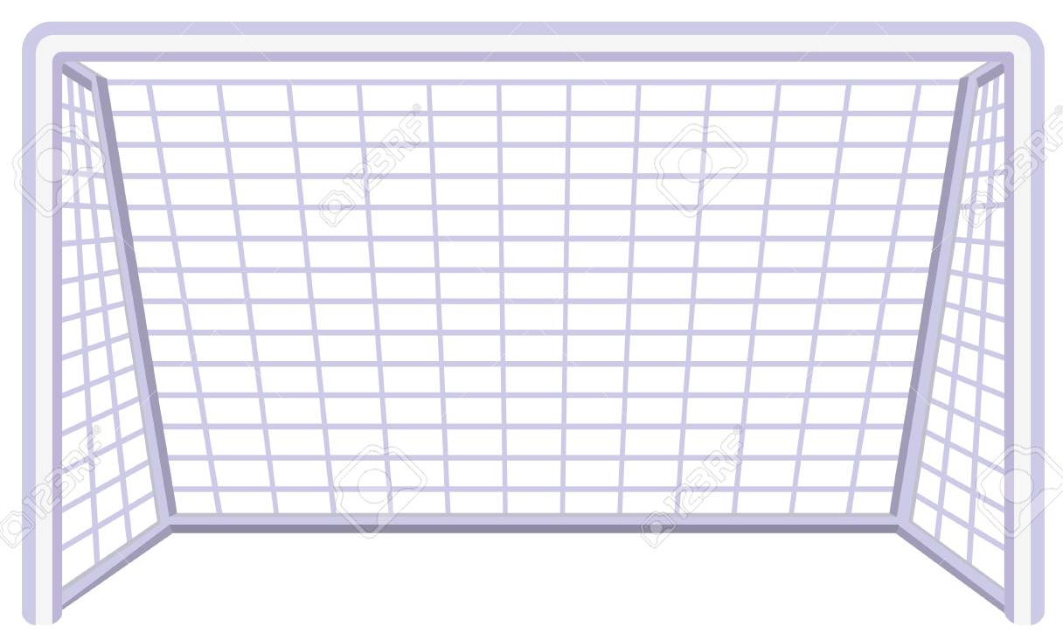

Secondary school is a great time to think about what you have achieved so far but also where you want to get to. Fill the net with your goals or draw a picture.

We have listed some goals below. (Add your own if we have missed some out)

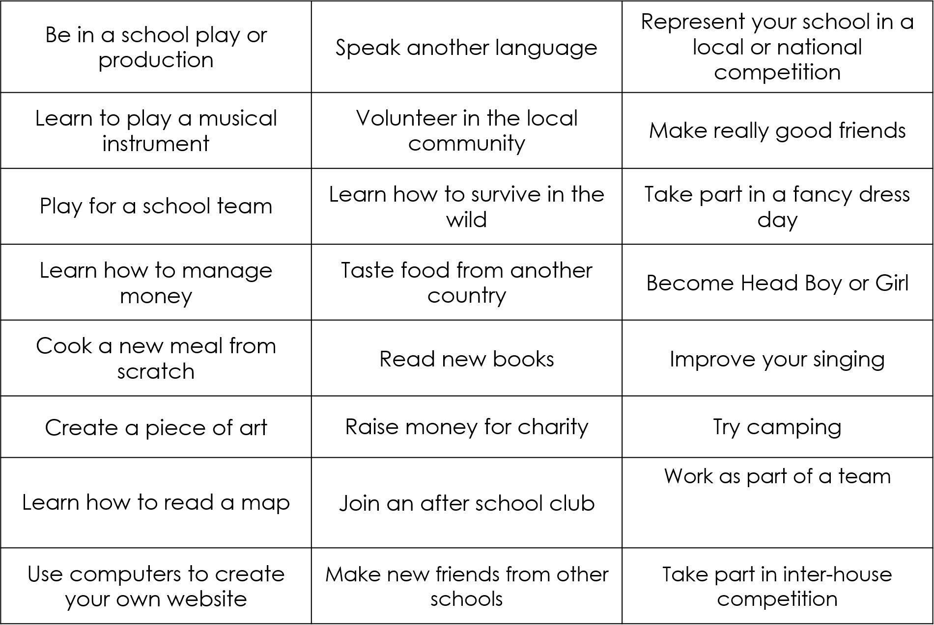

The KHS Challenge
To keep yourself going and get yourself ‘Kirkby High Ready’ over the summer holidays, try and complete the KHS challenge – 3 weeks of tasks waiting for you to try.

Share the work with us and we will share some of our favourites on our Twitter page!

ACTIVITY | Preparation for secondary school. | Developing Self Confidence and Wellbeing | Subject Knowledge | Staying Active
MONDAY | On your daily walk today, walk from your home to school and back, or look up what bus you will need to catch and the time. | What are three things you are confident about with yourself and your learning? | English: Write a short descriptive story about how you imagine your first day at Kirkby High School to be. | Mini work out:  25 sit ups  25-star jumps  1-minute jogging  25 press ups  25 squats
TUESDAY | Ask a family member about how they felt when they transitioned to secondary school. Even better if they are here already! | What are two things you would like to improve about yourself or your learning when you join us? | Maths: Recall the times tables for 3,6 and 9.  Draw 4 pizzas cut into 8 slices, then shade the number of slices that represent the following fractions ¼, ½, 3/8, 5/8 | Mini work out:  25 burpees  25 jumping jacks  1-minute skipping  25 Bicycle crunches  25 high knees
WEDNESDAY | What should you do if you are not going to be in school? Who should you contact at school? What is the telephone number? | Which subjects are you excited to study when you join us? | Biology: Research about animal and plant cells. What do they look like? What is inside them? What do the different parts do? How are they similar/different? | Mini work out:  25 Squat jumps  25 lunges  1-minute plank  25 high knees  25 sit ups
THURSDAY | What is the school’s expectation for attendance as a percentage? | What are three hobbies or interests you have that you could discuss with a new friend? | Spanish: If you have access to the internet, download the Duolingo app and start learning Spanish. | Mini work out:  25 press ups  25 high kicks  1-min mountain climbers  25 Bicycle crunches  25 high knees
FRIDAY | Write down your morning routine for when you join Kirkby High School. | What three qualities would make you a great new friend to have to someone from another primary? | Drama: Using a mirror, perform different facial expressions/emotions such as: happy, sad, frightened, confused, embarrassed, confident | Mini work out:  25 bunny hops  25-star jumps  1-minute climb  25 sit ups  2 minutes jogging
Week 1
Week 2
ACTIVITY | Preparation for secondary school. | Developing Self Confidence and Wellbeing | Subject Knowledge | Staying Active
MONDAY | From your alarm going off, time how long it takes you to get up and be ready to set off to school so you know what time to set your alarm for to be here on time. | Write down something kind you have done during lockdown that you could discuss with a new friend on transition. | English: Write a poem about your experience of lockdown. | Mini work out:  25 sit ups  25 frog jumps  1-minute jogging  25 press ups  25 squats
TUESDAY | What clubs will you join in September? | What is the kindest thing you saw/watched/heard someone else do yesterday? | Maths: How many mms in a cm, and a m? How many cm in a m? How many m in a km? How many g in a kg? Write the following as kg: 200g, 155g, 31g, 735g | Create your own:  Design a workout using… tinned veg or beans, pairs of socks, bottle of water, skipping rope, 2 objects of your choice.
WEDNESDAY | Make a list of what equipment you may need in your school bag each day. | Who haven’t you spoken to in ages? Send them a letter or an email today and tell them you were thinking of them. | Physics: What is a force? Can you name some examples of forces and where they may have an effect? | Mini work out:  25 Squat jumps  25 lunges  1-jumping  25 high knees  25 sit ups
THURSDAY | What items of school uniform will you need for September? Check out the information in your transition packs. | What are your three proudest achievements to date that you could share with your new form and form tutor? | Art: Create a mood board for transition. Draw all the things that will make you happy about coming to school. Consider your colour choices for happy. | Create your own:  Design a workout using… using at least 5 different exercises.
FRIDAY | Write down your after school/weekend routine for when you join Kirkby High School. | Write down three conversation openers to introduce yourself to a new friend at transition?  e.g. I really like your hair style that suits you, my name is… | Geography: Draw a map of your local area with a key; include key landmarks like schools, shops, monuments, areas of water, parks etc. | Mini work out:  25 spider man lunges  25-star jumps  1-mountain climbers  25 sit ups  2 minutes jogging

Week 3
ACTIVITY | Preparation for secondary school. | Developing Self Confidence and Wellbeing | Subject Knowledge | Staying Active
MONDAY | What will you have for your lunch? Make a meal planner for if you will make your own or eat from the menu under the parent section on our website – School meals | Complete three tasks around the home to support the adults looking after you. This could be putting the washing out, washing dishes, tidying up etc. | English: Write a short review for one of your favourite books. What happened? Who was your favourite character and why? | Mini work out:  25 sit ups  25-star jumps  1-minute jogging  25 press ups  25 squats
TUESDAY | Go back through the KHS’ Handbook – what else is there you need to know about Kirkby High School? | Design a thank you poster for key workers that you can put up in your window. | Maths: Mental maths: ask someone at home to read you their food shop receipt for this week and add up your family’s total spend. | Mini work out:  25 burpees  25 jumping jacks  1-minute skipping  25 Bicycle crunches  25 high knees
WEDNESDAY | We love to have a student voice, and our student leaders are fab. Design a poster highlighting an issue faced by young people. | Write a paragraph about someone who inspires you and read it to someone in your home. | Biology: Find a flower from your garden or from your walk. Draw it and label the parts. Then research and write a paragraph about photosynthesis. | Mini work out:  25 Squat jumps  25 lunges  1-minute plank  25 high knees  25 sit ups
THURSDAY | Set yourself 3 targets for the start of Y7. How will you achieve them? | Complete three tasks that will help support your local environment, such as: picking up litter from in front of your house, recycling the rubbish from your home, picking things to donate to a charity shop etc. | History: If you have access to the internet, research a historical monument from your local area, even better if you visit it on one of your walks. | Mini work out:  25 press ups  25 high kicks  1-min mountain climbers  25 Bicycle crunches  25 high knees
FRIDAY | Make a checklist for secondary school readiness that you can go through the week before we start in September. | Send the letter you have written to somebody at your primary school. | Technology: Create something for living things in your garden or outside, such as a bug hotel or a bird feeder by recycling a plastic bottle. | Mini work out:  25 bunny hops  25-star jumps  1-minute climb  25 sit ups  2 minutes jogging

