Careers Information
Term 2
During these uncertain times it is vitally important that as parents we support our children on their educational journey. As such I have attached links to useful websites which can be accessed to support your child’s careers guidance. To help make links between subjects and careers, success at schools, has provided a range of subject guides which can be downloaded from the link here.

Year 11: If your son or daughter is still considering their options for next year or would like to know more about what they can progress onto following their college or 6th form education, they can use one of the links on the last page for more information.

Year 10: Moving into your final year at Kirkby High School, you will need to plan for what you hope to do when you leave school. Your options include but are not limited to 6th form colleges, vocational colleges and apprenticeships. Please take this time away from school to plan and begin considering your applications. To help with this you I have attached a copy a website designed to support young people considering their next steps. https://www.thestudentroom.co.uk/a-level/sixth-form-college-application-personal-statements
The studentroom.co.uk offers advice on writing a college application, gives example personal statements to guide (Do not copy) you and links to apprenticeships and Universities for you to consider after your next step.

Year 7 – 9 – Careers Quiz
As you will need to begin planning your next steps before you even know it, please try this quiz to see if it can give you some insight to which career you would be best suited to.
Mr Jackson is……….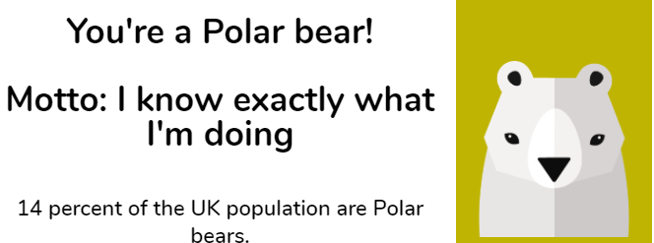
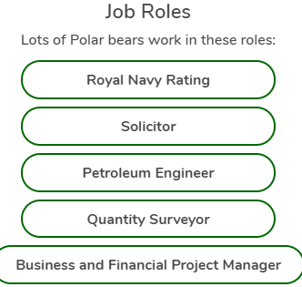
Teacher

Colleges
Knowsley Community College: https://www.knowsleycollege.ac.uk/
City of Liverpool College: https://www.liv-coll.ac.uk/
Winstanley College: http://www.winstanley.ac.uk/
Carmel College: https://www.carmel.ac.uk/
Hugh Baird College: https://www.hughbaird.ac.uk/

Apprenticeships (There are many degree level apprenticeships you can apply for once 18)
Apprenticeships: https://www.theapprenticeshiphub.co.uk/
Register for apprenticeship notifications: https://www.gov.uk/topic/further-education-skills/apprenticeships
Rate my Apprenticeships: https://www.ratemyapprenticeship.co.uk/

Universities
UCAS (University Information): https://www.ucas.com/
University of Liverpool https://www.liverpool.ac.uk/
John Moores University https://www.ljmu.ac.uk/
Edge Hill University https://www.edgehill.ac.uk/
Liverpool Hope University https://www.hope.ac.uk/
University of Chester https://www1.chester.ac.uk/
The University of Manchester https://www.manchester.ac.uk/

