Hello to our lovely Year 9.
Sadly, it’s been a while since we last saw one another. I hope you’re well & you’re taking time to look after yourselves.
Your form tutors and I are missing seeing your happy, smiling faces in form each and every morning. Hopefully you are in a routine, focusing on class charts & preparing yourselves as we move towards options in year 10.
To help keep you motivated, here are few things you can do help with how you are feeling & your routine. In the meantime, take care and look after yourselves! See you all soon,
Miss Gill

Eat well, feel well.
We have all been told about healthy eating, and usually it’s to keep our bodies fit and healthy. However, a good diet helps our mental health too. Don’t skip meals. If we don’t eat regularly or healthily, we can feel grumpy, tired, lose concentration and lack motivation to do anything. Eat breakfast every day. Our bodies and minds have run out of fuel during the night and we need to give ourselves a good start. Drink at least 6 glasses of water a day. It’s vital for our brain’s wellbeing.
Exercise.
Exercise is very important for your mental health. Moderate exercise is recommended for up to 30 minutes a day. Have a go!
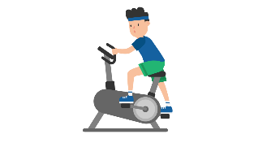

Organisation.

You’ll need some routine. Think about what you need to do (learning, exercise, friends-time, down-time) and what do you need to do to make that possible? More structure should, hopefully, mean less boredom.
Take Time Out.
Recharge your batteries – even if you just lie on your bed for 10 minutes in peace and quiet. Write down how you’re feeling. It’s a good way to get things off your mind without upsetting anyone else. Think of your favourite place. Remember what you might hear, see and feel like when you’re there.

