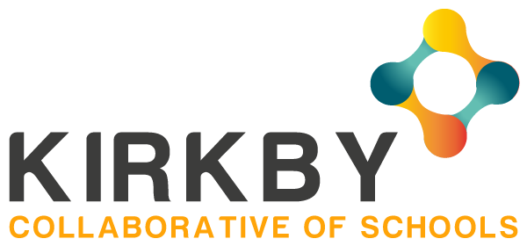

Dear Parents and Carers
We are writing to you as the Kirkby Collaborative of Schools with information regarding the recent government announcement concerning the potential opening of schools to additional year groups. We would like to reassure you that as a group of 14 Kirkby schools we have been very much working together, whilst taking note of national and local guidance, to try to find a way forward which is safe for both our children, our families and of course, our staff. We have a duty of care to safeguard all of the school community.
Over the past 8 weeks all 14 Kirkby Collaborative schools have been supporting the families of key workers and some additional children with the provision of over 3400 emergency childcare places, including during the Easter holiday period. In addition, teachers have been busy providing a wide range of home learning activities for your children which have had both an academic and a wellbeing focus.
Staff have been in regular contact with relevant families to check on wellbeing.
Schools have also coordinated the provision of free school meal vouchers, and responded to the numerous queries this brings.

What has the Government asked schools to do?
Schools have been asked by the government to begin preparing for a partial return to school of children from the year groups Nursery, Reception, Year 1 and Year 6. This was in recognition that children do need to return to school at some point and also to support parents and carers in returning to work. Headteachers have started to consider plans as, like yourselves, they want nothing more than to have children back in school learning and socialising with their friends. The government produced numerous documents detailing the actions schools would have to take prior to increased numbers of children returning. Some of these measures include:
- reduced class sizes to adhere to social distancing. All of our schools have now checked their classroom sizes and most can only fit small groups at any one time, for example, between 5 and 10 children maximum
- children to remain in the same group at all times with no mixing
- children to have the same teacher all the time
- increased hand washing facilities
- separate entry and exit points
- no parents / carers allowed on site
- one way systems to be established in schools
- reduced timetable / flexible days / staggered start & finish times
- home schooling resources to continue to be available
- desks to be positioned 2m apart if possible
- soft furnishings / toys to be removed from Nursery / Reception / other classrooms
- toys and equipment not to be shared
- small equipment which cannot be easily cleaned must not be used
- staggered break times with no mixing of groups
- provision of a sandwich lunch – again a staggered lunchtime with no mixing of groups
- additional cleaning throughout the day and week
There are a number of other requirements but we are sure you can understand that the children’s experience in school will be far removed from their usual routine and timetable. When we do open for additional children we will have a flexible approach to days and times which enables us to make the school environment as safe as we can and we will set out very prescriptive instructions which will have to be adhered to by all children and families. Even with all these additional measures in place we will not be in any position to guarantee that both children and adults will not be exposed to the virus at some point in our settings. All of this will be a challenge for school staff, children and parents / carers, but, as always, when the time is right, we will do our very best!

What will happen next?
Each collaborative school is now working on plans which have safeguarding as their main focus. These plans will take time to finalise so we can be sure about what is safely achievable and possible at this time. At present, no date in the Summer term has been set for a confirmed wider opening of any of our schools. Government and union guidance is continuing to be published daily and all schools will continue to work alongside each other, the local authority, academy trusts and trade unions to ensure that we welcome additional children into our schools at the most appropriate time. We will of course endeavour for this to be as soon as safely possible.

Whit Holiday
During the Whit holiday our schools have agreed to remain open to provide requested childcare for Key Workers and other identified children.
Teachers will not be providing online / home learning work during the Whit holiday.

After the Whit holiday period
Our schools will continue to support the childcare of our Key Workers and other identified children as they have been doing since the onset of this crisis. School will address the review of the list that takes place on 31st May and make any necessary additional places available.
Teachers will continue to provide a wide range of online / home learning resources to ensure your children can access age appropriate learning activities. And of course, we will always keep the wellbeing of our children and families at the forefront of our minds through our regular phone calls and social media presence. We will continue to support you all to the very best of our ability and capacity.
When the time comes for more children to safely attend school, your child / children’s school will contact you directly with further details and the next steps for you and your child / children.
In the meantime, we ask for your continued support and patience. Please look after yourselves and each other and if you need any additional advice or guidance, then staff in your school will always be willing to help. Please check individual school websites for contact details.

From the 14 Headteachers in The Kirkby Collaborative of Schools

