**Knowsley Virtual School**

**March 2020**

**Online Safety Newsletter**

**Snapchat**

Snapchat is a messaging app used to send photos, videos, text and drawings (called snaps) which disappear after they've been viewed. You should be 13+ to sign up. If you choose to allow your child to have an account then you should be aware of the following:

**Snap Map (sharing their location)**

The Map lets users see where their friends are if a friend has chosen to share their location at any given time. Location sharing with friends via the map is optional and is off by default (we recommend that this remains the default setting).

**Snapchat streaks**

Streaks count how many consecutive days two people have been sending Snaps to each other. A streak is shown by a little picture of a flame and a number (the number of days the streaks has gone on for) next to a contact’s name. There can be pressure to respond on a daily basis to maintain their streaks and it can cause issues with people logging into other’s account to carry on streaks for friends.

**Reporting**

Ensure your child knows how to report any issues when using Snapchat.

**Safety tips and resources**

It’s really important to talk to your child regularly and make sure that they know that you’re always there to talk to if they have any concerns.



**Tik Tok update**

**What is TikTok?**

Users can watch musical clips, record (up to) 60 second clips, edit them and add special effects.

**Is your child old enough?**

You must be over 13 years of age to use Tik Tok.

**Why should I be concerned?**

Some of the songs used in this app may contain explicit language and sexual imagery, which may not be suitable for your child to view.

If your child is using Tik Tok then we recommend setting the account as private.  Internet matters explains how to here:

<https://www.internetmatters.org/parental-controls/social-media/tiktok-privacy-and-safety-settings/>

**Did you know?**

Even with a private account, your child’s profile information such as their photo and bio is still visible so ensure your child understands the importance of not adding personal information (e.g. address, age and phone numbers).

**Talk to your child**

Why does your child use it? What do they like about it? Do they know their followers? What do they like watching on it? Have they ever seen anything that has worried them?

**Family safety mode**

This new tool has just been launched by TikTok which when enabled gives you control over your child’s safety settings. More information available here: <https://www.bbc.co.uk/news/technology-51561050>

**Further information**

* <https://parentzone.org.uk/article/tiktok-everything-you-need-know-about-video-production-app>
* <http://support.tiktok.com/?ht_kb=for-parents>



Users of this guide do so at their own discretion. No liability is entered into. Current as of the date released 1.3.20.

**Sexting**

**Sharing images**

Sexting is sending an explicit image or video of yourself to somebody else. It can also be called ‘pic for pic’ or ‘nude selfies’. Once you send an image/video you no longer have control of it, it could be posted online or shared with others. Remember that even if you use a webcam or an app like Snapchat to share it, somebody could take a screenshot of it. Sexting can also leave you exposed to potential bullying and blackmail.

We understand that some conversations can be awkward but it’s important to chat to your child about the potential risks of sharing explicit images, the law and where they can get help. Perhaps start the conversation by relating it to something in the news. Ask them why they think people do it and if they have ever seen it happen in school. Emphasise that they should never feel pressure to share images of themselves and that they should never share images of others. Ensure that they know they can talk to you if anything ever goes wrong.

Whilst sexting can be seen by teenagers as harmless fun it is actually **illegal** to create or share an explicit image, even when the person doing so is a child themselves. It’s important to remember that whilst the age of consent is 16, the age in relation to explicit images is 18. **You are breaking the law if you:**

* **take** an explicit photo or video of yourself or a friend.
* **share** an explicit image or video of a child.
* **possess, download or store** an explicit image or video of a child.

*If under-18s are found to be engaging in sexting, then whilst the matter will be investigated, police can choose to record that a crime has been committed but that taking formal action isn't in the public interest.*

ChildLine have created ‘Zip-It’ which your child can use to help them if someone is trying to pressure them into sexting: <https://www.childline.org.uk/info-advice/bullying-abuse-safety/online-mobile-safety/sexting/>

**Need help? How to report**

Stay calm! If your child talks to you about an incident then you may be shocked but it is important to remain calm and listen to your child. Try to find out who the image has been sent to and who it has been shared with. Ask your child to delete any images from their phone and any social media accounts (if they have uploaded them to there). You can also do the following:

* Report to any individual sites where possible and ask then to remove the image.
* If you need help in getting a sexual image of your child removed from the internet, you can get in contact with Childline or the Internet Watch Foundation (IWF).
* If your child is being threatened as a result of sharing a sexual image or someone online is asking your child to share an image then you should report it to CEOP: [www.ceop.police.uk/safety-centre](http://www.ceop.police.uk/safety-centre)
* Your child can use the Childline ‘Report Remove’ tool: <https://www.childline.org.uk/info-advice/bullying-abuse-safety/online-mobile-safety/sexting/report-nude-image-online/>

**Further information**

There’s lots more advice available about sexting here:

* <https://www.nspcc.org.uk/preventing-abuse/keeping-children-safe/sexting/>
* <https://www.thinkuknow.co.uk/parents/articles/Has-your-child-shared-a-nude-selfie-subtitled/>
* <https://www.childnet.com/parents-and-carers/hot-topics/sexting>
* <https://parentinfo.org/article/when-teens-share-nudes>



**What is Roasting?**

This is a form of cyberbullying. This involves people asking to be insulted on social media, it can lead to very hurtful comments. You should talk to your child about this type of behavior and why they shouldn’t participate in this type of behavior even if they see it as a game. Further information available here:

<https://parentinfo.org/article/roasting-a-guide-for-parents>

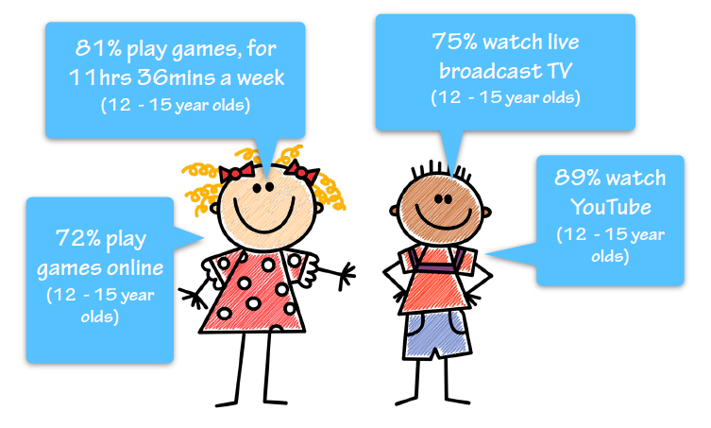This report examines children’s media literacy providing evidence on current media use, attitudes and understanding among children. The report highlights that half of ten-year-olds now own their own smartphone – the importance of understanding what your child is doing online, going online with them and talking to them about what they do online continues to be of upmost importance.

**New Apps**

This article lists the latest 5 apps you should know about and includes a top tip if your child is using them:

<https://www.vodafone.co.uk/mobile/digital-parenting/five-apps>

**Ofcom:**

**media use and attitudes**

Access the full report here: <https://www.ofcom.org.uk/research-and-data/media-literacy-research/childrens/children-and-parents-media-use-and-attitudes-report-2019>

**Realities**

**Online Gaming**

**Is the game your child playing age appropriate?**

Check the PEGI rating, it will either be rated 3, 7, 12, 16 or 18. As an example, if it is rated 18, then the game should not be played by anybody under the age of 18. <https://www.askaboutgames.com/pegi-rating/>

**Does your child know how to block and report other users?**

Most games include the option to block or report other users that are upsetting you or behaving inappropriately. Talk to your child about these reporting tools for every game that they play.

**Does the game include chat?**

There are many games played online which include the option to chat (either by typing or talking through headsets). This article includes more information including 4 tips to help you to support your child to stay safe when chatting: <https://www.thinkuknow.co.uk/parents/articles/gaming/>. If you are concerned about who your child is chatting to online then this article provides further information about online grooming: <https://www.childline.org.uk/info-advice/bullying-abuse-safety/online-mobile-safety/online-grooming/>

**In game/app purchases**

Make sure you have appropriate parental controls set up and that your credit/debit card details are not stored to prevent receiving an unexpected bill! Ensure your child understands that they must seek your permission before purchasing anything.

**Is your child being bullied?**

It’s important to have regular chats with your child about what they do and see online. If you think your child is being bullied online or they tell you they are then this article will provide you with further advice on what you can do to help: <https://www.childline.org.uk/info-advice/bullying-abuse-safety/types-bullying/bullying-cyberbullying/>

Finally, if your child is playing online then don’t forget to set up the appropriate parental controls to provide a further layer of protection.