Summary of Impact for Disadvantaged Students

Contents Page

Introduction 3

Cohort Profile 4

2018 Accountability Measures 5

Analysis of Attainment and progress 6

Progress Key stage 3 9

Kirkby High School Provisional GCSE Results 2018 for Disadvantaged Students

Introduction

Pupil premium funding was introduced by the Government in April 2011. Schools are allocated a proportion of funding in order to close any gap in achievement and improve outcomes for children on free school meals (currently or anytime within the last 6 years, known as Ever6), looked after children and those children from families with parents in the armed forces.

New accountability measures for all UK secondary schools were implemented for GCSE results from 2016 onwards. The new progress measures take into account the GCSE grades of all students of all prior academic abilities.

From 2016, the secondary performance tables does not include measures of “in-school” performance gaps between disadvantaged pupils and other pupils at the school. The performance tables will still include measures that report the difference between disadvantaged pupils at the school and other pupils nationally as the most appropriate basis on which to judge schools’ performance.

This reflects our values at Kirkby High School as we pride ourselves on the progress our students make through their learning journey with us.

The new KS4 performance measures are as follows…

- Attainment 8: the actual average attainment score a student achieves in a suite of 8 qualifications – English, mathematics, 3 EBacc subjects and 3 other GCSEs/approved qualifications.

- Adjusted Progress 8: the difference between the average actual attainment of all students and the estimated average attainment of all our students nationally for all prior abilities. This year schools will see their adjusted and adjusted scores.

- % Basics: the % of students achieving grade 5 (secure pass) and grade 4 (standard pass) in English Language or Literature and mathematics

- EBacc: % entered for the English Baccalaureate and the % who achieved it.

Disadvantaged Cohort Profile 2017/2018

Cohort size = 69
Number of boys = 30
Number of girls = 39
Key Stage 2 Information
Prior attainment band | % of KHS disadvantage (out of 69) | % of KHS other (Out of 43) | % KHS (All) | % National (ALL)
Upper | 23% | 28% | 27% | 42%
Middle | 58% | 56% | 58% | 45%
Lower | 19% | 12% | 15% | 13%

Key Stage 2 English/mathematics fine points score
EM fine points score (based on the average for Key Stage 2 reading and mathematics) on entry for KHS disadvantaged was 4.5 compared to KHS other of 4.6

2018 Accountability Measures for Disadvantaged Students

Attainment 8 Score: 33.25
The average grade achieved by Kirkby Hall High School is categorised as 3
Progress 8 Score: -0.9*
The progress 8 score for disadvantaged students is -0.9* compared with the school’s overall progress 8 score of -0.79

Basics:
19 % of KHS disadvantaged students achieved grade 5 or above in both an English GCSE qualification and mathematics GCSE and 38% of KHS disadvantaged students achieved grade 4 or above in both an English GCSE qualification and mathematics GCSE
EBacc:
Entered/Achieved
8.7 % of disadvantaged students were entered for the English Baccalaureate and 4.35% achieved a strong pass and 7.25% achieved a standard pass.

The Education Endowment Foundation (EEF) is an independent charity dedicated to raising the educational attainment of disadvantaged pupils in English schools. Please follow the link below to search for Hawkley Hall High School. Comparison is made to a family of similar schools nationally of pupil premium students over a three year period.

https://educationendowmentfoundation.org.uk/toolkit/families-of-schools/

Grading new GCSEs from 2017

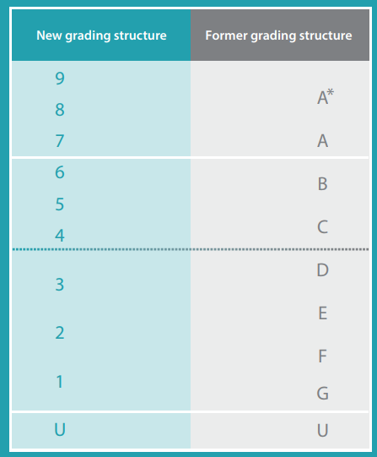
Comparison of Other Headline Figures for Disadvantaged
Students
Performance measure | *KHS 2018 | *KHS 2017 | *KHS 2016
Attainment 8 Score | 33.25 | 34.94 | 34.72
Progress 8 score | -0.82* | -0.78 | -0.86
Basics (Grade 4) | 38% | 43% | 34%
Basics (Grade 5) | 19% | 13% | 12%
5 or more GCSE grades 9-4 | 30% | 36% | 34%
5 or more GCSE grades 9-4 Inc English and Maths | 29% | 34% | 29%
5 or more 9-1 grades | 94% | 98% | 88%

*Exact comparisons between 2016 and 2018 can’t be made due to the new performance measure of 9-1 replacing A*-C.

KS4 Attainment of disadvantaged students
Disadvantaged
65% of the cohort were in receipt of pupil premium funding and 35% were not.
Disadvantaged:33.25 (3-/D-) other pupils: 36.99 (D+/3+)
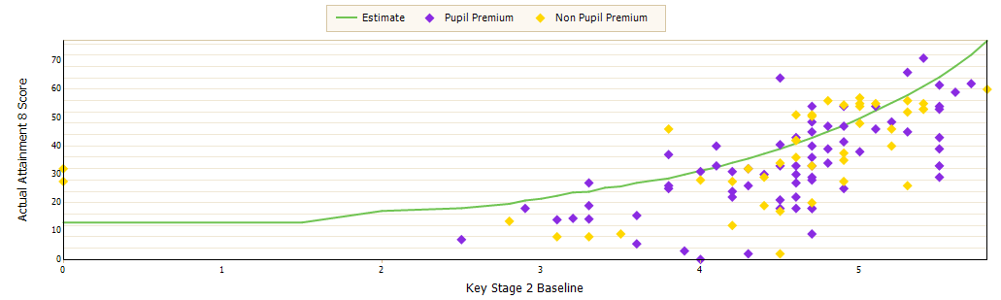

Disadvantaged gender split
Disadvantaged Boys: 31.38 (3-/D-) and Disadvantaged Girls: 34.69 (3/D)

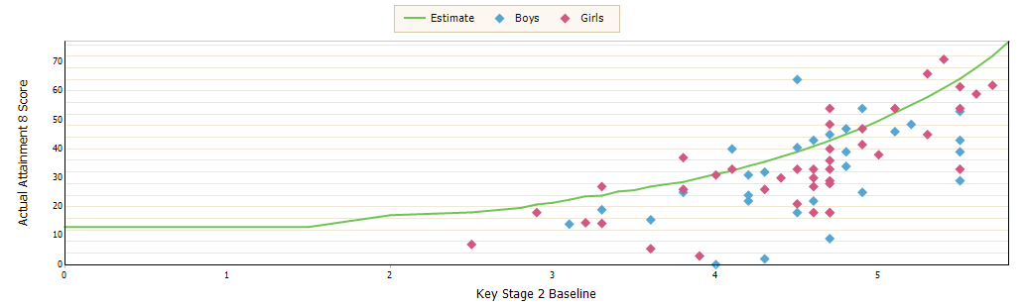

Disadvantaged Prior Attainment Band
Upper:50.13 (5/C+), Middle:31.66( 3-/D-) ,Lower: 17.37 (1+/F)
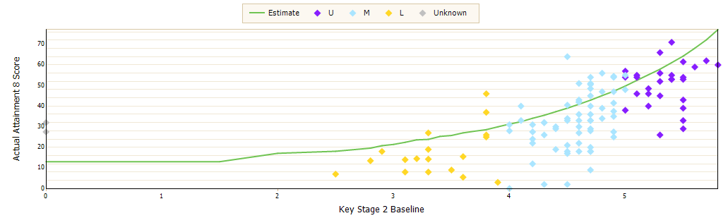

Summary of Attainment for disadvantaged students
Group(Number of students) | Attainment 8
All Students (69) | 33.81
Boys (30) | 31.38
Girls (39) | 34.69
Upper(16) | 50.13
Middle(40) | 31.66
Lower (13) | 17.37
EHCP(2) | 10.5
K/SEN support (2) | 8.63
Summary of Progress for disadvantaged students
Group(Number of students) | Progress 8*
All Students (69) | -0.9
Boys (30) | -1.07
Girls (39) | -0.77
Upper(16) | -0.69
Middle(40) | -0.79
Lower (13) | -0.8
EHCP(2) | -1.11
K/SEN support (2) | -1.83

Summary of Attainment and progress data for disadvantaged students
Element | Attainment 8 | Progress 8*
English | 7.36 | -0.92
Maths | 6.78 | -0.64
Ebac | 9.04 | -0.95
Open | 10.06 | -1.02

Attainment 8 for disadvantaged pupils
2017_2018
Number of disadvantaged pupils = 69
2017_2018 attainment 8 for disadvantaged students V National to be added here once 2018 National picture has been released

KS3 progress of disadvantaged students
Year 9 2017-2018
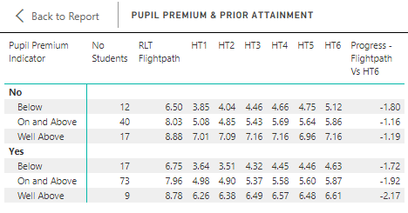
In year 9 Pupil Premium low ability students are making better progress than Non pupil Premium Low ability students.
The high and middle ability pupil premium students are making less progress than non- pupil premium students
Year 8 2017-2018
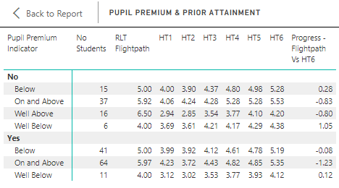
In year 8 the progress gap between PP and Non-PP is less than 0.3 of a stage .

Year 7 2017-2018
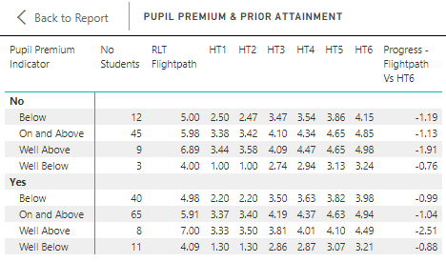
In year 7 the progress gap between PP and Non PP is less than 0.2 of a stage except for the High ability students where the gap is 0.6.

Key Stage 3 Disadvantaged students
 | Year 7 | Year 8 | Year 9
End of year (2018) | 4.99 | 5.73 | 6.03
End of year (2017) | 4.55 | 5.31 | 6.13

Year 7 (2017/2018)
All Disadvantaged Students | End of previous Year 7 Cohort (2016/2017) | End of Year 7 Cohort  (2017/2018) | Improvement on previous year 7 cohort | Year 8 HT1  (2018/2019) | Improvement from end of year 7 to Y8 HT1
All Disadvantaged | 4.55 | 4.99 | +0.44 | 5.39 | +0.4
Boys | 4.46 | 4.89 | +0.43 | 5.26 | +0.37
Girls | 4.72 | 5.08 | +0.36 | 5.52 | +0.44
Ethnic Groups | 4.49 | 5.16 | +0.67 | 5.86 | +0.7
CLA | 5.87(3) | 5.63(1) | -0.24 | 6.03(1) | +0.4
*In brackets is the number of students

Year 8 (2017/2018)

All Disadvantaged Groups | End of Previous Year 8 Cohort  (2016/2017) | End of Year 8 Cohort  (2017/2018) | Improvement on previous year 8 cohort | Year 9 HT1  (2018/2019) | Improvement from end of year 8 to Y9 HT1
All Disadvantaged | 5.31 | 5.73 | +0.42 | 6.14 | +0.41
Boys | 5.37 | 5.52 | +0.15 | 5.96 | +0.44
Girls | 5.78 | 5.85 | +0.07 | 6.33 | +0.48
Ethnic Groups | 6.48(10) | 5.27(3) | -1.21 | 5.90(3) | +0.63
CLA | 5.89 (1) | 6.07(3) | +0.18 | 5.76(3) | -0.31

*In brackets is the number of students

